APPENDIX A LAND DEVELOPMENT ORDINANCE^{[1]}
Footnotes:
--- (1) ---
Editor's note— Printed herein is the Land Development Ordinance of the City, Ordinance of 01-02-2018(1) , as adopted by the City of Cleveland on January 2, 2018. Amendments to the ordinance are indicated by parenthetical history notes following amended provisions. The absence of a history note indicates that the provision remains unchanged from the original ordinance. Obvious misspellings and punctuation errors have been corrected without notation. For stylistic purposes, headings and catchlines have been made uniform and the same system of capitalization, citation to state statutes, and expression of numbers in text as appears in the Code of Ordinances has been used. Additions made for clarity are indicated by brackets.

ARTICLE 1. - INTRODUCTORY PROVISIONS

Sec. 101. - Title.
This document shall be known and referred to as the Land Development Ordinance of the City of Cleveland, Mississippi.
Sec. 102. - Purpose.
This Land Development Ordinance has been prepared in accordance with the City of Cleveland's Comprehensive Plan and is enacted to preserve and promote the public health, safety, and general welfare of the citizens of the City of Cleveland. This Ordinance is to generally encourage and facilitate orderly, healthy, and efficient, physical and economical growth and expansion of the City. Specific Articles within this Ordinance may create regulations applicable to certain areas of the City for the purpose of reasonably preserving and promoting the character of these specific areas and encouraging the most appropriate use of land.
Specific Purposes. In addition to the overall general purpose and goal of this Land Development Ordinance, the City of Cleveland also recognizes individual and specific purposes for the enactment of this Ordinance. Those more specific purposes and goals are:
1. To avoid undue concentration of population and prevent the overcrowding of land by controlling the division of land and regulating the density of existing and proposed developments.
2. To prevent injury and secure safety from fire, crime, panic, flooding, and other dangers.
3. To protect property values along with the integrity and character of neighborhoods by establishing design regulations for existing buildings or sites, and new construction.
4. To separate incompatible uses and prevent the unusual mixture of land uses, indoors and outdoors, by enacting zoning districts and regulations which control the location of uses.
5. To lessen congestion on the streets by establishing minimum standards governing the construction of streets and utilities as well as other public improvements and by ensuring proper coordination of future planned streets and future improvements to existing streets.
6. To facilitate the provision of transportation, water, sewerage, schools, parks, and other public facilities and requirements.
7. To promote a pro-active growth and development strategy that will maintain the long-term economic viability and the quality of life of the City of Cleveland.
8. To preserve, enhance, and perpetuate those aspects of the City having historical, cultural, architectural, and archeological merit.
9. To encourage specific design and architectural principles for developments which create innovative and unique solutions that are practical as well as aesthetically pleasing and harmonious in appearance.
10. To promote and enhance the City's attractions to visitors and to support business and industry through the continued use, preservation, and revitalization of its resources.
Sec. 103. - Interpretation.
In interpreting and applying this Ordinance, its provisions shall be held to the minimum requirements for the promotion of the public safety, health, convenience, comfort, morals, prosperity, and general welfare. It is not the intent of this Ordinance to interfere with, abrogate or annul any ordinance, rules, regulations, or permits previously adopted or issued that are not in conflict with any of the provisions of this Ordinance. Nor is it the intent of this Ordinance to interfere with, abrogate or annul any easement, covenant, or other agreements between parties except where this Ordinance imposes greater restrictions, in which case this Ordinance shall control.
Sec. 104. - Conflict and repeal.
All ordinances or parts of ordinances in conflict with this Land Development Ordinance are repealed, but nothing contained herein shall prevent the prosecution of any person or the bringing of a civil action to enjoin any person for the prior violation of any ordinance or part of any ordinance hereby repealed.
Sec. 105. - Severability
If any part, section, subsection, paragraph, sentence, clause, or phrase of this Ordinance should be declared invalid for any reason whatsoever, such decision shall not affect the remaining portion of this Ordinance, which shall remain in full force and effect. To this end the provisions of this Ordinance are hereby declared severable. It is intended that the Ordinance be held inapplicable in such cases, if any, where its application would be unconstitutional. A constitutional construction is intended and shall be given. The Mayor and Board of Aldermen do not intend to violate the Constitution of the State of Mississippi or the Constitution of the United States of America.
Sec. 106. - Effective date
This ordinance shall be published and shall become effective and be in force one month from and after its passage as provided by law.
ARTICLE 2. - REVIEW AND DECISION-MAKING BODIES

Sec. 201. - Mayor and Board of Aldermen.
The Mayor and Board of Aldermen act as the Governing Body for the City of Cleveland. They have authorized the establishment of the other decision-making bodies as described below. As specifically related to the Land Development Ordinance, their primary duties include, but are not limited to, the following:
A. Appointing Committee Members. The Mayor and Board of Aldermen appoint members to the various committees and boards such as the Planning Commission, Board of Appeals, and Heritage Commission and shall determine the appropriate terms for members to serve.
B. Hearings and Decisions. The Mayor and Board of Aldermen shall hear recommendations from the Planning Commission regarding rezoning and subdivision applications and shall make the final decision. Final approval of subdivision plats and other data shall be the responsibility of the Mayor and Board of Aldermen as prescribed by law. In regards to rezoning, the Mayor and Board of Aldermen shall also hold the appropriate public hearing and publish sufficient notice according to Article 5, Section 507. The Mayor and Board of Aldermen and the City Clerk shall hold the Official version of the Zoning Map.
The Mayor and Board of Aldermen shall hear any appeals from decisions of the Board of Appeals regarding Special Exceptions, Variances, and appeals of decisions made by the Building Official, Code Enforcement officer, and the Plan Review Committee.
The Mayor and Board of Aldermen shall hear recommendations from the Board of Appeals regarding special exceptions for restaurant uses located in the B-1 zoning district and be the body with approval authority for such uses. A notice and public hearing shall be required prior to approval of any B-1 restaurant use.
The Mayor and Board of Aldermen shall also hear recommendations from the Board of Appeals regarding special approval for the consumption of alcoholic beverages. They shall specifically review and be the only body with approval authority for all applications for facilities that provide for the consumption of beer, wine or alcoholic beverages upon the premises. Such approvals shall be personal to the applicant and therefore not transferable, may be reviewed at any time, and terminated by the Mayor and Board of Aldermen upon finding that such uses are adversely affecting the public interest. Prior to the special approval and granting of uses with the sale alcoholic beverages to be consumed upon any premises by the Mayor and Board of Aldermen, public notices shall not be required but such notices may be given within the discretion of the Mayor and Board of Aldermen.
The Mayor and Board of Aldermen shall also hear appeals from the Heritage Commission and shall designate historic districts, landmarks, or sites in consultation with the Heritage Commission.
Sec. 202. - Planning commission.
The City of Cleveland Planning Commission is authorized and directed to advise and assist the Mayor and Board of Aldermen in the administration and coordination of these regulations. The Department of Community Development is authorized and directed to enforce all provisions of this Land Development Ordinance.
The Planning Commission is charged with the responsibility of reviewing and making recommendations to the Mayor and Board of Aldermen regarding amendments to Article 6, Zoning and to the Official Zoning Map and regarding preliminary subdivision plat approval. Where the Plan Review Committee feels additional review is necessary, the Planning Commission may also be responsible for reviewing and approving site plans for multi-family and other non-residential developments in Cleveland.
Sec. 203. - Planning commission acting as the board of appeals.
The City of Cleveland Planning Commission is also designated as the Board of Appeals. The Planning Commission and/or Board of Appeals shall adopt rules necessary to the conduct of its affairs and in accordance with the provisions of this Ordinance.
An appeal stays all proceedings in furtherance of the action appealed from unless a stay would cause eminent peril to life or property as certified to the Board of Appeals by the officer from whom the appeal is taken. In such cases, proceedings shall not be stayed other than by a restraining order which may be granted by the Board of Appeals or by a Court of Record, on application or notice to the officer from whom the appeal is taken and on cause shown.
The Board of Appeals shall have the following powers and duties:
A. Administrative Review. To hear and decide appeals from persons aggrieved by any officer, department, board or bureau of the City of Cleveland, or affected by any decision of the Building Official, Code Enforcement Officer, or Plan Review Committee; OR where it is alleged there is an error in any order, requirement, decision or determination made by an administrative official in the enforcement of this Ordinance. Upon the hearing of an appeal, the Board of Appeals is empowered to permit the following exceptions:
1. To permit the extension of a zoning use district where the boundary line of a district divides a lot or parcel of land in single ownership as shown on record, provided the distance involved does not exceed fifty (50) feet.
2. To permit the erection and use of a building or the use of premises in any location of a public service corporation for public utility purposes which the Board deems reasonably necessary for the public convenience or welfare.
3. To interpret the provisions of this Ordinance, where street layout actually on the ground varies from the street layout as shown by the Official Zoning Map.
4. The Board of Appeals shall make a finding, and may grant the special exception as authorized, provided such special exception will not adversely affect the public interest.
5. In the granting of any exception or special exception, the Board of Appeals may prescribe appropriate conditions and safeguards in conformity with this Ordinance. Violations of such conditions and safeguards when made a part of the terms under which the special exception is granted, shall be deemed a violation of this Ordinance and shall be punishable under Article 3 of this Ordinance.
6. Every special exception authorized shall not be personal to the applicant, but shall be transferable and shall run with the land until change pursuant to the provisions of this Ordinance for changes or amendments.
7. The Board of Appeals shall prescribe a time limit which action on the special exception will be commenced, completed, or both. Failure to commence or complete such action within the time limit set shall void the special exception.
B. Variances.Where the strict application of this Ordinance would result in peculiar and exceptional practical difficulties to or exceptional hardship upon the owner of such property, the Board of Appeals is empowered to authorize upon an appeal relating to such property, a variation from such strict application so as to relieve such difficulties or hardships. For example, by reason of exceptional narrowness, shallowness, or shape of a specific piece of property at the time of the original adoption of the regulations, or by reason of exceptional topographical conditions or other extraordinary or exceptional situation or condition of a specific piece of property, or by reason of the location of trees, natural drainage courses, lakes or other desirable or attractive features, which condition is not generally prevalent in the neighborhood.
The potential for economic loss or gain on the part of the applicant resulting from the action of the Board of Appeals shall not be considered a sufficient basis for the approval of any variance. The fact that an owner could realize a greater financial return by a use of his property that is contrary to these regulations is not a sufficient reason for change. Hardship cannot be proved where it can be shown that property was purchased with the knowledge of existing restrictions, nor can hardship be claimed in terms of prospective sales or potential customers.
C. Nonconforming Uses. The Board of Appeals is further granted the power and authority to permit extensions and enlargements to existing buildings being utilized for nonconforming uses, provided the total of such extensions or enlargements shall not exceed 25 percent of the total area of the existing principal structure and shall not infringe on the side, front and rear yard requirements for the particular district in which the nonconforming use is located, and provided further that the Board of Appeals shall first find that such extension or enlargement does not result in a diminution of conforming uses, will not be detrimental to and will not tend to alter the character of the neighborhood.
D. Exercising of Powers Granted. In the exercising of the powers granted, such Board of Appeals may, in conformity with the provisions of this Ordinance, reverse or affirm, wholly or partly, or may modify the order, requirement, decisions, or determination appealed from and may make such order, requirement, decision or determination as ought to be made, and to that end shall have all the powers of the office from whom the appeal is taken.
E. Consideration of Appeals. In any consideration of all appeals, the Board of Appeals shall, before making any finding in a specific case, first determine that the proposed change will not constitute change in the Official Zoning Map and will not impair an adequate supply of light and air to adjacent property or impair established property values within the surrounding area or in any other respect impair the public health, safety, comfort, morals, and general welfare of the City of Cleveland.
F. Required Appeal Vote. The concurring vote of two-thirds of the members of the Board of Appeals shall be necessary to reverse any order, requirement, decision, or determination of an administrative official.
Sec. 204. - Cleveland Heritage Commission.
The Cleveland Heritage Commission has been duly established and is reaffirmed by this Ordinance to preserve, promote, and develop the City's historical resources and to advise the City on the designation of preservation districts, landmarks, and landmark sites and perform such other functions as may be provided by law.
Sec. 205. - Plan review committee.
A Plan Review Committee for the City of Cleveland, Mississippi, is re-established and confirmed through this Ordinance. The Committee shall have the structure, powers and functions as described below. The Committee consists of the following City staff members: Building Official, City Engineer, and Fire Inspector. This Committee shall review Development Plans submitted for multi-family and all non-residential developments within the City based on requirements and criteria discussed in Article 5, Section 509 and Article 10. The Plan Review Committee manages any amendments or modifications to previously approved Development Plans. The Plan Review Committee is also charged with reviewing any applications for preliminary and final subdivision plats and makes recommendations to the Planning Commission and Board of Aldermen thereof. The Plan Review Committee reviews all non-single-family residential building permit applications and building plans as covered in this Ordinance. Any appeals of the Plan Review Committee's decisions are heard by the Board of Appeals.
ARTICLE 3. - ADMINISTRATION

Sec. 301. - Enforcement.
The Department of Community Development, as designated by the Mayor and Board of Aldermen of the City of Cleveland shall administer and enforce this Ordinance. This department may be provided with the assistance of such other persons as deemed necessary by the Mayor and Board of Aldermen.
Any officer, employee, Board or Commission member, or other agent of the City of Cleveland may enter and inspect or abate any building or premises whenever necessary, as a part of their designated duties, to secure compliance with, or prevent violation of, any provision of this Ordinance. If required by law, the officer, employee or agent shall first obtain consent of the responsible party or an appropriate court order.
No officer, employee, appointee, Board or Commission member, contractor, or other agent of the City of Cleveland shall be personally liable for any damage that may accrue to any person as a result of any act, decision, or other consequence or occurrence arising out of the discharge of duties and responsibilities pursuant to this Ordinance.
Sec. 302. - Permits and certificates.
Building permits shall be issued in accordance with the following provisions:
1. Building Permits Required. No building or other structure shall be erected, altered, moved, added to, or renovated without a permit therefore, issued by the Department of Community Development.
2. Compliance with Codes. No property shall be occupied or used and no building erected or structurally altered shall be occupied or used in whole or in part for any purpose whatsoever, until a certificate of occupancy is issued by the Department of Community Development.
3. Change of Use. No change of use shall be made in any building or part thereof erected or structurally altered without a permit being issued by the Department of Community Development. No permit shall be issued to make a change unless the changes are in conformity with the provisions of this Ordinance.
4. Discontinuance. Nothing in this Ordinance shall prevent the continuance of a nonconforming use unless discontinuance is necessary for the safety of life and property.
5. Occupancy Certificates. No structure shall be occupied without a valid and current Certificate of Occupancy. Once issued, a Certificate of Occupancy shall be valid for a period of twelve (12) months from the date of issuance or until there is a change in ownership or tenant, whichever is more restrictive. For new construction, certificates of occupancy shall be issued after the lawful erection of the building or structure is completed. A record of all certificates shall be kept on file in the office of the Department of Community Development, and copies shall be furnished on request to any person having a proprietary or tenancy interest in the building affected.
6. Commencement of Work. Work shall not commence on any construction project until the necessary permits are obtained from the Department of Community Development. No building or premises can be occupied without a certificate of occupancy. Work commenced prior to the issuance of a permit is subject to double permit fees and shall be in violation of this Ordinance.
7. Application for Building Permit. All applications for building permits shall be accompanied by plans in duplicate, drawn to scale, showing the actual dimensions and shape of the lot to be built upon; the exact sizes and locations on the lot of buildings already existing, if any; and the location and dimensions of the proposed building or alteration. Plans submitted for all commercial, industrial, or multi-family projects shall be submitted in both paper and electronic formats. The application shall include such other information as lawfully may be required by the Department of Community Development, including existing or proposed construction or alteration, existing or proposed uses of building and land, and other matters as may be necessary to determine conformance with and provide for the enforcement of this Ordinance. Construction plans shall be prepared by a licensed design professional whenever a proposed project meets any of the following criteria:
a. The intended use is of a type A, E, I, or H occupancy; or
b. The proposed construction is three (3) stories or more in height; or
c. The proposed construction is five thousand (5,000) square feet or greater; or
d. If required by the Plan Review Committee.
8. Expiration of Building Permit. If the work described in any building permit has not commenced with six (6) months from the date of issuance thereof, said permit shall expire and shall be canceled by the Department of Community Development. If a permitted project is inactive for a period of six (6) months, said permit shall expire and shall be canceled by the Department of Community Development. Written notice shall be given the person or persons affected, together with notice that any work as described in the canceled permit shall not proceed unless and until a new building permit has been obtained.
9. Penalty for Violation. Building permits or certificates of occupancy issued on the basis of plans and applications approved by the Department of Community Development authorize only the use, arrangement, and construction specified in such approved plans and applications, and any other use, arrangement, or construction shall be deemed in violation of this Ordinance, and punishable as provided under this Article.
Sec. 303. - Certificate of appropriateness.
No exterior feature of any resource in a historic district shall be altered, relocated, or demolished until after an application for a certificate of appropriateness of such work has been approved by the Heritage Commission. Likewise, no construction which affects a resource in a historic district shall be undertaken without a certificate of appropriateness unless the work is considered regular and routine maintenance as described in Article 5, Section 510.
Sec. 304. - Violations, sanctions, and penalties.
304.1 - General.
If the Building Official finds that any of the provisions of this Ordinance are being violated, he shall notify in writing the person or persons responsible for such violation indicating the nature of such violation and order the action necessary to correct it. He shall order discontinuance of illegal uses of land, buildings, structures or signs; removal of illegal buildings, structures, signs, additions, alterations, or structural changes thereto; discontinuance of any illegal work being done; or shall take any other action authorized by this Ordinance to insure compliance with or to prevent violation of its provisions.
Any arrangement of construction different from that approved as a part of this Ordinance shall constitute a violation of these standards. In case any building or structure is erected, constructed, reconstructed, altered, repaired, converted or maintained or any building, structure or land is used in violation of this Ordinance, the Building Official, in addition to other remedies, shall institute any appropriate action or proceedings in the name of the City of Cleveland, Mississippi, to prevent such unlawful erection, construction, reconstruction, alteration, repair, conversion, maintenance or use, to restrain, correct or abate such violation to prevent the occupancy of said building, structure or land, or to prevent any illegal act, conduct, business or use in or about said premises.
Any person or corporation who shall violate any of the provisions of this Ordinance or fail to comply herewith or with any of the requirements of this Ordinance shall be deemed guilty of a misdemeanor and shall be liable to a fine of not less than One Hundred Dollars ($100.00) and not more than One Thousand Dollars ($1,000.00) or by imprisonment in the county jail not to exceed 90 days, or both such fine and imprisonment. Each day such violation shall be permitted to exist may constitute a separate offense. The owner or owners of any building or structure or facility or premises or part where anything in violation of this Ordinance shall be placed or shall exist, and any architect, builder, contractor, individual person or corporation employed in connection therewith and who may have assisted in the commission of any such violation shall be deemed guilty of a separate offense and upon conviction shall be fined as herein provided.
In addition to the penalties authorized and established above, any violation shall be sufficient grounds for the Building Official to issue stop work orders, withhold further permits, and void current permits. The City Attorney is also authorized to take such actions in law or in equity as may be required to halt, terminate, remove, or otherwise eliminate any violations of these standards.
304.3 - Specific to historic districts.
The following civil and criminal penalties may be imposed upon those persons found to have violated requirements or prohibitions related specifically to Article 11 regarding Historic Districts and preservation.
1. Civil penalty.
a. Any person who constructs, alters, relocates, or demolishes any resource in violation of this Ordinance shall be required to restore the resource to its appearance or setting prior to the violation. Any action to enforce this provision shall be brought by the City. This civil remedy shall be in addition to, and not in lieu of, any criminal prosecution and penalty.
b. If construction, alteration, relocation or demolition of any resource occurs without a certificate of appropriateness, then the license of the company, individual, principal owner, or the successor in interest performing such acts shall be revoked for a period of three years.
c. If demolition of a resource occurs without a certificate of appropriateness, then any permits on subject property will be denied for a period of three years. In addition, the applicant shall not be entitled to have issued to him any permit allowing any curb cuts on subject property for a period of three years from and after the date of such demolition.
2. Criminal penalty. Any person violating any provision of Article 11 shall be guilty of a misdemeanor and shall be guilty of a separate violation for each day during which any violation is committed. Upon conviction, each violation shall be punishable by a fine not to exceed One Thousand Dollars ($1,000.00).
ARTICLE 4. - WORD USAGE AND DEFINITIONS
For the purpose of this Ordinance, certain words and phrases are defined. Words and phrases defined shall be given the defined meaning. Words or phrases not defined shall be given their usual meaning, except where the context clearly indicates a different or specified meaning.
Words used in the present tense include the future tense and the singular includes the plural.
The term "shall" and "must" are always mandatory and not discretionary; the words "may" or "should" are permissive.
The term "person" or "applicant" or "developer" includes a firm, organization, association, partnership, trust, company, limited liability company, limited partnership, or corporation, as well as an individual.
The terms "use" or "occupy" shall include the concept of intended, designed, or arranged to be used or occupied.
The term "building" includes the term "structure" or "any portion of a building or structure".
Whenever any reference is made in this Ordinance to any other section or provision of this or any other ordinance, such reference shall be deemed to include the provisions or regulation to which the reference is made.
Definitions are provided in alphabetical order:
ABATE/ABATEMENT: Action to terminate, stop, cease, repair, rehabilitate, replace, demolish, correct or otherwise remedy nuisance activity, condition, premises or conduct by such means and in such manner as to bring the activity, condition, premises or conduct into compliance with the laws or regulations of the City of Cleveland and/or the State of Mississippi or in such manner as is necessary to promote the health, safety or general welfare of the public.
ACCESSORY BUILDING or STRUCTURE: Any detached minor building in the rear or side of the main building consisting of masonry, frame walls, or poles without walls, and a roof, one (1) or two (2) stories in height, that is subordinate or incidental to the principal or main structure or use and located on the same lot. Any and all accessory buildings will be located behind the front building line of the main structure in the rear or side yards. Further, the accessory building or structure will not be located less than five (5) feet from the side or rear property lines, or ten (10) feet from a side street property line for corner lots, or eight (8) feet from another structure in any residential zone or twenty (20) feet from another structure in any commercial or industrial zone. It is the intent of this ordinance that there shall be but one (1) main structure plus any permitted accessory structures on any lot used for residential purposes; also, that accessory structures, including storage buildings, shall not include living quarters.
ACCESSORY USE: A subordinate use that is incidental to and customary in connection with the principal building or use and located on the same lot.
ADDITION: An extension, expansion, enlargement or increase in the area or height of a building or structure or the number of dwelling units within the building or structure. Generally, any new construction added to an existing building or structure.
ADDITIONAL INSPECTION: All inspections after the second inspection during the process of obtaining a certificate of occupancy.
ADMINISTRATIVE OFFICIAL: The official or officials designated by the governing body of the City of Cleveland to administer this Land Development Ordinance, primarily the Director of Community Development or Building Official.
ADULT ARCADE: An adult entertainment establishment where, for any form of consideration, one or more motion picture projectors, slide projectors, VCRs, or similar machines for viewing by five or fewer persons each, are used to show films, motion pictures, video tapes, slides, or other photographic reproductions which are characterized by emphasis upon the depiction or description of "specified sexual activities" or "specified anatomical areas".
ADULT BOOKSTORE: An adult entertainment establishment which has as a substantial portion of its stock-in-trade and offers for sale, for any form of consideration, any one or more of the following:
(a) Books, magazines, periodicals, or other printed matter, or photographs, films, motion pictures, video cassettes, slides, or other visual representations which are characterized by an emphasis upon the depiction or description of "specified sexual activities" or "specified anatomical areas", or
(b) Instruments, devices, or paraphernalia which are designed for use in connection with "specified sexual activities".
ADULT CABARET: A nightclub, bar, restaurant, theater, or similar adult entertainment establishment which regularly features live performances which are characterized by the exposure of "specified anatomical areas" or by "specified sexual activities" or films, motion pictures, video tapes, slides, or other photographic reproductions which are characterized by an emphasis upon the depiction or description of "specified sexual activities" or "specified anatomical areas".
ADULT ENTERTAINMENT ESTABLISHMENT: An adult arcade, adult bookstore, adult cabaret, adult motel, adult motion picture theater, massage parlor, or similar establishment which regularly features or depicts behavior which is characterized by the exposure of "specified anatomical areas" or by "specified sexual activities", or where any employee, operates, or owner exposes his/her "specified anatomical area" for viewing by patrons.
ADULT MOTEL: A motel or similar adult entertainment establishment which includes the word "adult" in any name it uses or otherwise advertises the presentation of adult material, offering public accommodations for any form of consideration which provides patrons with closed-circuit television transmission, films, motion pictures, video tapes, slides, or other photographic reproductions which are characterized by an emphasis upon the depiction or description of "specified sexual activities" or "specified anatomical areas".
ADULT MOTION PICTURE THEATER: An adult entertainment establishment where, for any form of consideration, films, motion pictures, video tapes, slides, or similar photographic reproductions are shown, and in which a substantial portion of the total presentation time is devoted to the showing of material which is characterized by an emphasis upon the depiction or description of "specified sexual activities" or "specified anatomical areas".
AGENT: A person, agent, manager, or other individual or entity representing the owner of a property, and who may serve as a point of contact on inspections under this ordinance.
ALTERATION: Work which impacts any exterior architectural feature including construction, reconstruction, or removal of any building or building element.
ALTERNATIVE MEDICINE: Any range of therapies that are used in place of the traditional standard of medical care, not regarded as orthodox in the medical profession, and not included in the traditional medical curricula in the United States. These therapies include, but are not limited to, acupuncture, chiropractic therapy and other body manipulation therapies, cupping, ear candling, herbal medicine, and reiki.
APARTMENT HOUSE: See DWELLING, MULTIPLE.
APPEARANCE: The outward aspect visible to the public.
APPURTENANCE: The visible, functional objects accessory to and part of buildings.
ARCH: A curved construction which spans an opening and supports the weight above.
ARCHITECTURAL CHARACTER: The composite or aggregate of the characteristics of structure, form, materials, and function of a building, group of buildings, or other architectural composition.
ARCHITECTURAL FEATURE: A prominent or significant part or element of a building, structure, or site.
ARCHITECTURAL STYLE: The characteristic form and detail of a building, structure, or site, as of buildings of a particular historic period.
AWNING: A sloped projection supported by a frame attached to the building façade.
BASEMENT: A story having part but no more than one-half its height below average grade of the adjoining ground. A basement is counted as a story for the purpose of height regulations, if subdivided and used for business or dwelling purposes by other than a janitor employed on the premises.
BAY: The horizontal divisions of a building, defined by windows, columns, pilasters, etc.
BED AND BREAKFAST: A building or portion thereof, formerly a single-family dwelling unit, where an owner-operator is paid for lodging in a limited number of guest bedrooms, for specific time periods, with meals provided only to registered guests. This definition does not include hotels, restaurants, cafes, or any other activities that involve sales or services to non-registered guests.
BERM: An earthen mound designed to provide visual interest, screen undesirable elements of a project from public view, and/or decrease noise.
BOARD OF APPEALS: The Cleveland Planning Commission.
BOARDING HOUSE: A building other than a hotel, where for compensation and by prearrangement for definite periods, meals, or lodging and meals, are provided.
BODY PIERCING: that activity as defined in Mississippi Code Annotated Section 73-61-3 said statutory definition being hereby adopted by reference.
BOND (two definitions in context): A monetary guarantee, which secures installation of improvements in the event a developer defaults on required subdivision improvements. An acceptable bond shall include a surety bond from a company licensed to do business in the State of Mississippi; cashier's check, assignment of certificates of deposit, or irrevocable letters of credit from banks located in the State of Mississippi on all Cleveland banks. Also, a term used to describe the various patterns in which brick is laid.
BRACKET: A decorative support feature located under eaves or overhangs.
BROKEN INSPECTION APPOINTMENT: Failure of the owner or agent to notify the City of Cleveland Code Compliance Department at least one (1) hour in advance that the owner or agent will be unable to keep a scheduled inspection appointment.
BUFFER AREA: An area set aside to remain vacant or to be planted and landscaped to reduce the blighting effect of commercial or industrial uses of adjacent residential property.
BUILDABLE WIDTH: Width of the building site left after the required yards have been provided.
BUILDING: Any structure having a roof supported by columns or walls built for the support, shelter, or enclosure of persons, animals, or property of any kind, but not including any vehicle, trailer (with or without wheels), nor any movable device. When divided by walls without openings each portion of such structure shall be deemed a separate building. It is the intent of this ordinance that there shall be but one (1) main structure plus any permitted accessory structures on any lot used for residential purposes; also, that accessory structures, including storage buildings, shall not include living quarters.
BUILDING, ALTERATION OF: Any change or rearrangement in the supporting members including bearing walls, beams, columns, or girders of a building, any addition of a structure or movement of a building from one location to another.
BUILDING, HEIGHT OF: The vertical distance measured from the average elevation of finished grade along the front of the building to the highest point of the coping of a flat roof, to the deck line of a mansard roof, or the average height between eaves and ridges for a gable, hip or gambrel roof. Exception to Height Limits: The height limitations shall not apply to church spires, belfries, cupolas and domes not intended for human occupancy, nor shall they apply to monuments, smoke stacks, conveyors, flag poles, masts, stand-pipes, parapet walls, outdoor theater screens, amateur radio antenna structures, and other similar structures and appurtenances, provided their construction conforms with existing or hereafter adopted Ordinances of the City.
BUILDING PERMIT: A permit issued by the Department of Community Development authorizing the construction, renovation, addition or alteration of a specific building on a specific lot.
BULKHEAD: The panel between framing members and beneath the display windows in a storefront; also known as a kickpanel or kickplate.
CALIPER: The average diameter of a tree measured thirty-six (36) inches above the ground.
CANNABIS CULTIVATION FACILITY: a business entity licensed and registered by the Mississippi Department of Health that acquires, grows, cultivates and harvests medical cannabis in an indoor, enclosed, locked and secure area.
CANNABIS PROCESSING FACILITY: a business entity that is licensed and registered by the Mississippi Department of Health that (i) Acquires or intends to acquire cannabis from a cannabis cultivation facility; (ii) Possesses cannabis with the intent to manufacture a cannabis product; (iii) Manufactures or intends to manufacture a cannabis product from unprocessed cannabis or a cannabis extract; and (iv) Sells or intends to sell a cannabis product to a medical cannabis dispensary, cannabis testing facility or cannabis research facility.
CANNABIS RESEARCH FACILITY: a research facility at any university or college in this state or an independent entity licensed and registered by the Mississippi Department of Health pursuant to this chapter that acquires cannabis from cannabis cultivation facilities and cannabis processing facilities in order to research cannabis, develop best practices for specific medical conditions, develop medicines and provide commercial access for medical use.
CANNABIS TESTING FACILITY: an independent entity licensed and registered by the Mississippi Department of Health that analyzes the safety and potency of cannabis.
CANOPY: A shaped or curved projection from the building façade or attached to the building façade to shelter the storefront and pedestrian traffic.
CAPITAL: Topmost member of a column or pilaster.
CARPORT: See GARAGE, PRIVATE.
CAST-IRON FRONT: A storefront made of glass and pieces of utilitarian and decorative iron case in easily assembled parts.
CELLAR: A story having more than one-half of the height below grade. A cellar is not included in computing the number of stories for height unless it is designed and used for dwelling purposes.
CERTIFICATE: A certificate of occupancy.
CERTIFICATE OF APPROPRIATENESS: A document evidencing the approval of the Heritage Commission for work proposed by an applicant within a historic district.
CERTIFICATED LOCAL GOVERNMENT: A federal program authorized by the National Historic Preservation Act 16 U.S.C. 470 et seq., which provides for the participation of local governments in a federal/state/local government preservation partnership. The federal law directs the state historic preservation officer and the secretary of the interior to certify local governments to participate in this partnership. Specific state requirements for the program are published in the State of Mississippi Guidelines and Regulations for the Certified Local Government Program.
CHECK-CASHING BUSINESS: Any individual, partnership, association, joint stock association, trust or corporation, excluding the U.S. Government and the government of Mississippi, who exchanges cash or other value for any check, draft, money order, personal money order, or other instrument for the transmission or payment of money, except travelers checks and foreign drawn payment instruments, and who charges a fee therefore, and who may defer deposit of a personal check cashed for a customer. This definition does not include any federally or state chartered bank, savings institution or credit union.
CHROMA COLORS: Any of various brilliant pigments containing chromium compounds, such as chromium green or chromium yellow. Generally, any metallic color.
CHURCH: A building used principally for religious worship, but the word church shall not include or mean a funeral chapel or building, religious educational institution or parochial school, day care center, or any type of religious owned or sponsored residential facilities.
CITY: The City of Cleveland, Mississippi, or its representative.
CITY PLANNING COMMISSION: The City of Cleveland Planning Commission or Cleveland Board of Appeals.
CLUSTER DEVELOPMENT: A development pattern for residential subdivisions that permits a reduction in lot area and bulk requirements, provided there is no increase in the number of lots permitted under a conventional subdivision and the resultant land area is devoted to open space.
COHESIVENESS: The unity of composition between design elements of a building, structure, and site.
COLUMN: A vertical, cylindrical or square supporting member, usually with a classical capital.
COMMON AREA: An open space area within or related to a site designated as a development and designed and intended for the shared use or enjoyment of residents and owners of the development. Common open space may contain such complementary structures and improvements as are necessary and appropriate for the shared use or enjoyment of residents and owners of the development.
COMPATIBILITY: The harmony in appearance of two or more buildings, structures, and landscaping elements in the same vicinity.
COMPREHENSIVE PLAN: A statement of public policy for the physical development of the entire municipality or county adopted by resolution of the governing body. As used in this Ordinance, the term refers to the most recently adopted Comprehensive Plan of the City of Cleveland, as amended and supplemented from time to time by ordinance of the Mayor and Board of Aldermen.
CONDOMINIUM: The ownership of single units in a multi-unit structure with common areas and facilities. Also, a building or group of buildings, where units are owned individually, and where the structure, common areas and facilities are owned by all the owners on a proportional, undivided basis.
CONFORMING USE: Any lawful use of a building or lot which complies with the provisions of this Ordinance.
CONSTRUCTION: The addition or placement of any improvement to a resource.
CONVENIENCE STORE: Any retail establishment offering for sale a limited line of groceries and household items generally necessary for everyday living, and intended for the convenience of the neighborhood.
COPING: The capping member of a wall or parapet.
CORBELING: A series of stepped or overlapped pieces of brick or stone forming a projection from the wall surface.
CORNICE: The uppermost, projecting part of an entablature, or feature resembling it.
COURSE: A horizontal layer or row of stones or bricks in a wall.
COURT or COURTYARD: An open unobstructed space on the same lot as the building.
CURB CUT: Any interruption or break in the line of a street curb in order to connect a driveway to a street, or otherwise provide vehicular access to abutting property.
CURB LEVEL: The level of the established curb in front of the building measured at the center of such front. Where no curb has been established, the City Engineer shall authorize and approve the establishment of such curb or its equivalent for the purpose of this Ordinance.
DAY CARE CENTER: A place that provides shelter and personal care for five or more persons, regardless of age, for any part of a 24-hour day, whether such place be organized or operated for profit or not. Care of a person shall not exceed twelve and one half (12½) hours for any part of the 24-hour day. The term day care center includes day care babysitting service, child or adult care centers and any other facility that is within the scope of this definition, regardless of auspices. Excluded from this definition is any facility operating a kindergarten, nursery school or Head Start Program in conjunction with an elementary school and/or secondary school system, whether it be public, private or parochial, whose primary purpose is a structured school readiness program. Also excluded is any medical care facility, such as a nursing home or rehabilitation center. Space requirements shall comply with Mississippi State Board of Health and the International Building Code, or other appropriate state or federal agency provisions.
DAY SPA: a business establishment which people visit specifically for professionally administered personal care treatments, such as massages and facials, similar to a beauty salon in that it is only visited for the duration of the treatment. Any massage therapist operating within a day spa shall be licensed and permitted in accordance with Sections 73-6-1 et seq and the "Mississippi Physical Therapist Practice Law" of the Mississippi Code of 1972, as amended.
DEMOLITION: The complete or partial removal of a building, structure, object, or site, including landscape features.
DEMOLITION BY NEGLECT: Improper maintenance or lack of maintenance of any resource which results in substantial deterioration of the resource and threatens its continued preservation.
DENTIL: One of a series of small, square, tooth or block-like projections forming a molding.
DENSITY: The number of families, individuals, dwelling units, households or housing structures per acre of gross land area.
DEVELOPER: Any person or other legal entity engaged in the development or redevelopment of land, buildings or structures; also any person other legal entity dividing or proposing to divide land so as to constitute a subdivision.
DIRECTOR: The Director of Community Development / Building Official of the City of Cleveland or his duly authorized representative.
DISPLAY PUBLICLY: Placing, posting, exhibiting, or in any way displaying in any location, whether public or private, an item in such a manner that it may be readily visible from a street, public space, or another property.
DOUBLE-HUNG WINDOW: A window having two sashes, one sliding vertically over the other.
DRUG STORE: An establishment engaged in the retail sale of prescription drugs, nonprescription medicines, cosmetics, and related supplies.
DWELLING: Any building, or portion thereof, which is designed and used for residential purposes. It shall not include boarding or rooming houses, tents, hotels, recreational vehicles, mobile home or RV parks, or other structures designed or used primarily for transient residents.
DWELLING, ONE-FAMILY or SINGLE-FAMILY: A detached building, designed, arranged, and occupied exclusively by one family.
DWELLING, TOWNHOUSE: A single-family dwelling forming a group or series of three or more attached single-family dwellings separated from one another by party walls without doors, windows, or other provisions for human passage or visibility through such walls from basement or cellar to roof and having roofs which may extend from one of the dwelling units to another.
DWELLING, MULTIPLE: Any building or portion thereof which is designed, built, rented, leased or hired out to be occupied or which is occupied as a home or residence of two or more families living independently of each other. The term "multiple dwelling" shall be understood to include apartment houses, bungalow courts, duplexes, tri-plexes, and all other dwellings of similar character.
EARTHTONE COLORS: Colors considered to be various shades of reddish-brown, brown, tan, ochre, umber, flat gold, sand, and flat greens. The following are not ordinarily considered earthtone colors: bright primary colors, blue, canary yellow, red, orange, violet, magenta, bright green, silver, gray, or metallic finishes.
EASEMENT: A right distinct from ownership giving authorization by a property owner for the use by another of any designated part of his property for a specified purpose. For example:
a. Utility: An easement reserving space for utilities.
b. Access: An easement allowing a private path which is permanently reserved for vehicle or pedestrian access to abutting property. The terms of use which are public record.
c. Drainage: An easement reserving space for conveyance of water.
ELEVATION: Any of the external faces of a building.
ENTABULATURE: The horizontal group of members supported by the columns, divided into three major parts, and consisting of architrave, frieze, and cornice.
ENFORCEMENT OFFICER: The Code Enforcement Officer, Housing Inspector, Building Inspector, Building Official, Director of Community Development, any sworn Police Officer of the City of Cleveland, Mississippi, or any other City official named by the Mayor and Board of Aldermen to enforce the provisions of this Ordinance.
EXTERIOR BUILDING COMPONENT: An essential and visible part of the exterior of a building.
EXTERIOR DESIGN FEATURE: The architectural style and general arrangement of such portion of a building or structure as is to be open to view from a public street, place, or way, including the kind, color, and texture of the building material of such portion, and the type of windows, doors, and lights, or ground signs and other fixtures appurtenant to the building.
FAÇADE: The front elevation or "face" of a building.
FAMILY: Any number of individuals related by blood, marriage, or other legal arrangement or a group of unrelated individuals not to exceed six unrelated persons living together as a single housekeeping unit and in which food preparation is conducted on the premises.
FANLIGHT: A semicircular or semi-elliptical window with radiating muntins suggesting a fan.
FASCIA: A projecting flat horizontal member or molding forming the trim of a flat roof or a pitched roof; also part of a classical entablature.
FENCE: A barrier intended to mark a boundary, screen a view or prevent intrusion. All fences shall be able to withstand normal wear, function as a barrier and keep an attractive appearance, and shall be built in a sound workmanlike manner, with adequate footings.
FENESTRATION: The arrangement of window openings in a building. Generally, any exterior window or door.
FINIAL: A projecting decorative element at the top of a roof turret or gable.
FLASHING: Thin metal sheets used to make the intersections of roof planes and roof/wall junctures watertight.
FLOODPLAIN: Any land area susceptible to being inundated by flood waters from any source. The 100-year Floodplain is the area of the floodplain that has a one percent chance of being inundated in any given year.
FLOODWAY: The channel of a watercourse and portions of the floodplain adjoining the channel, which are reasonably required to carry and discharge the floodwater of any natural stream or river. No building, other obstructions, or construction may undertaken within the Floodway.
FLOOR AREA: The square feet of floor space within the outside line of walls and including the total of all space on all floors of a building but not including porches, garages, or space in a basement or cellar not used for dwelling purposes.
FOLLOW-UP INSPECTION: The second inspection of a building or structure during the process of obtaining a certificate of occupancy.
FOOTPRINT: The outline of a building's floor area from a top or plan view.
FOUNDATION: The lowest exposed portion of the building wall, which supports the structure above.
FRAME CONSTRUCTION: A method of construction in which the major parts consist of wood.
FRENCH DOOR: A door made of many glass panes, usually used in pairs and attached by hinges to the sides of the opening in which it stands.
FRIEZE: The middle horizontal member of a classical entablature, above the architrave and below the cornice.
FRONTAGE: The total linear distance of a property measured along the side of the street or street rights-of-way which the property touches.
FUTURE LAND USE PLAN and MAP: The part of the Comprehensive Plan for Cleveland now and hereafter adopted which includes the adopted Future Land Use Plan and Map and which sets forth identification, location, area and classifications of proposed future land uses.
GABLE ROOF: A pitched roof with one downward slope on either side of a central, horizontal ridge.
GARAGE, PRIVATE: An accessory building or portion of a main building used for vehicular storage. The term includes carport.
GARAGE, PUBLIC: A building, or portion thereof, other than a private or storage garage, designed or used for servicing, repairing, equipping, hiring, selling or storing motor-driven vehicles.
GARAGE, STORAGE: A building or portion thereof designed or used exclusively for housing four or more motor-driven vehicles.
GOVERNING BODY: The Mayor and Board of Aldermen of Cleveland, Mississippi.
GRADE: The elevation at which a building, sign, or other structure meets the ground. Generally, the average elevation of the land around the building or site.
GRAPHIC ELEMENT: A letter, illustration, symbol, figure, insignia, or other device employed to express and illustrate a message or part thereof.
GREEN BELT: A strip or tract of publicly owned land dedicated for public use only to divide certain use zones to maintain a permanent separation between the various uses.
GROUND COVER: Sod or other low growing plants installed in such a manner so as to form a continuous cover over the ground surface.
HARMONY: A quality which produces an aesthetically pleasing whole in the arrangement of varied architectural and landscape elements.
HOME OCCUPATION: An occupation conducted in a dwelling unit, provided that no person other than members of the family residing on the premises shall be engaged in such occupation. The use of the dwelling unit for the home occupation shall be clearly incidental and subordinate to its use for residential purposes by its occupants, and there shall be no change in the outside appearance of the building or premises or other visible evidence of the conduct of such home occupation. No home occupation shall be conducted in any accessory building; no traffic shall be generated by such home occupation in volumes greater than would normally be expected in a residential neighborhood; and any need for parking generated by the conduct of such home occupation shall be met off the street and other than in a required front yard. No equipment shall be used other than is normally used for domestic or household purposes. The dwelling floor plan shall remain unaltered from that appropriate with a household. No uses resembling a commercial establishment shall be conducted on the premises.
HOME OWNERS ASSOCIATION (HOA), or PROPERTY OWNERS ASSOCIATION (POA): A community association which is organized in a development in which individual owners share common interests in common property such as open space, private drives, or facilities. The HOA/POA manages and maintains the common property and enforces certain covenants and restrictions. To assure that common property is maintained, any development that proposes to have private amenities and/or common properties, those that are not being dedicated to and accepted by the City of Cleveland, shall have a HOA/POA that is established with the first phase of the development. The HOA/POA shall be mandatory in membership and dues and shall apply to the entire development. All lots within the subdivision should be included in one HOA /POA for the development.
HOOD MOLDING: A projecting molding above an arch, doorway, or window originally designed to direct water away from the opening; also called a drip mold.
HOTEL: A building used as the abiding place of not less than six transient persons who are lodged for compensation with or without meals.
IMMEDIATE FAMILY: Spouses, children, stepchildren, brothers and sisters, half-brothers and half-sisters, parents and stepparents, grandparents, and grandchildren.
IMPROVEMENTS (two definitions by context): Street pavement or resurfacing, curbs, gutters, sidewalks, water lines, sewer lines, gas lines, street lights, flood control and drainage facilities, utility lines, landscaping, dirt work, and other related matters normally associated with the development of undeveloped land into building sites. Also, additions to or new construction on landmarks or landmark sites including, but not limited to, buildings, structures, objects, landscape features, manufactured units like mobile homes, carports, and storage buildings.
INFILL: New construction where there had been vacant land or an opening before. This applies to a new structure such as a new building between two older structures or new material such as block infill in an original window opening.
INITIAL INSPECTION: The first inspection during the process of obtaining a certificate of occupancy.
INSTITUTION: A building occupied by a nonprofit corporation or nonprofit establishment for public use.
JACK ARCH: An arch with wedge shaped stones or bricks set in a straight line; also known as a flat arch.
JAMB: The vertical side of a doorway or window.
JUNKYARD: A place where waste, discarded, or salvaged materials are bought, sold, exchanged, baled, packed, recycled, disassembled, or handled including auto-wrecking yards, house-wrecking yards, used-lumber yards, and places or yards for storage or salvaged house-wrecking and structural steel materials and equipment but not including such places where such uses are conducted entirely within a completely enclosed building, and not including pawn shops and establishments for the sale, purchase, or storage of used furniture and household equipment, used cars in operable condition, or salvaged materials incidental to manufacturing operations.
KENNEL: The keeping of six or more domestic animals for monetary gain, whether for boarding, breeding or sale.
KEYSTONE: The top or center member of an arch.
LANDMARK: A building, structure, or object and its historically associated land or other appropriate setting designated by the Heritage Commission and approved by the City through an ordinance, which possesses particular architectural, cultural, or historic significance by meeting at least one of the following criteria source:
a. Exemplifies or reflects the broad cultural, political, economic, or social history of the nation, region, state, county, or city;
b. Is identified with historic personages or with important events in national, state, or local history;
c. Embodies distinguishing characteristics of a landscape type or is a specimen inherently valuable for the study of a period, style of a period, style, method of construction, or use of indigenous materials or craftsmanship; or
d. Is representative of the notable work of a master builder, designer, or architect whose individual ability has been recognized or who influenced his age.
LANDMARK SITE: An unimproved or improved parcel of ground designated by the Heritage Commission and approved by the City through an ordinance, which possesses particular archaeological, architectural, geological, or historic significance. A landmark site differs from a landmark in that the physical location, not the building, structure, or objects, possesses primary significance. For the purposes of this Ordinance, a landmark site encompasses prehistoric or historic sites on unimproved or improved land. Landmark sites meet at least one of the following criteria:
a. Exemplifies or reflects the broad cultural, political, economic, or social history of the nation, region, state, county, or city;
b. Is identified with historic personages or with important events in national, state, or local history;
c. Embodies distinguishing characteristics of an architectural type or is a specimen inherently valuable for the study of a period, style, method of construction, or use of indigenous materials or craftsmanship; or
d. Has yielded, or may be likely to yield, information important in prehistory or history. A landmark site may be a culturally significant natural feature other than landscape.
LANDSCAPE: Any improvement or vegetation including, but not limited to: shrubbery, trees, plantings, outbuildings, walls, courtyards, fences, swimming pools, planters, gates, street furniture, exterior lighting, and site improvements, including but not limited to, subsurface alterations, site regrading, fill deposition, and paving.
LIGHT: A single pane of glass.
LINTEL: A horizontal beam over a door or window which carries the weight of the wall above which is usually made of stone or wood.
LIQUOR/PACKAGE STORE: An establishment or place of business primarily engaged in the sale for off-premises consumption of alcoholic liquors, wine, and beer and/or an establishment that holds a package retailers permit pursuant to Mississippi Code Annotated 61-1-51(b).
LODGING HOUSE: A building where lodging only is provided for compensation to three or more, but not exceeding 20 persons, in contradistinction to hotels open to six or more transients.
LOT: A parcel of land occupied or intended for occupancy by one main building together with its accessory buildings and uses customarily incidental to it, including the open spaces required by this Ordinance, and having its principal frontage upon a street or upon a place that has been officially approved.
Examples of types of lots are shown below:
Lot, Corner: A lot that fronts on two or more streets at the junction of these streets.
Lot, Double Frontage: A lot that fronts on two or more non-intersecting streets.
Lot, Flag: A lot where the only frontage on a public street is a narrow strip of land which is generally wide enough to accommodate a driveway but is too narrow to accommodate any structures.
LOT TYPES:
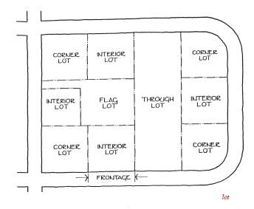
Source:A Planners Dictionary,PAS report 521/522 (2004)
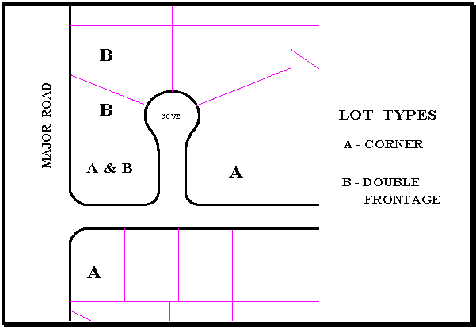
Lot, Interior: A lot with only one frontage on a public or private street.
Lot Area: The total ground area included within lot lines.
Lot Coverage: The lot area covered by all buildings located thereon, expressed as a percentage of the total lot area.
Lot Frontage: The dimension of a lot or portion of a lot abutting on a public or private street.
Lot Lines: The lines bounding a lot as defined herein.
Lot Number: The number assigned to a lot on a subdivision plat for identification purposes.
Lot of Record: A numbered or lettered tract of land in a subdivision recorded in the Plat Records of the County, or a parcel described by metes and bounds in the Deed Records of the County.
Lot Width: The width of a lot measured at the building line.
MANUFACTURED HOME: A factory manufactured movable home as provided in Section 75-49-3, Mississippi Code of 1972, Annotated. Any structure, transportable in one or more sections, which is built on a permanent chassis and designed to be used with or without a permanent foundation when connected to the required utilities. Manufactured homes are defined by and shall be constructed in accordance with the National Manufactured Housing Construction and Safety Standards Act of 1974, as amended, and shall be manufactured after June 14, 1976.
MASONRY: Brick, block, or stone which is secured with mortar.
MASSAGE PARLOR: An adult entertainment establishment where, for any form of consideration, massage, alcohol rub fomentation, electric or magnetic treatment, or similar treatment or manipulation of the human body is administered as the primary service unless such treatment or manipulation is administered by a licensed professional including but not limited to a medical practitioner, chiropractor, or physical therapist, each as defined and regulated by the laws of the State of Mississippi, including but not limited to Sections 73-6-1 et seq and the "Mississippi Physical Therapist Practice Law" of the Mississippi Code of 1972, as amended.
MASSING: A term used to define the overall volume of a building.
MECHANICAL EQUIPMENT: Devices and accessories, the use of which relates to water supply, electrical supply, drainage, heating, ventilation, air conditioning, and similar purposes.
MEDICAL CANNABIS DISPENSARY: means an entity licensed and registered with the MDOR that acquires, possesses, stores, transfers, sells, supplies or dispenses medical cannabis, equipment used for medical cannabis, or related supplies and educational materials to cardholders.
MEDICAL CANNABIS ESTABLISHMENT: a cannabis cultivation facility, cannabis processing facility, cannabis testing facility, cannabis dispensary, cannabis transportation entity, cannabis disposal entity or cannabis research facility licensed and registered by the appropriate agency.
MINOR: Any person under the age of eighteen (18) years and who is not emancipated.
MOBILE HOME: As defined within Section 75-49-3 of the Mississippi Code of 1972, Annotated, a factory built movable home manufactured before June 15, 1976 that is not constructed in accordance with the National Manufactured Housing Construction and Safety Standards Act of 1974, as amended. A single-family residence, not including camp or travel trailers, designed for transportation after fabrication on streets, highways, land, air, or water, and arriving at the site where it is to be occupied as a dwelling unit complete and ready for occupancy after location on the site, whether the location be by wheels, jacks, or permanent foundations, and connected to utilities.
MODILLION: A horizontal bracket, often in the form of a plain block, ornamenting, or sometimes supporting, the underside of a cornice.
MODULAR HOMES: A residential dwelling unit assembled on-site in accordance with the municipal building code and composed of components substantially constructed in a manufacturing plant and transported to the building site for final, permanent assembly on a permanent foundation.
MORTAR: A mixture of sand, lime, cement, and water and used as a binding agent in masonry construction.
MULLION: A heavy vertical divider between windows or doors.
MUNICIPAL COURT: The Municipal Court of the City of Cleveland, Mississippi.
MUNTIN: A secondary framing member to divide and hold the panes of glass in a window.
NAIL SALON: An establishment that whose primary use is providing professional nail care services by technicians possessing state mandated licenses to provide such services, with services ranging from basic pedicures and manicures to nail enhancements using acrylic, silk, fiberglass or other similar materials, nail art, paraffin treatments and other similar personal nail services.
NATIONAL HISTORIC LANDMARK: Any district, site, building, structure, and/or object that has been formally designated as a national historic landmark by the secretary of the interior and possesses exceptional value or quality in illustrating or interpreting the heritage of the United States in history, architecture, archaeology, engineering, and culture and that possesses a high degree of integrity of location, design, setting, materials, workmanship, feeling, and association. National Historic Landmarks are automatically listed in the National Register.
NATIONAL REGISTER OF HISTORIC PLACES: The nation's official list of buildings, sites, and districts which are important in our history or culture. Created by Congress in 1966 and administered by the states.
NON-CONFORMING BUILDING: A structure or building where the size, dimensions or location of which was lawful prior to the adoption, revision or amendment to this ordinance, but which fails by reason of such adoption, revision or amendment, to conform to the present requirements of the zoning district.
NON-CONFORMING LOT: A lot where the area, dimensions, and/or location, was originally lawful and conformed to the zoning article, but no longer conforms to this Ordinance or any subsequent amendments of the zoning district where it is located.
NON-CONFORMING USE: A use of any structure or land that though originally lawful, no longer conforms with the provisions of this ordinance or any subsequent amendments thereto for the district in which it is located. Uses established after the passage of this ordinance that are in violation of this ordinance are illegal uses and shall not be given the status of nonconforming uses.
NURSING HOME: A home for the aged or infirmed, in which three or more persons not of the immediate family are received, kept, housed overnight, or provided with food and shelter or care, for compensation, but not including hospitals, clinics, or similar institutions.
OBJECT: A material thing of functional, cultural, historical, or scientific value that may be, by nature or design, movable, yet related to a specific setting or environment.
OFFICE: Space or rooms, clinics, suites, or buildings used for conduct of a business such administrative, clerical, professional, and similar uses. These offices shall include, but shall not necessarily be limited to, professional offices, medical (doctors and dentists), attorneys, accountants, real estate brokers, insurance agents, architects or engineers, but shall in no way be construed as permitting undertaking establishments, funeral homes, massage parlors, body piercing or tattoo locations, or living quarters.
OPEN STORAGE: A depository or place for storing goods related to the establishment on the same premises and not located within a building.
ORDINARY REPAIR AND MAINTENANCE: Any work done to prevent deterioration of a resource or any part thereof by returning the resource as nearly as practical to its condition prior to such deterioration, decay, or damage.
OWNER: Any person or other entity who/which owns the premises, real property, or physical premises.
OWNER OF RECORD: The owner of a parcel of land, improved or unimproved, reflected on the city tax roll and in county deed records.
PARAPET: A low protective wall located at the edge of a roof.
PARKING AREA: An open, unoccupied space used or set aside to be used for the parking of automobiles, in which no other business is conducted, and such parking area is connected to the street or alley by a driveway permitting ingress and egress. This definition does not include grassy or other non-hard surface areas of lots. It is the intention of this Ordinance that each lot should be designed to accommodate the parking requirements of the normal occupants of the lot/building/house in a hard surface area, driveway or garage without parking in the street. Coves should be left clear of parked vehicles to allow access and turning of emergency vehicles and school buses.
PARKING ROW: Spaces for the parking of vehicles. Further defined as:
a. Single Loaded Parking Row—A single row of spaces for the parking of vehicles.
b. Double Loaded Parking Row—Two parallel rows of spaces for the parking of vehicles arranged so that, when parked, the front end of each vehicle faces the front end of another vehicle.
PARKING SPACE: An area that is a minimum of 10′ by 20′ of hard surfaced space that is designed for and dedicated to the parking of motorized vehicles.
PAWN SHOP: Any business that loans money on deposit of personal property or deals in the purchase or possession of personal property on condition of selling the same back again to the pledgor or depositor, or loans or advances money on personal property by taking chattel mortgage security thereon, and takes or receives such personal property.
PEDIMENT: A triangular crowning element forming the gable of a roof; any similar triangular element used over windows, doors, etc.
PHARMACY: Any place where prescription drugs are prepared and/or compounded and dispensed to the consumer.
PIER: A vertical structural element, square or rectangular in cross section.
PILASTER: A pier attached to a wall, often with capital and base.
PITCH: A term which refers to the steepness of roof slope.
PLACE: An open unoccupied space other than a street or alley permanently reserved as the principal means of access to abutting property.
PLAN REVIEW COMMITTEE: The administrative review group consisting of the Director of Community Development/Building Official, City Engineer, and Fire Inspector of the City of Cleveland.
PLANNING COMMISSION: The City of Cleveland Planning Commission or Board of Appeals.
PLAT: A map or drawing showing the lot and street arrangement or other features or details of the area being subdivided and is further defined as follows:
a. Preliminary Plat: A plat conforming to the requirements of Article 5 and 7 hereof for preliminary approval.
b. Final Plat: A plat conforming to the requirements of Article 5 and 7 for final approval and recording in the Office of the Chancery Clerk.
PORTALS AND CANOPIES: Any structure attached to, or part of, a building at the inner end, or also a freestanding structure, having supporting posts or columns, meant to provide shelter from the weather.
PORTICO: A roofed space, open or partly enclosed, forming the entrance and centerpiece of the façade of a building, often with columns and pediment.
PORTLAND CEMENT: A strong, inflexible (too much so for historic buildings) hydraulic cement used to bind mortar.
PREDOMINATE: Having the most publicly visible surface area.
PREMISES or REAL PROPERTY: Any location, building, structure, residence, garage, room, shed, shop, store, dwelling, lot, parcel, land or portion thereof, whether improved or unimproved.
PRESERVATION DISTRICT: A district designated by the Cleveland Heritage Commission and approved by the City through an ordinance, which contains a geographically definable area, urban or rural, possessing a significant concentration of sites, buildings, structures, or objects associated by past events or by plan or physical development, and which meets at least one of the following criteria:
a. Exemplifies or reflects the broad cultural, political, economic, or social history of the nation, state, county, or city;
b. Is identified with historic personages or with important events in national, state, or local history;
c. Embodies distinguishing characteristics of architectural types or contains examples inherently valuable for the study of periods, styles, methods of construction, or uses of indigenous materials or craftsmanship; or
d. Is representative of the notable work of master builders, designers, or architects whose individual abilities have been recognized or who influenced their eras.
PROPERTY: Any real property within the City including an improved street or highway.
PROPERTY MAINTENANCE CODE: The International Property Maintenance Code, as adopted by the Mayor and Board of Aldermen of the City of Cleveland and enforced by the City of Cleveland pursuant to local Ordinances. All definitions contained in the Property Maintenance Code shall be applicable to this Ordinance.
PROPORTION: The relationship between parts of a building, landscape, or structures to each other and to the whole.
PUBLIC BUILDING: A building owned or used exclusively by the City, County, State, or Federal governments.
QUOINS: Decorative blocks of stone or wood used on the corners of buildings.
RECESSED PANEL: A decorative element that often functions as an area for signage.
RECREATIONAL VEHICLE: A vehicular type portable structure without permanent foundation, which can be towed, hauled or driven and primarily designed as temporary living accommodation for recreational, camping and travel use and including but not limited to travel trailers, truck campers, camping trailers, and self-propelled motor homes.
RELOCATION: Any changes in the location of a building, object, or structure in its present setting or to another setting.
RESOURCE: Parcels located within preservation districts, individual landmarks, and landmark sites, regardless of whether such sites are presently improved or unimproved. Resources can be separate buildings, districts, structures, sites, and objects, and related groups thereof.
RESPONSIBLE PARTY or PERSON: Any individual, business or entity responsible for creating, causing, maintaining or permitting the nuisance activity, premises, condition or conduct; and includes, but is not limited to, the property owner, tenant, lessee, possessor, or occupant of real property, the president or other officer of the corporation, a business owner or manager of a business.
RIGHT-OF-WAY (ROW): A strip of land acquired by reservation, dedication, forced dedication, prescription or condemnation and intended to be occupied by a road, communication, crosswalk, electric transmission lines, oil of gas pipeline, water line, sanitary storm sewer and similar uses (see drawing below).
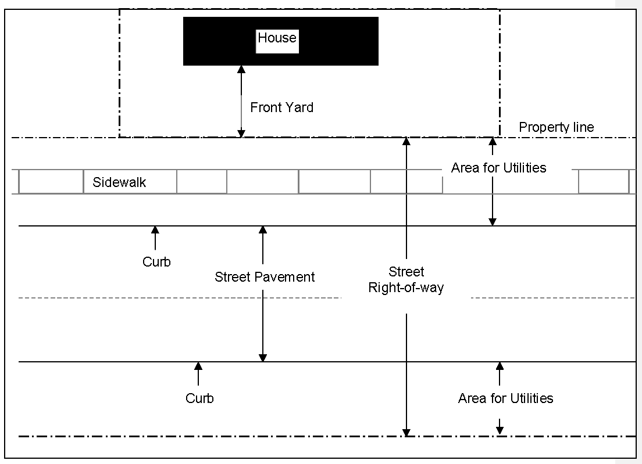
RIGHT-OF-WAY (ROW) LINE: The line delimiting the Public/Private boundary of the street and being identical with the property line of persons owning property fronting upon the streets.
ROOF: Any surface covering a building area or space that is horizontal and is intended to protect the structure from precipitation. The term "roof" also includes the overhangs of porches, porticos, and covered walks.
ROOF LINE: The highest point of the coping on a flat roof, false mansard, or parapet wall; the ridge line between the upper and lower slopes of a gambrel roof; or the mean height level between the eaves and ridge of a gable or hip roof.
ROOMING HOUSE: Any dwelling, or part of any dwelling containing one or more rooming units, in which space is let by the owner or operator to three or more persons who are not husband or wife, son or daughter, mother or father, or sister or brother of the owner or operator, and where the occupants share common bathroom, cooking and eating facilities.
ROOMING UNIT: Any room used or intended to be used for sleeping purposes.
SASH: The portion of a window that holds the glass and which moves.
SATELLITE DISK or DISH: Any disc-shaped or mast mounted equipment designed to transmit or receive electronic audio-visual or telemetric signals.
SCALE: A term used to define the proportions of a building in relation to its surroundings. The harmonious relationship of the size of a building or parts of a building to one another and to the human figure.
SEMI-PUBLIC: A use of land and/or premises by a private organization or agency to meet a basic public need such as: churches, privately endowed hospitals, cemeteries, fraternal groups, parochial schools and other similar activities.
SETBACK: A term used to define the minimum distance a building can be located from a lot line or street right-of-way.
SETBACK LINE: The minimum distance required to be maintained between a given lot line and the nearest outside wall or foundation of the building front, rear, or side (also see YARDS).
SHRUB: A woody plant, smaller than a tree, consisting of several small stems from the ground or branches near the ground.
SIDELIGHT: A glass window pane located at the side of a main entrance way.
SIDING: The exterior wall covering or sheathing of a structure.
SIGN: Any single structure, display, device, balloon or graphic on or attached to any land, building or structure, which is used to communicate any message, or which advertises or promotes any business, product, activity, service, person or interest. Signs include, but are not limited to, letters, numbers, words, illustrations, decorations, decals, emblems, trademarks, logos and lights. For the purpose of determining the number of signs, the name of the business is considered one sign, any advertised product sold by that business is considered a separate sign, and any advertised service offered by that business is considered a separate sign unless created on one rectangular sign blank and meeting the square footage requirements for that particular zoning district. Services or products which are displayed as a phrase, where the words are connected by an "&" or other means shall be considered one single separate sign as long as they are arranged on one sign blank (see Example 3 below). Below are some examples of how to determine the number of signs:

Example 1
This example is considered one sign because it is either painted or installed on one sign blank advertising a business name, a product, and a service for that business.
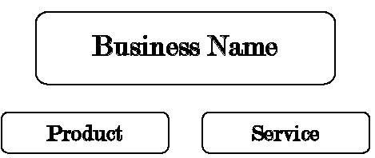
Example 2
This example is considered three signs because it is either painted or installed on three sign blanks advertising a business name, a product, and aservice for that business.

Example 3
This example is considered two signs because it is cutout letters installed on a building advertising the name of the business and a phrase of products or sercices for that business.
Types of Signs:
1. Banner Sign - Any sign intended to be hung either with or without frames possessing characters, letters, illustrations or ornamentations applied to paper, plastic, or fabric of any kind. National flags, flags of political subdivisions, and symbolic flags of any institution or business shall not be considered banner signs.
2. Bench Sign - A sign located on any part of the surface of a bench or seat placed adjacent to a public right-of-way.
3. Billboard Sign - A freestanding sign structure which advertises activities that do not take place on the site.
4. Blade Sign - A small sign which is suspended from an overhang, canopy, marquee, or awning or is suspended from a mounting attached directly to the building wall and hangs perpendicular to the building wall. An 8-foot clearance is required between a blade sign and the finished grade. Blade signs are typically seen in downtown areas and historic districts.
5. Directory Sign - Any sign on which the names and indications of occupants or the use of the building or shopping center is given. This shall include office buildings and church directories.
6. Freestanding Sign Structure - Any permanent or temporary sign structure not securely attached to the outside wall, roof, or window of any building. Also known as a ground or post sign.
7. Illuminated Sign - Any sign illuminated in any manner by an artificial light source.
8. Nonconforming Sign - Any sign which does not conform to the regulations of this Ordinance.
9. Projecting Sign - Any sign other than a wall sign affixed to any building or wall whose leading edge extends beyond such building or wall. A projecting sign may extend not more than six (6) feet outward from the wall at a height not less than twelve (12) feet from ground level.
10. Roof Sign - Any signs erected or constructed wholly upon and over the roof of any building and supported solely on the roof structure. This type of sign is prohibited in Cleveland.
11. Subdivision Entrance Sign - A permanent ground mounted sign that identifies the subdivision.
12. Temporary Sign - Any sign that is not permanently attached to the ground, a building, or another structure by direct attachment to a rigid wall, frame, or structure. Window signs can be a type of temporary signage.
13. Wall Sign - Any sign painted on or attached to and erected parallel to the face of the outside wall of any building which displays only one advertising surface.
14. Window Sign - Any graphic element painted upon or in any manner affixed to a window facing the outside and which is intended to be seen from the exterior. Window signs must be located and attached on the inside of the window. Any temporary signs hanging from the interior of the business and visible from the public right-of-way are also considered to be window signs and shall be calculated as part of the allowable window signage area.
SIGN AREA (CALCULATION): The sign area is that area enclosed by one continuous line, connecting the extreme points or edges of a sign. The area shall be determined using the largest sign area visible at any one time from any one point. This area does not include the main supporting sign structures. On a two-sided sign, only one face is counted in computing the sign area.
SILL: The horizontal member located at the top of a foundation supporting the structure above; also the horizontal member at the bottom of a window or door.
SITE: The location of a significant event, a prehistoric or historic occupation or activity, or a building or structure, whether standing, ruined, or vanished, where the location itself maintains historical or archaeological value regardless of the value of any existing buildings, or objects.
SOD: A layer of earth containing grass plants and their matted roots. Also known as turf.
SPECIAL EXCEPTION: A use so specifically designed in this Ordinance, that would not be appropriate for location generally or without restriction throughout a given zoning district, but which, if controlled as to number, area, location, or relation to the neighborhood, would in the opinion of the Board of Zoning Appeals, or Mayor and Board of Aldermen, as the case may be, promote the public health, welfare, morals, order, comfort, convenience, appearance, prosperity, or general welfare.
SPECIFIED ANATOMICAL AREAS: Less than completely and opaquely covered human genitals and pubic region, cleavage of the human buttocks, or less than 50 percent of the human female breast below a point immediately above the top of the areolae; or human male genitals in a discernibly turgid state even if completely and opaquely covered.
SPECIFIED SEXUAL ACTIVITIES: Human genitals in a state of sexual stimulation or arousal; acts of human masturbation, sexual intercourse, or sodomy; fondling or other erotic touching of human genitals, pubic regions, buttocks, or chests; flagellation or torture in the context of a sexual relationship; masochism, erotic, or sexually oriented torture, beating, or the infliction of physical pain; erotic touching, fondling, or other such contact with an animal by a human; or human excretion, urination, menstruation, vaginal, or anal irrigation as part of or in connection with any of the activities set forth in this section.
STAGE SET FAÇADE: A structure in which the primary elevation of the building presents a distinct and separate design from the remainder of the building. A structure where the continuity of design does not continue beyond the primary elevation to the sides and rear of the building. This may also include separate materials and colors from the remainder of the building. An example of a stage set facade would be a brick facade reflecting a parapet on a pre-engineered steel or wood frame building with a pitched roof.
STATE HISTORIC PRESERVATION OFFICE: The historic preservation division of the state department of archives and history (SHPO).
STATE HISTORIC PRESEERVATION OFFICER: The director of the state department of archives and history.
STOREFRONT: The street-level façade of a commercial building, usually having display windows.
STORY: That portion of a building included between the upper surface of any floor and the surface of the floor next above it or if there be no floor above it, then the space between the floor and the ceiling next above it.
STREET: A public right-of-way which affords primary means of access to abutting property and including all property dedicated or intended for public or private street purposes or subject to public easements therefore.
The term street means a way for vehicular traffic, whether designated as a street, highway, thoroughfare, parkway, throughway, road, avenue, boulevard, lane, place, or however otherwise designated.
a. Arterial streets and highways are those which are used primarily for fast or heavy traffic and which provide a means to either bypass the City or be routed expeditiously through the City.
b. Major streets are those streets which provide easy access to the various traffic generators within the City and to the arterial highway system.
c. Collector streets are those which carry traffic from minor streets to the major streets in residential and business areas and include the principal entrance streets of a residential development and streets for circulation within such a development.
d. Local or Minor streets are those which are used primarily for access to the abutting properties.
e. Alleys are public or private right-of-ways which are used for vehicular access to the back or the side of properties and not the primary means of access to a street.
f. Culs-de-sac are dead-end streets with turn-arounds and permanently closed to through traffic and used primarily for access to the abutting properties.
STREETSCAPE (2 definitions): The combination of building facades, sidewalks, street furniture, etc. that define the street. Also refers to the strip of land designed for street tree planting or landscaping along the right-of-way frontage of property.
STREET LINE: A dividing line between a lot, tract, or parcel of land and a contiguous street.
STRUCTURE: Anything constructed or erected, the use of which requires permanent location on the ground or attachment to something having a permanent location on the ground, including advertising signs, billboards, and poster panels. This definition does not include telephone poles and overhead wires.
STUCCO: Any kind of plasterwork but usually an outside covering of Portland cement, lime, and sand mixture with water.
SUBDIVISION: The division of a parcel of land into two or more lots or parcels for the purpose of transfer of ownership or building development or if a new street is involved, any division of a parcel of land. A division of land for agricultural purposes not involving a new street and not involving the construction of any dwelling shall not be deemed a subdivision. The term includes re-subdivision and when appropriate to the context, shall relate to the process of subdividing or to the land subdivided.
SUBSTANTIAL FOOD ITEM: Means food items prepared or cooked on the licensed premises and that are typically served as a main course or entrée. Some examples of a substantial food item are: fish; steak; chicken; pasta; pizza; sandwiches; and dinner salads. Side dishes, appetizer items, dessert items, and snack items such as popcorn, peanuts, chips, and crackers do not qualify as substantial food items.
SURROUND: An encircling border or decorative frame, usually around a window or door.
TATOO PARLOR: Those activities as defined in Mississippi Code Annotated Section 73-61-1, said statutory definitions being hereby adopted by reference.
TEMPORARY USE: A use established for a temporary period of time with the intent to discontinue such use upon the expiration of the time period not intended to exceed 30 days.
TENANT: Any person, other than a legal or equitable titleholder or immediate family member, occupying or possessing a dwelling or part thereof.
TITLE-LOAN BUSINESS: Any business that regularly makes either loans to individuals secured by the title to a vehicle or title pledge agreements with pledgors, unless the business or individual is exempt from the definition of "title pledge lender" under Mississippi Code Annotated Section 75-67-403 (1972), or unless more than ninety percent (90%) of the loans that the business makes which are secured by vehicle titles are made in the context of the purchase of the vehicle.
TOURIST or TRAILER COURT: An area containing one or more structures designed or intended to be used as temporary living facilities for one or more families and intended primarily for automobile transients or providing proper space and facilities for two or more auto trailers of mobile dwelling unit character.
TRANSOM: A small operable or fixed window located above a window or door.
TREE: A large woody plant having one or several self-supporting stems or trunks and numerous branches.
UNOBSTRUCTED OPEN SPACE: An area of land required to be maintained as specified herein, upon which no structure may be erected.
UNREASONABLE ECONOMIC HARDSHIP: The inability of an owner to obtain a reasonable return or a reasonable beneficial use from a resource as required by the United States Supreme Court in Penn Central Transportation Company v. New York City, 438 U.S. 104 (1978), and subsequent decisions.
UTILITY SUBSTATION: A facility containing high voltage electrical equipment, transformers or specialized transmission facilities for gas, water, sewer, telephone or other public utilities enclosed in a single area and connected to a transmission network but not requiring office space or other space with regular attendants.
VARIANCE: A modification from the literal provisions of this Ordinance by the Board of Appeals in cases where a literal enforcement of its provisions would result in unnecessary hardship due to circumstances unique to the individual property or use for which the variance is granted.
VEHICLE: Any machine propelled by power other than human power designed to travel along the ground by use of wheels, treads, runners, or slides and transport persons or property or pull machinery and shall include, without limitation, automobiles, trucks, trailers, motorcycles, tractors, buggies and wagons.
WALL: Any exterior surface on a building or structure that is vertical and is intended to support or capable of supporting a roof structure.
WIRELESS COMMUNICATION FACILITIES: Any unstaffed facility for the transmission and/or reception of wireless telecommunication services, usually consisting of a tower or monopole tower with antenna arrays, cabling and associated ground equipment and a support structure.
Stealth Design: Any communications tower or Wireless Communications Facility (WCF) which is designed to enhance compatibility with adjacent land uses, including, but not limited to, architecturally screened roof-mounted antennas, antennas integrated into architectural elements, and tower structures designed to look other than like a WCF and with a visual appearance whereby the structure suggests a purpose other than a WCF. This includes steeples, flagpoles and trees. Towers and other WCF utilizing Stealth Design may be approved by the Planning Commission and does require approval as a Special Exception under this Ordinance.
WROUGHT IRON: Decorative iron that is hammered or forged into shape by hand, as opposed to cast iron which is formed in a mold.
YARD: An open space at grade between a building and the adjoining lot lines, unoccupied and unobstructed by a portion of the structure from the ground upward, except as otherwise may be provided. In the measuring of a yard for the purpose of determining width of a side yard, the least horizontal distance between the lot line and main building shall be used.
YARDS FIGURE
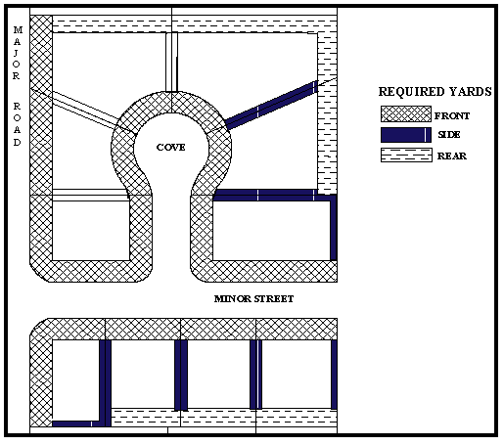
Yard, Front: The unoccupied space on the same lot with a building and situated between the street line and the front line of the building projected to the sideline of the lot.
Yard, Side: Yard between the main building and the sideline of the lot, and extending from the front yard line to the rear yard line on a corner or interior lot, or from one front yard line to the other front yard line on a double frontage lot.
Yard, Rear: A yard extending the full width of the lot between a main building and the rear lot line.
ZERO-LOT LINE DEVELOPMENT: A development approach in which a building is located on a lot in such a manner that one or more of the building's sides rest directly on a lot line.
ZONE: An established area or district within the City in which provisions of this Ordinance are applicable.
ARTICLE 5. - PROCEDURES FOR DEVELOPMENT APPROVAL

Sec. 501. - General requirements.
In presenting any application for approval as required by this Ordinance, the burden of proof shall rest with the applicant to provide the necessary evidence to clearly show that the proposal meets the minimum standards defined within this Ordinance.
All decisions made by the appropriate Boards, Committees, or Commissions shall be in writing and shall state the findings, recommendations, and reasons for approval or disapproval.
Sec. 502. - General appeals.
Aggrieved applicants of decisions regarding any matter of this Ordinance shall appeal to the appropriate Board or Commission of higher authority within ten (10) days of the decision.
1. Any decisions made by the City of Cleveland Department of Community Development, Building Official, Code Enforcement Officer, or Plan Review Committee shall seek appeal through the Board of Appeals.
a. Appeals to the Board of Appeals shall be discussed at the next meeting of the Board of Appeals, or within one (1) month after the date of the appeal. The appeal of a decision shall be filed in writing with the Department of Community Development. The staff shall transmit the information to the Board of Appeals including all papers constituting the record upon which the action appealed from was taken.
b. When an appeal has been filed with the Board of Appeals, the Department of Community Development shall immediately notify the Chairman of the Board of Appeals, who shall fix a time for the holding of the meeting to hear such appeal and shall issue a call, if a regular meeting is not to be held within a reasonable time, and give public notice of such hearing, if required.
2. Any decisions made by the Planning Commission, Heritage Commission, or Board of Appeals shall seek appeal through the Mayor and Board of Aldermen.
a. Appeals to the Mayor and Board of Aldermen shall be discussed at the next meeting of the Board, or within one (1) month after the date of the appeal. The appeal of a decision shall be filed in writing with the Department of Community Development.
b. When an appeal has been filed to the Board of Aldermen, the Mayor shall fix a time for the holding of the meeting to hear such appeal and shall issue a call, if a regular meeting is not to be held within a reasonable time, and give public notice of such hearing, if required.
3. Any decisions made by the Mayor and Board of Aldermen shall seek appeal through any court of competent jurisdiction as provided by law.
Sec. 503. - General amendments.
No change of any nature shall be made to this Land Development Ordinance except in conformity with the procedures set forth in this Ordinance. Any unauthorized change by any person or persons shall be considered a violation and punishable under Article 3 of this Ordinance.
Sec. 504. - Zoning changes and amendments.
504.1. - Reasons for amendments.
Article 6 and the Official Zoning Map shall not be amended except to correct an error in the text, to reflect changed or changing conditions in a particular area or in the municipality generally, to rezone an area or to extend the boundary of an existing zone, or to change the regulations and restrictions of existing zones.
504.2. - Eligible bodies to request amendments.
Zoning changes can occur at the request of two main bodies: the City (Staff, Planning Commission, Board of Appeals, or Mayor and Board of Aldermen) and the citizens/property owners. Requested changes to the zoning map or zoning text by the City (Staff, Planning Commission, Board of Appeals, or Mayor and Board of Aldermen) are typically more general in nature. Requested zoning changes by the citizens/property owners of Cleveland are more personal in nature and involve specific pieces of property that the applicant either owns or has the option to buy. Individuals requesting specific changes shall follow a more detailed procedure for zoning amendments as described in Section 504.4 of this Article.
Depending on the type of amendment, zoning changes can either affect the zoning text or the zoning map or possibly both. Amendments or changes to the zoning text are typically done by the City to either update current regulations or correct past errors. These amendments are based on the overall well-being of the City as opposed to specific properties. Amendments to the zoning map are more commonly at the request of citizens/property owners who want different uses allowed on their property, but they are also made by the City to correct past errors and update and reflect development changes.
504.3. - Types of zoning amendments.
Zoning text amendments
The Mayor and Board of Aldermen may, from time to time, amend the zoning text of Article 6 in accordance with this Ordinance and the Mississippi code. All amendments are to be approved only as reasonably necessary to promote the purpose of this Ordinance and namely the promotion of the public health, safety or general welfare. Text amendments may be initiated by the Mayor and Board of Aldermen, Board of Appeals, Planning Commission, City staff, or citizens. Typically, text amendments are concerned with a specific section of the zoning article. Another common text change is when the entire Article 6 may be amended to update existing regulations and reflect proactive development standards for the future of the City.
Zoning map amendments or replacement
In the event that the Official Zoning Map becomes damaged, destroyed, lost or difficult to interpret because of the nature or number of changes and additions, the Mayor and Board of Aldermen, Board of Appeals, Planning Commission, or City staff may initiate revisions or replacement of the Official Zoning Map. The new Official Zoning Map may also correct drafting and other errors or omissions in the prior Official Zoning Map, but no such corrections shall have the effect of amending Article 6, or any subsequent amendment thereof. Citizens/property owners seeking a change in zoning on their personal piece of property may also initiate amendments to the Official Zoning Map. All proposed changes to the Official Zoning Map shall be reviewed by the Planning Commission. The Planning Commission shall make a recommendation to the Mayor and Board of Aldermen who may, by resolution, adopt a new Official Zoning Map which shall supersede the prior zoning map. The new Official Zoning Map shall be identified by the signature of the Mayor, attested by the City Clerk, and bear the seal of the City under the following words: "This is to certify that this Official Zoning Map supersedes and replaces the Official Zoning Map adopted Date by the City of Cleveland, Mississippi."
504.4. - Application procedures for zoning changes and amendments.
1. All applications for amendments to Article 6 or the Official Zoning Map shall be filed with the Department of Community Development of the City of Cleveland.
2. The application shall contain the following:
a. The applicant's name, address, and interest in the application and the name, address, and interest of every person, firm, corporation or political subdivision represented by the applicant in the application.
b. The description of the proposed amendment and the effects of the proposed change.
c. A plat showing the land area which would be affected by the proposed amendment, the present zoning classification of the area and of all abutting properties, all private and public rights-of-way and easements bounding and intersecting the designated area and abutting properties.
d. If applicable, the error in Article 6 or the Official Zoning Map that would be corrected by the proposed amendment.
e. If considered necessary, the applicant may be required to furnish additional information of a pertinent and reasonable nature.
3. Following receipt of an application for an amendment, the Planning Commission shall review the proposed amendment and make a recommendation to the Mayor and Board of Aldermen.
4. Upon recommendation by the Planning Commission, the applicant shall deposit with the Department of Community Development the estimated costs for public notice procedures as described in Section 507 of this Article.
5. The City Planning Commission shall forward a written summary of its recommendations concerning the application to the Governing Body of the Municipality, together with a copy of the application. Upon receipt of the application and the findings and recommendations of the Planning Commission, the Mayor and Board of Aldermen shall set a public hearing regarding the proposed amendment according to guidelines discussed in Section 507 of this Article.
6. At least fifteen (15) days prior to the public hearing date, the City shall publish sufficient public notice of the upcoming meeting in an official newspaper and shall post sufficient notice on the property as described in Section 507 of this Article.
7. At the set hearing date, the Mayor and Board of Aldermen shall review the proposed amendments and solicit any public comment from those present at the meeting. Upon review of the proposed amendment, the Mayor and Board of Aldermen may approve or reject the application.
8. In case, however, of a protest against such change signed by the owners of twenty (20) percent, or more, either of the area of the lots included in such proposed change, or of those immediately adjacent to the rear thereof, extending one hundred sixty (160) feet therefrom or of those directly opposite thereto, extending one hundred sixty (160) feet from the street frontage of such opposite lots, such amendment shall not become effective except by the favorable vote of three-fifths (⅗) of the members of the Mayor and Board of Aldermen who are not required by law or ethical considerations to recuse themselves.
9. Any party aggrieved at the decision may appeal to any court of competent jurisdiction as provided by law.
504.5. - Approval criteria for amendments.
1. The amendment shall be examined and recommended by the City Planning Commission.
2. Each zone, having the same classification and bearing the same symbol or designation on the Official Zoning Map, shall have the same regulations and restrictions. Proposed amendments shall not suggest differing regulations within one individual zoning district.
3. Proposed amendments that suggest a less restrictive zoning classification for an area shall demonstrate a clear necessity in the area for the applied changes in regulations and uses.
4. A smaller, single parcel of land may be of a single classification different from the neighboring properties if it serves as a buffer between two districts. As for example, a lot may be zoned neighborhood commercial where it serves as a buffer between a highway commercial district and a residential district.
Sec. 505. - Special exceptions.
A special exception is a use specifically designated in Article 6, that would not be appropriate for the location generally or without restriction throughout a given zoning district, but if controlled by number, area, location, or relation to the neighborhood, would in the opinion of the Board of Appeals or Mayor and Board of Aldermen promote the public health, safety, morals, order, comfort, convenience, appearance, prosperity, or general welfare.
505.1. - Application procedures.
1. All applications for special exceptions shall be filed with the Department of Community Development for the City of Cleveland.
2. Special exception applications shall contain the following:
a. The applicant's name and address and any other interested person, firm, corporation or political subdivision represented by the applicant in the application.
b. A statement of need for this special exception, description of the neighboring conditions, and description of proposal which plans to blend the character and relationship between the special exception and the existing area.
c. A plat showing the land area which would be affected by the special exception, the present zoning classification of all abutting properties, all private and public rights-of-way and easements bounding and intersecting the designated area and abutting properties.
d. A draft site plan showing the proposed building location, circulation, landscaping, etc.
e. If considered necessary, the applicant may be required to furnish additional information of a pertinent and reasonable nature.
3. At the time of application, the applicant shall deposit, with the Department of Community Development, the estimated costs for public notice procedures as described in Section 507 of this Article.
4. If the next scheduled Board of Appeals meeting is more than fifteen (15) days from the date of application, the Board of Appeals may then set the public hearing date for that meeting. If the next scheduled meeting is less than fifteen (15) days, the Board of Appeals shall set the public hearing for their following meeting.
5. At least fifteen (15) days prior to the public hearing, the City shall publish sufficient public notice of the upcoming meeting in an official newspaper and shall post sufficient notice on the property as described in Section 507 of this Article.
6. Upon receipt of application for the special exception from the Department of Community Development, the Board of Appeals shall review the proposed application and shall either approve or disapprove the request based upon criteria in Section 505.2.
7. Any party aggrieved by the decision of the Board of Appeals may submit an appeal to the Mayor and Board of Aldermen.
505.2. - Approval criteria.
1. The proposed special exception shall not adversely affect the public interest.
2. The Board of Appeals shall specifically comment and make findings regarding the following conditions:
a. Vehicular and pedestrian circulation, including but not limited to parking and loading, within the site as well as how the proposed site plan will affect the adjacent properties in terms of circulation, traffic flow, safety, etc. as described in Article 8.
b. Availability of existing utilities
c. Landscaping, screening and buffering along the streetscape, around adjacent property lines, around specific interior areas, within parking lots, and at the foundation of buildings in regards to the appropriate requirements as described in Article 10.
d. Proposed signage regarding the amount, type, location, size, and lighting source as described in Article 9.
e. General compatibility with the character of surrounding properties and neighborhood.
3. In the granting of any special exception, the Board of Appeals may prescribe appropriate conditions and safeguards. Non-compliance of such conditions and safeguards, when made a part of the approval terms under which the special exception is granted, shall void the special exception, shall be deemed a violation and shall be punishable under Article 3 of this Ordinance.
505.3. - Expiration.
All special exceptions shall not be personal to the applicant but shall be transferable and shall run with the land unless other provisions are made in this Ordinance and until change occurs within the provisions of this Ordinance. However, the Board of Appeals may prescribe a time limit within which action on the special exception will be commenced, completed, or both. Failure to commence or complete such action within the time limit set shall void the special exception.
Sec. 506. - Variances.
Variances are modifications from the literal provisions of this Ordinance made by the Board of Appeals in cases where a literal enforcement would result in unnecessary hardship due to circumstances unique to the individual property or use for which the variance may be granted. For variances specific to Article 10, see Section 509.4 of this Article.
Where the strict application of this Ordinance would result in peculiar and exceptional practical difficulties to or exceptional hardship upon the owner of such property, a variation from such strict application may be permitted so as to relieve such difficulties or hardships for example, by reason of exceptional narrowness, shallowness, or shape of a specific piece of property at the time of the original adoption of the regulations, by reason of exceptional topographical conditions or other extraordinary or exceptional situation or condition of a specific piece of property, or by reason of the location of trees. Natural drainage courses, lakes or other desirable or attractive features, which condition is not generally prevalent in the neighborhood.
The potential for economic loss or gain on the part of the applicant resulting from the action of the Board of Appeals shall not be considered a sufficient basis for the approval of any variance. The fact that an owner could realize a greater financial return by a use of his property that is contrary to these regulations is not a sufficient reason for change. Hardship cannot be proved where it can be shown that property was purchased with the knowledge of existing restrictions, nor can hardship be claimed in terms of prospective sales or potential customers.
506.1. - Application procedures.
1. All applications for variances shall be filed with the Department of Community Development.
2. Variance applications shall contain the following:
a. A written statement that describes the unique conditions of the site and circumstances which create an undue hardship that demonstrates these unique conditions were not created by the property owner, and that the variance approval will not grant special privilege to the individual property which all other lands do not have.
b. Some form of visual description which portrays the undue hardship in graphic terms. This may be, but shall not be limited to, an aerial photograph, a plat or site plan, or regular photographs.
c. If considered necessary, the applicant may be required to furnish additional information of a pertinent and reasonable nature.
3. At the time of application, the applicant shall deposit, with the Department of Community Development the estimated costs for public notice procedures as described in Section 507 of this Article.
4. If the next scheduled Board of Appeals meeting is more than fifteen (15) days from the date of application, the Board of Appeals may then set the public hearing date for the next meeting. If the next scheduled meeting is less than fifteen (15) days, the Board of Appeals shall set the public hearing for their following meeting.
5. At least fifteen (15) days prior to the public hearing, the City shall publish sufficient public notice of the upcoming meeting in an official newspaper and shall post sufficient notice on the property as described in Section 507 of this Article.
6. Upon receipt of application for the variance from the Department of Community Development, the Board of Appeals shall review the proposed application and shall either approve or disapprove the request based upon criteria in Section 506.2.
7. Any party aggrieved by the decision of the Board of Appeals may submit an appeal to the Mayor and Board of Aldermen.
506.2. - Approval criteria.
1. Variances shall be approved by the Board of Appeals if the Board feels the proposal has the following hardships:
a. Exceptional narrowness, shallowness, or shape of a specific piece of property at the time of the original adoption of the zoning regulations
b. Exceptional topographical conditions or other extraordinary or exceptional situation or condition of a specific piece of property
c. The location of trees
d. The location of natural drainage courses, lakes or other desirable or attractive features
2. The variance shall NOT significantly alter the character of or be detrimental to the neighborhood.
3. The potential for economic loss or gain on the part of the applicant resulting from the action of the Board of Appeals shall NOT be considered a sufficient basis for the approval of any variance.
4. In the granting of any variance, the Board of Appeals may prescribe appropriate conditions and safeguards. Non-compliance of such conditions and safeguards when made a part of the approval terms under which the special exception is granted, shall be deemed a violation and shall be punishable under Article 3 of this Ordinance.
Sec. 507. - Public notice and public hearing.
Any alteration or deviation of this Ordinance requires public advertisement so that neighboring citizens are aware of the proposed changes and have the opportunity to comment. Public notice and public hearings are required for the following actions:
1. Map amendments requested by an individual property owner or by the City.
2. Zoning text amendments requested by an individual property owner or by the City.
3. Special exceptions.
4. Variances.
The Procedures shall be as follows:
1. The Department of Community Development shall request at the appropriate time the appropriate fees from the applicant to cover the costs of public notices.
2. When required, the appropriate governing body shall set a public hearing.
3. Public notice of the meeting date, time, location, and purpose shall be published in an official paper or newspaper of general circulation in the City at least fifteen (15) days prior to the hearing.
4. Additional public notice shall also be posted on the property involved which consists of one (1) sign at least three (3) by four (4) feet and is supported by center posts with the bottom of the sign at least four (4) feet above ground level. Letters shall be legible from the nearest street or of a size determined by the Board of Appeals.
a. The sign shall include the following information:
i. The present zoning classification of the property
ii. The zoning classification, use, variance or other matter sought by the application
Iii. The date, time, and place of the public hearing
iv. Any other appropriate information about the subject of the hearing
b. Where more than one parcel or tract of land is involved in the proposed change or action, the sign shall be posted at a centrally located point, and in addition, at least one sign shall be posted on each block or each street involved in the proposed change.
c. The signs shall read as follows:
REZONING NOTICE
NOTICE IS HEREBY GIVEN THAT APPLICATION HAS BEEN MADE TO CHANGE THE ZONING OF THIS PROPERTY FROM *___________ TO *___________. A PUBLIC HEARING WILL BE HELD BEFORE
______________________
(Board of Appeals or Governing Body of the Municipality),
AT _____ P.M. ON _______, AT THE CITY HALL, CLEVELAND, MISSISSIPPI, AT WHICH TIME AND PLACE ALL PERSONS WISHING TO BE HEARD REGARDING THE CHANGE IN ZONING SHOULD APPEAR.
DATE THIS ________ DAY OF ________.
______________________
(NAME OF APPLICANT)
* Zoning classification to be indicated by the word residential, commercial, or industrial, followed by the numerical and alphabetical definition.
SPECIAL EXCEPTION NOTICE
NOTICE IS HEREBY GIVEN THAT A SPECIAL EXCEPTION APPLICATION HAS BEEN FILED TO ALLOW THIS PROPERTY TO BE DEVELOPED ACCORDING TO THE FOLLOWING USE *___________. A PUBLIC HEARING WILL BE HELD BEFORE ______________________
(Board of Appeals or Governing Body of the Municipality)
AT ________ P.M. ON ________, AT THE CITY HALL, CLEVELAND, MISSISSIPPI, AT WHICH TIME AND PLACE ALL PERSONS WISHING TO BE HEARD REGARDING THE CHANGE IN USE SHOULD APPEAR.
DATE THIS ___________ DAY OF ___________.
______________________
(NAME OF APPLICANT)
* Type of use should be listed.
VARIANCE NOTICE
NOTICE IS HEREBY GIVEN THAT A VARIANCE APPLICATION HAS BEEN FILED REGARDING A *___________ ISSUE. A PUBLIC HEARING WILL BE HELD BEFORE ______________________
(Board of Appeals or Governing Body of the Municipality)
AT ________ P.M. ON ________, AT THE CITY HALL, CLEVELAND, MISSISSIPPI, AT WHICH TIME AND PLACE ALL PERSONS WISHING TO BE HEARD REGARDING THIS CHANGE SHOULD APPEAR.
DATE THIS ___________ DAY OF ___________.
______________________
(NAME OF APPLICANT)
* Type of variance should be listed, i.e. setback, height limitation, lot width, etc.
HISTORIC PRESERVATION NOTICE
NOTICE IS HEREBY GIVEN THAT AN APPLICATION HAS BEEN FILED REGARDING AN ALTERATION, RELOCATION, DEMOLITION, OR NEW CONSTRUCTION OF A BUILDING OR STRUCTURE ON THIS SITE. A PUBLIC HEARING WILL BE HELD BEFORE THE CLEVELAND HERITAGE COMMISSION AT ________ P.M. ON ________, AT THE CITY HALL, CLEVELAND, MISSISSIPPI, AT WHICH TIME AND PLACE ALL PERSONS WISHING TO BE HEARD REGARDING THIS CHANGE SHOULD APPEAR.
DATE THIS ___________ DAY OF ___________.
______________________
(NAME OF APPLICANT)
Sec. 508. - Subdivision plat.
508.1. - Pre-application conference.
Before filing an application for preliminary subdivision approval, the sub-divider may submit plans and data to the Plan Review Committee. This step does not require formal application, fee, or filing of plat with the governing body. The purpose of this conference is to afford the sub-divider an opportunity to consult early and informally with the Plan Review Committee before preparation of the preliminary plat. The Plan Review Committee shall promptly inform the sub-divider that the plans and data as submitted or as modified meet the objectives of these regulations, and if they do not meet the objectives, the respects in which they do not.
508.2. - Preliminary plat—Application and approval.
On reaching conclusions, informally as recommended above, regarding the general program and objectives, the sub-divider shall prepare a preliminary subdivision plat together with improvement plans and other supplementary material, including an application and fees, for submission to the City Planning Commission and the Plan Review Committee.
Three (3) paper copies of the preliminary plat and two (2) copies of the supplementary material specified shall be submitted to the City Planning Commission for evaluation and recommendation. Also one (1) copy of the preliminary plat and supplementary material shall be submitted in an approved electronic format.
This data shall be submitted at least seven (7) days prior to the Planning Commission meeting at which they are to be considered.
It shall be the duty of the Plan Review Committee of the City of Cleveland to examine any proposed preliminary plat and supplemental documents or plans to determine if the same conforms to the existing streets; water mains and systems; electric light distributing system; fire protection; and health and sanitation facilities now afforded by the City of Cleveland. This is done so that each said subdivision plat or map may be so drawn and designed as to permit the extension of all such facilities in a reasonable manner, with a minimum of expense and a maximum of efficiency, provided the Governing Body of the City of Cleveland deems proper to do so. They are to make report to the Planning Commission and Governing Body promptly of findings.
Following a review of the preliminary plat and other material submitted for conformity to these regulations and negotiations with the sub-divider on changes deemed advisable and the kind and extent of improvements to be made in the proposed subdivision by the City Planning Commission and staff, the Commission shall make a recommendation regarding the proposed preliminary subdivision plat to the Mayor and Board of Aldermen. The Commission may recommend approval, and state any conditions of such approval, or if not recommended for approval, the Commission shall express its reasons for recommending denial for the proposed preliminary subdivision plat.
The action of the Planning Commission, and any conditions thereof, shall be noted on copies of the preliminary plat.
The preliminary plat shall next be considered for approval by the Mayor and Board of Aldermen. Approval of a preliminary plat shall not constitute approval of the final subdivision plat, but it shall be deemed an expression of approval to the layout submitted on the preliminary plat that shall be used as a guide to prepare the final plat. It also constitutes permission to make the proposed infrastructure improvements such as water, sewer, streets, etc., as shown on the preliminary plat and supplemental documents.
508.3. - Preliminary plat—Requirements.
The preliminary plat shall be eighteen (18) inches by twenty-four (24) inches prepared at a scale sufficient to show required details. Where necessary, the preliminary plat may be on several sheets accompanied by an index sheet showing the entire subdivision. Data required as a basis for the preliminary and final plat shall include information about the existing conditions as follows:
a. Boundary lines: Bearings and distances. Survey must close mathematically.
b. All Easements: Location, width and purpose (for example: utility—-water, sewer, electric, gas, also drainage, ingress/egress).
c. Streets on and adjacent to the tract: Name, right-of-way width and location; type, width, and elevation of surfacing; legally established centerline elevations; and walks, curbs, gutters, culverts, etc.
d. Utilities on and adjacent to the tract: location, size, and invert elevation of sanitary, storm and combined sewers; location and size of water mains; location of gas lines; fire hydrants, electric and telephone poles, and street lights; if water mains and sewers are not on or adjacent to the tract, indicate the direction and distance to, and size of nearest ones, showing invert elevation of sewers.
e. Ground elevations on the tract and within one hundred (100) feet of the tract boundary on adjacent property, based on Mean Gulf Datum: Show contours with a one-half (½) foot interval and spot elevation along canals or ditches and at any breaks in grade or changes in elevation not readily discernable from the contours. On slopes in excess of three (3) percent, contour lines may be shown at two (2) foot intervals.
f. Other conditions on the tract: water courses, marshes, wooded areas, houses, barns, shacks, and other significant features. On all watercourses leaving the tract, the direction of flow shall be indicated; and for all watercourses entering the tract, the drainage area above the point of entry shall be noted.
g. Location of any and all Special Flood Hazard Areas (SFHA's), or floodway, and base flood elevations (BFE).
h. Other conditions on adjacent land (across the street is considered as adjacent): approximate direction and gradient of ground slope, including any embankments or retaining walls; character and location of buildings, railroads, power lines, towers, and other nearby nonresidential land uses or adverse influences; owners of adjacent un-platted land; for adjacent platted land, refer to subdivision plat by name, recordation book and page number and show approximate percentage build up, typical lot size, and dwelling type.
i. The location of all major existing tree growth. Major tree growth shall be defined as trees greater than eight (8) inches in diameter at three (3) feet above the ground.
j. Photographs, if required by the Governing Body and Planning Commission: camera locations, directions of views and key numbers.
k. Zoning on and adjacent to the tract.
l. Proposed public improvements: highways or other major improvements planned by public authorities for future construction on or near the tract.
m. Vicinity map showing location of the tract in relation to the City of Cleveland.
n. Title under which proposed subdivision is to be recorded, with names and addresses of owners, notation stating acreage, scale, north arrow, datum bench-marks, and date of survey.
Preliminary plat shall show all existing conditions required above and shall show all proposals including the following:
a. Streets: names, right-of-way and roadway widths; approximate grades and gradients; similar data for alleys, if any.
b. Other rights-of-way or easements: location, width and purpose.
c. Location of utilities, it not shown on other exhibits, including location, invert elevation, and sizes of storm and sanitary sewers, location and size of sanitary service connections, location, bottom elevation, and cross section of any ditches or canals.
d. Lot lines for all proposed lots, with dimensions, bearings and acreages, and block numbers.
e. Lot numbers, with every lot being numbered in sequential order, even lots to be used for common space, open space, drainage or other use.
f. Every lot shall be shown in its entirety on one sheet or another. Lots split across pages as the only portrayal of the lot are not acceptable.
g. The proposed use of all land in the subdivision including any reserved areas and the acreages.
h. Sites, if any, to be reserved or dedicated for parks, playgrounds, or other public use.
i. Sites, if any, for multi-family dwellings, shopping centers, churches, industry or other nonpublic uses exclusive of single family dwellings.
j. Minimum building and yard setback lines.
k. Site data, including number of residential lots, typical lot size, and acres in parks, etc.
l. Title, scale, north arrow, and date.
m. Required or proposed landscape buffering (shown on the plan graphically and in cross section).
n. A "phasing" map and schedule if the subdivision is proposed for development in multiple sections at different times.
o. Other preliminary plans:
• Profiles showing existing ground surface and proposed street grades, including extensions for a reasonable distance beyond the limits of the proposed subdivision.
• Typical cross sections of the proposed grading, roadway and sidewalks.
• Preliminary plan of proposed sanitary, potable water, and storm water sewers with grades and sizes indicated.
• Traffic studies or other specialize reports that are required because of the particular site or proposal.
p. Draft of the protective covenants, whereby the sub-divider proposes to regulate land use in the subdivision and otherwise protect the proposed development. The sub-divider shall prepare a final version of protective covenants, in a form for recording, at the time of the final plat approval submission.
q. A drainage plan showing the design of the storm sewer system and specifically the location and size of pipes and ditches, manholes and catch basins, culverts with headwalls and aprons for same, and bridges with plans for same approved by the City Engineer, contours of the project, street layout and lot pattern with lot numbers. The drainage plan will also show the invert elevations, grade and the drainage area contributory to each drainage pipe or channel, including off-site areas.
r. A street lighting plan showing the locations of lights and distribution of light
s. A landscaping plan showing the materials as required by screening and bufferyards in Article 10.
t. Such other data, if any, as otherwise specified by the Governing Body, or as shall be required by statutes of the State of Mississippi for plats.
508.4. - Final plat—Application and approval.
The final plat shall substantially conform to the preliminary plat as approved and may constitute only that portion of the approved preliminary plat which was proposed for recording and development as this phase.
An application for final subdivision approval, appropriate non-refundable fees, five (5) paper copies of the final plat and the final versions of other required documents shall be prepared as specified herein and shall be submitted to the Department of Community Development upon approval of the City Engineer for all constructed improvements. One (1) copy of the final plat and supplementary material shall be submitted in an approved electronic format.
This data shall be submitted at least seven (7) days prior to the Planning Commission meeting at which they are to be considered.
The Planning Commission shall review the final plat and other required documents and make a recommendation to the Mayor and Board of Aldermen. This review shall include reports from the staff and/or developer that the completed portion of infrastructure improvements of the subdivision as shown on the final plat, were constructed to the standards required by the City and conform to the preliminary plat. The recommendation from the Planning Commission shall then be forwarded to the Governing Body for consideration and potential approval.
Prior to the consideration of the final plat by the Governing Body, the sub-divider shall have prepared and submitted a certificate of title of the land shown on the final plat for subdivision to the City Attorney for approval.
The Mayor and Board of Aldermen shall consider the Planning Commission recommendation for the final plat and approve the recommendation, with or without conditions, deny the application, or remand it to the Planning Commission for additional review.
In the event the Governing Body should approve the proposed final plat of said subdivision, an endorsement shall be made by the Mayor, indicating such approval together with the date of the Governing Body's order. A copy of said final plat shall be filed with the Clerk of the City of Cleveland as well as with the Clerk of the Chancery Court of Bolivar County, after having been properly signed and acknowledged and otherwise bonded and provided with proper documentation.
508.5. - Final plat—Requirements.
The final plat shall be eighteen (18) inches by twenty-four (24) inches prepared at a scale sufficient to show required details. Where necessary, the final plat may be on several sheets accompanied by an index sheet showing the entire subdivision. For large subdivisions, the final plat may be submitted for approval progressively in contiguous sections as approved in the preliminary plat process. The final plat shall show the following:
a. Primary control points, approved by the City Engineer or descriptions, and "Ties" to such control points to which all dimensions, angles, bearings, and similar data on the Plat shall be referred.
b. Tract boundary lines, right-of-way lines of streets, easements and other rights of way, and property lines of residential lots and other sites; with accurate dimensions, bearings or deflection angles and radii, arcs and central angles of all curves.
c. Name and right-of-way width of each street or other right-of-way.
d. Location, dimensions, and purpose of any easements.
e. Number to identify each and every lot numbered consecutively and identical to numbering for Preliminary Plat; or with translation for numbering changes from Preliminary to Final Plat.
f. Every lot shall be shown in its entirety on one sheet or another—-no lots split across pages as the only portrayal of the lot.
g. Purpose of which sites, other than residential lots, are dedicated or reserved.
h. The accurate outline of any portions of the property intended to be dedicated or granted for public use with a statement of dedication thereon.
i. Minimum building and yard setback lines on all lots and other sites.
j. Locations and description of boundary monuments.
k. Location of any and all Special Flood Hazard Areas (SFHA's), or floodway, and base flood elevations (BFE).
l. Reference to recorded subdivision plats of adjoining platted land by record name, book and page number.
m. Certificate by surveyor or engineer certifying to accuracy of survey and plat.
n. Certification of title showing that applicant is the land owner.
o. Title, scale, north arrow, and date.
p. Acknowledgement of the owner of owners of the plat, and restrictions including dedication to public use of all streets, alleys, parks or other open spaces shown thereon and the granting of easements required.
q. Anything else required by the statutes of Mississippi relating to Plats. In case of any conflict between these regulations and a statute of Mississippi, the statute shall control.
r. A final version of any protective covenants in form for recording.
s. Other data such as certificates, affidavits, or endorsements as may be required by the City in the enforcement of these regulations.
t. A drainage plan showing the design of the storm sewer system and specifically the location and size of pipes and ditches, manholes and catch basins, culverts with headwalls and aprons for same, and bridges with plans for same approved by the City Engineer, contours of the project, street layout and lot pattern with lot numbers. The drainage plan will also show the invert elevations, grade and the drainage area contributory to each drainage pipe or channel, including off-site areas.
508.6. - Construction plans and as-built drawings.
One (1) reproducible copy of all construction drawings modified to reflect the location, size, and material of all improvements "as built" during the construction phase shall be submitted to the City Engineer at the completion of improvements and before approval of the final plat. As-built drawings are required for all construction drawings including, but not limited to, the following improvements: water, sanitary sewer, storm drainage, other utilities, site grading, street layout, grading and drainage, and landscaping. One (1) electronic version of the "as-built" plans shall also be submitted.
Sec. 509. - Development plan.
509.1. - Projects requiring a development plan.
A building permit shall not be issued for the construction of the following buildings, structures, or uses of land until a development plan has been submitted, reviewed, and approved in conformance with the requirements of this ordinance:
1. All new construction, additions, change in exterior appearance, or exterior alteration, for either land, buildings, or buildings and land in combination for all categories of multi-family residential, commercial, and industrial construction in the Multi-family Residential (R-5), Manufactured Housing Residential (R-6), Neighborhood Commercial (B-1), Central Business (B-2), Historic Crosstie Central Business (B-2H), Highway Commercial (B-3), Light Industrial (M-1), Heavy Industrial (M-2), Government (X-1), and Planned Unit Development (PUD) Zoning Districts as well as non-residential special exception uses in zoning districts not listed here.
2. The construction, re-construction, alteration, or expansion of a parking area for automobiles, trucks, trailers, recreational vehicles, mobile homes, manufactured homes or other vehicles, whether for customer parking, sales, or temporary or long-term storage.
3. Fences, signs, and landscaping requirements for multi-family, commercial and industrial uses in the Multi-family Residential (R-5), and Manufactured Housing Residential (R-6), Neighborhood Commercial (B-1), Central Business (B-2), Historic Crosstie Central Business (B-2H), Highway Commercial (B-3), Light Industrial (M-1), Heavy Industrial (M-2), Government (X-1), and Planned Unit Development (PUD) Zoning Districts as well as non-residential special exception uses in zoning districts not listed here.
4. Subdivision entrance signs and landscape plans for subdivisions or planned unit developments, including entrances, landscaped buffer areas, medians, and streetscaping.
509.2. - Projects exempt from a development plan.
The items listed below are exempt from the requirements of a development plan and the requirements of this Article and Article 10.
1. Single-family residences and all accessory structures appurtenant thereto.
2. Any permit necessary for the compliance with a lawful order of the Building Official, City Engineer, or Fire Inspector related to the immediate public health or safety.
3. All permits for interior alterations, repairs, or renovations.
4. All permits for demolition.
509.3. - Application, approval and expiration.
Pre-Application Conference: Prior to filing an application for development plan approval, the prospective applicant may request a pre-application conference with the Plan Review Committee to conduct a preliminary review and overall assessment of the proposal's compliance with the standards set forth in Article 10. One (1) copy of all required submittals must be provided in order for this review to be performed. After said pre-application conference, the developer may proceed to develop a complete development plan. In addition to the submittals required above, one (1) electronic version
Formal Application: An application for development plan approval shall be filed in the office of the Department of Community Development upon the forms provided. An application shall consist of one (1) complete set of paper drawings and one (1) electronic copy measuring not more than twenty-four (24) inches by thirty-six (36) inches, drawn to a scale as large as practical.
The filing of a proposed development plan for approval constitutes an agreement by the owner and applicant, their successors and assigns, that if the development plan is approved, permits issued for the improvement of the property, and the activities subsequent thereto, shall be in conformance with the approved development plan.
Conditions of Approval: An approved development plan authorizes only the arrangement and construction set forth in such approved plan and application. In approving a development plan application, the Plan Review Committee, may impose such reasonable conditions as deemed necessary to meet the spirit and intent of the standards. These conditions may include, but are not necessarily limited to:
1. Performance standards;
2. Height limitations;
3. Minimum yard requirements;
4. Off-Street parking and loading requirements;
5. Sign regulations;
6. Architectural elevations of any proposed structures or alterations to existing structures;
7. Landscaping provisions;
8. In those instances where those conditions deemed necessary involve minimum requirements or standards set by other Articles, such as Article 6 Zoning or Article 7 Subdivision, the conditions may be more restrictive than the minimum requirement or standard, but they may not be used as a substitute for a variance, or otherwise as a method of implementing standards that are less restrictive than those required by the applicable Article.
In the event that some additional approval is required by another governmental authority or agency (i.e., Mississippi Department of Transportation, County Health Department, City Planning Commission, etc.), approval of the development plan shall not become effective until written notice of that approval is received by the Plan Review Committee.
Upon submission and review of the formal application, development plan, and all other required materials by the Community Development Department, a report and recommendations shall be developed by the Plan Review Committee and submitted to the developer.
Approval Criteria: The Plan Review Committee shall approve the development plan if it finds that the plan meets the requirements of all applicable codes and ordinances.
Expiration: Development plan approval expires under the following conditions:
1. If work on the project is not commenced within six (6) months following the date of development plan approval.
2. If work on the project is idle for a continuous period of six (6) months after the date of development plan approval, unless an extension is applied for and approved by the Plan Review Committee.
Upon expiration, the Building Official shall file with the records of the Department of Community Development a certificate of noncompliance, and no building permit or occupancy certificate shall be issued until a new application for a development plan is approved.
Upon request of the applicant, and after good cause is shown, the Building Official may grant one (1) extension.
509.4. - Amendments, modifications and revisions to the development plan.
1. An approved development plan may be amended upon written application to the Department of Community Development.
2. The Plan Review Committee shall review the proposed modifications to certify that they comply with all applicable City standards and requirements, and determine if the proposed modifications do not alter the project's compliance with these standards.
3. If, as a result of the proposed modification, the requested modification shall not be approved by the Plan Review Committee, the original approved development plan shall remain in effect.
4. If the Plan Review Committee finds that the proposed modification complies with all of the City's standards and requirements, the Plan Review Committee shall approve the modification, and it shall supersede the original development plan approval.
5. In the instance of a development plan approved through the Plan Review Committee, the proposed amendment shall be submitted to the Plan Review Committee for their review. In no instance shall any change be made in a development plan approved by the Plan Review Committee unless and until approval of the proposed change is secured from that Plan Review Committee.
6. The approval of any requested modification shall not take effect, nor work proceed, until the applicant has submitted to the Department of Community Development a complete set of revised plans, incorporating all approved modifications, to replace the previously approved plans currently on file.
509.6. - Development plan requirements.
All plans, architectural drawings, renderings, photographs, reports, or other documents, materials, or visual aids either initially submitted as part of the formal application or presented at a later date shall become part of the permanent record of any decision and shall not be returned to the applicant.
The following information shall be included as part of the development plan submission:
Development Plan Existing Conditions:
1. Scale, date, north arrow, title of the project, and a vicinity map reflecting the location of the proposed project.
2. The boundaries, dimensions, and total gross acreage of the subject property.
3. The relationship of the project to the surrounding road system, including the widths of right-of-way and pavement for all adjacent roads.
4. The location and dimension of all existing man-made features, such as roads, utilities, and structures on both the petitioned site and adjacent properties, along with an indication as to which features on the petitioned site are to be removed.
5. The location and dimensions of existing easements, watercourses, city or state drains, utilities, water and sewer lines, and other important physical features in and adjoining the project.
Development Plan Proposed Conditions:
1. The "footprint", location, dimensions, and height of the proposed main and accessory buildings, their relation one to another and to any existing structures to remain on the site. The distance from all proposed buildings and structures to the adjacent property lines and to each building.
2. The location of the one hundred (100) year floodplain, where applicable, and the existing or proposed lowest floor elevations of all structures and exterior mechanical equipment, and the lowest and highest adjacent grade.
3. The internal circulation pattern for both vehicular and pedestrian traffic, including the location and dimensions of all existing and proposed streets, driveways, traffic aisles, and sidewalks, as well as the location, size, and number of parking spaces within off-street parking areas, as well as the identification and dimensions of service islands, service parking, and loading zones.
4. Total building square footage under roof.
5. Percentage of landscaping/open space areas and percentage of impervious surface areas to the total area of the site.
6. Size, location, materials, and orientation of all signs.
7. Location, height, and type of all exterior lighting.
8. The names, addresses, telephone numbers, and fax numbers of the developer(s), the property owner(s), and the designer(s) of the plan.
9. Proposal for sanitary sewer, storm sewer, water, natural gas, electrical, telephone, and cable services.
10. Identification of additional roadway needs, including improvements necessary to adequately access and service the site. In reviewing such a proposal, the Plan Review Committee may require the preparation of a transportation impact study, at the applicant's expense, to identify the traffic impacts and problems which are likely to be generated by the proposal and to identify all improvements required to insure safe ingress and egress from the proposed development, elimination of hazards, and the maintenance of adequate street capacities.
11. A complete survey of the property proposed for the development meeting the minimum requirements of the State Board of Registration for Professional Engineers and Land Surveyors.
Landscape and Lighting Plan:
1. The location and delineation of existing trees eight (8) inches in diameter or larger, as measured three (3) feet above the ground, and information as to which trees will be removed.
2. Location and dimensions of all landscape areas, common open space areas, and bufferyard areas, including the location, number, type and size of all landscaping materials, as well as any other proposed amenities.
3. Location, area, and type of screening for all exterior trash collection and/or recyclables collection areas.
4. Location, height, and type of all exterior lighting.
Architectural Elevations:
1. Architectural drawings, drawn to scale showing all elevations of the proposed structures and other improvements as they will appear on completion of construction.
2. If the exterior of an existing structure is to be changed, both the proposed and existing elevations of such structures shall be shown.
3. If an addition to an existing structure is proposed, the elevation of the existing structure shall be shown together with those of the addition.
4. The elevations shall also show all superstructures and equipment above the roof, projections from the wall of the structure, mechanical units, etc.
5. A fully labeled and dimensioned floor plan for all structures.
6. Exterior materials to be used shall be noted in terms of type, location, texture, and color.
7. The location and type of screening for all mechanical units, utility services, and so forth.
Grading and Drainage Plan:
1. Contours of the site with elevations of the pre-developed site and the proposed finished grades at one-half (½) foot intervals.
2. Calculations of the storm water run-off and retention/detention needs based upon the Rational Method.
3. Proposals for the management and retention/detention of storm water drainage if applicable.
Phasing Plan:
The proposed phasing of construction for the project, if applicable, including:
1. The approximate date when construction of each phase of the project is anticipated.
2. The order in which the phases of the project will be built.
3. The minimum area and the approximate location of common open space and public improvements that will be required at each stage.
Sec. 510. - Historic preservation certificate of appropriateness.
Property owners within the Crosstie Historic District shall obtain an approved certificate of appropriateness by the Heritage Commission before any exterior feature of the structure is altered, relocated, or demolished even if a building permit is not required. Any alteration, relocation, or demolition of a structure within the Crosstie Historic District without an approved certificate of appropriateness is a violation of this Ordinance and shall be punishable under Article 3 of this Ordinance. Building permits shall not be issued until the certificate of appropriateness is granted. A certificate of appropriateness is not required for work deemed to be ordinary maintenance or repair by the CLG Coordinator. The requirements of the Historic Preservation Ordinance, Historic Preservation Manual, and Cleveland Heritage Commission shall be observed when proposing exterior renovations or construction within the Crosstie Historic District.
In addition to following all other requirements of this Ordinance, all developments and projects within the Crosstie Historic District shall meet the following requirements and criteria. Where there is conflict specifically between Article 10 and any guidelines regarding historic preservation, the more strict guidelines and requirements shall apply.
510.1. - Application procedure.
1. All applications for a certificate of appropriateness shall be filed with the Department of Community Development.
2. The application shall consist of the following:
a. A site plan or aerial photograph of the site showing all existing buildings, structures, drives, alleys, easements, setbacks, etc. in relation to the surrounding properties.
b. The approximate location of mature landscaping. Mature trees shall measure at least eight (8) inches in diameter measured three (3) feet above the ground.
c. Photographs showing the architectural, cultural, and historical significance of the site. The photographs shall correspond to a numbered site plan showing the location where and direction towards which the photographs were taken. Specific photos and numbered plan depicting area(s) which are proposed to be demolished.
d. Any other information the Staff or Heritage Commission deems necessary in order to make an informed decision regarding the application.
e. Regarding immediate demolition applications specifically, replacement or new construction plans shall be submitted simultaneously with the original application for review.
f. Replacement plans shall include, but not be limited to, the proposed project concept, preliminary elevations and site plan, and completed working drawings for at least the foundation plan which will enable the applicant to receive a permit for foundation construction.
3. Upon filing, Staff shall notify the Heritage Commission of the application.
4. The Heritage Commission Chairman or Vice-Chairman shall then set a meeting time and date no later than one month after the filing of the application and inform the staff of the meeting. At this time, the Department of Community Development shall mail notice of the scheduled meeting to the applicant and all members of the Heritage Commission.
5. At least five (5) days prior to the Heritage Commission meeting, the City shall post public notice on the property with details of the meeting time and place.
6. Before the meeting, the applicant may request a preliminary conference with a member of the Heritage Commission or City Staff to review the proposed application and make any necessary adjustments that may be more consistent with the interests and standards of the Heritage Commission.
7. The hearing shall consist of a presentation by the applicant and any other relevant information presented by the City or the Heritage Commission. The Heritage Commission may recommend changes or modifications to the proposed application before a decision is made. The Heritage Commission may also make changes or modifications as conditions of approval at that meeting.
8. Within no more than twenty-one (21) days of the public hearing, the Heritage Commission shall make a decision regarding the application either approving, denying, or deferring. There shall be a two-thirds majority to approve a certificate of appropriateness.
9. Approval by the Heritage Commission shall result in an issued certificate of appropriateness for the proposed work listed in the application. This certificate shall not take the place of any other permits required by the City.
10. Following approval of a certificate of appropriateness, the applicant may request the appropriate permits from the City. If the approved application regarded demolition and new construction, the applicant shall be permitted to receive a demolition permit in conjunction with a construction permit. These permits serve as financial proof of the applicant's ability to complete the project. However, these permits shall not be issued until the applicant has sought approval for all plans under all appropriate Boards, Commissions, and Departments as required by the City.
510.2. - Approval criteria.
The following criteria shall be used in reviewing an application for certificate of appropriateness:
General
a. Existing style of and proposed alteration of the architectural design of existing building, structure, or appurtenance
b. Historical significance of the building or structure
c. General appearance and condition of the building or structure
d. Materials composing the building or structure
e. Size of the building or structure
f. The relationship of these general factors relating to the building or structure in question to its immediate surroundings and the entire district as well as the effects the proposed changes will have on the architectural and historical character and integrity of the Crosstie District.
New Construction
g. Prior to new construction within the Crosstie District, steps shall be taken to evaluate the possible locations of archaeological resources as described in the Mississippi Antiquities Act.
h. The following aspects of new construction, but not limited to, shall be visually compatible with the surrounding character of the Crosstie District:
i. Height;
ii. Gross volume;
iii. Proportion between width and height of the façade;
iv. Proportion and relationship between doors and windows;
v. Rhythm of solids to voids as created by openings in the façade;
vi. Materials, colors, textures, patterns, and trims;
vii. Design of the Roof;
i. Existing rhythm created by existing building masses and spaces between them shall be preserved.
j. The landscape plan shall be compatible with the site and its surroundings. Proposed landscaping shall not be detrimental to features of historic significance.
k. No specific architectural style shall be required.
Exterior Alteration
l. All exterior alterations to a building, structure, object, site, or landscape feature shall be compatible with the historic resource itself. The original design of a building, structure, object, site, or landscape feature shall be considered when making exterior alterations.
m. Exterior alterations shall not affect the architectural character or historic quality of a landmark and shall not destroy the significance of landmark sites.
Demolition
n. Consider the individual architectural, cultural, and historical significance of the resource in question
o. Consider the importance of the resource in question to the overall character of the historic district
p. Consider the importance and contribution of the resource in question to the neighboring property values
q. Consider the difficulty or impossibility of reproducing a similar resource because of its architectural, cultural, and historical significance
510.3. - Unreasonable economic hardship.
If the property owner feels the requirements of this Ordinance within the Crosstie Historic District creates an unreasonable economic hardship to him personally, the owner shall present sufficient evidence proving that as a result of this Ordinance or an action by the Heritage Commission he is unable to obtain a reasonable return or beneficial use.
Property owners claiming unreasonable economic hardship shall submit the following to the Department of Community Development:
1. Date the property was acquired by the current owner.
2. Price paid for the property and the relationship between the buyer and seller
3. Mortgage history of the property, including current mortgage
4. Current market value of property
5. Equity in current use and in alternative uses
6. Past and current income and expense statements for a two-year period
7. Past capital expenditures during ownership of current owner
8. Appraisals of the property obtained with the previous two-years
9. Income and property tax factors affecting the property
10. Any additional information deemed relevant by the Heritage Commission.
11. Any other studies or economic analyses from other city agencies or private organizations deemed relevant by the Heritage Commission.
Should the Heritage Commission determine that the owner's present return is not reasonable, they must consider whether there are other uses currently allowed that would provide a reasonable return and whether such a return could be obtained through investment in the property for rehabilitation purposes.
Should the applicant satisfy the Heritage Commission that he will suffer an unreasonable economic hardship if a certificate of appropriateness is not approved, the certificate of appropriateness shall be approved.
ARTICLE 6. - ZONING

Sec. 601. - Zoning districts.
In order to classify, regulate and restrict the location of commerce, industry, residences and buildings designed for specific uses, to regulate the height and bulk of buildings erected or altered, and to regulate the intensity of uses on lots, the land inside the City of Cleveland, Mississippi is hereby divided into 15 "Zoning Districts". The said districts shall be known as follows:
• A-1 Agricultural District.
• R-1 Residence 1 District.
• R-2 Residence 2 District.
• R-3 Residence 3 District.
• R-4 Residence 4 District.
• R-5 Multifamily Residence District.
• R-6 Manufactured Housing District.
• B-1 Business 1 Neighborhood Commercial District.
• B-2 Business 2 Central Business District.
• B-2H Business 2 Historic Crosstie Central Business District.
• B-3 Business 3 District: Highway Commercial.
• X-1 Government District.
• M-1 Light Industrial District.
• M-2 Heavy Industrial District.
• PUD Planned Unit Development.
Sec. 602. - Official zoning map.
The zoning districts described within this Article are identified and delineated on a map entitled "Official Zoning Map of the City of Cleveland, Mississippi". The map is attached to and made a part of this Ordinance. The Official Zoning Map shall be identified by the signature of the Mayor, attested by the City Clerk, and bear the seal of the City under the following words: "This is to certify that this is the Official Zoning Map referred to in Article 6 of the Combined Land Development Ordinance of the City of Cleveland, Mississippi, as adopted by the Mayor and Board of Aldermen."
If, in accordance with the provisions of this Ordinance and Statutes of the State of Mississippi, changes are made in zoning district boundaries or other matters portrayed on the Official Zoning Map, such changes shall be made on the Official Zoning Map promptly after the amendment has been approved by the Mayor and Board of Aldermen together with an entry on the Official Zoning Map as follows: "On Date , by official action of the Mayor and Board of Aldermen of the City of Cleveland, the following change(s) was/were made in the Official Zoning Map: (brief description and nature of change and reference to where the amending ordinance is recorded). No amendment to this Ordinance which involved matters portrayed on the Official Zoning Map shall become effective until after such change and entry has been made on said map.
No change of any nature shall be made on the Official Zoning Map or matter shown thereon except in conformity with the procedures set forth in this Ordinance. Any unauthorized change of whatever nature by any person or persons shall be considered a violation of this Ordinance and punishable as provided under Article 3 of this Ordinance.
Regardless of the existence of purported copies of the Official Zoning Map, which may from time to time be made or published, the Official Zoning Map, located in the office of the City Clerk, shall be the final authority as to the current zoning status of the land, buildings, and other structures in the City of Cleveland.
Interpretation of Boundaries—Where boundaries of zoning districts are uncertain as shown on the Official Zoning Map, the following rules shall apply:
• The center lines of streets, railroad rights of way, highways, or alleys shall be indicated as boundaries between districts when any uncertainty exists as to the accurate boundary of these districts.
• Approximate boundaries following platted lot lines or city limits shall be construed as following these lot lines or city limit line.
• Boundaries indicated as approximately following the center lines of streams, rivers, ditches, gullies, or other bodies of water shall be construed to follow such center lines.
• Boundaries indicated as parallel to or extensions of features described above shall be so construed. Distances not specifically indicated on the Official Zoning Map shall be determined by scale of the Map.
• Whenever any street or alley is vacated, the particular district applying to property fronting on any such street or alley shall automatically permit use to the center line of any such street or alley.
Any discrepancy noted of a district boundary line not covered shall be interpreted by the Building Official, with appeals of that decision heard by the Board of Appeals.
Sec. 603. - Zoning map or text amendments.
From time to time and as needed or requested, the Mayor and Board of Aldermen may amend the zoning text or map. The procedures are described in Article 5.
Sec. 604. - Zoning text general.
The following regulations established by this Ordinance within each zoning district shall be minimum regulations and shall apply uniformly throughout the district, except as hereinafter provided.
No building shall be erected, converted, enlarged, reconstructed or structurally altered, nor shall any building or land be used which does not comply with all district regulations established by this Ordinance for the district in which the building or land is located.
No part of a yard or other open space or off-street parking or loading space required for the purposes of compliance with this Ordinance shall be included as part of a yard or open space or off-street parking or loading space similarly required for any other building.
No yard or lot existing at the time of passage of this Ordinance shall be reduced in dimension or area below the minimum requirements set forth herein. Yards or lots created after the effective date of this Ordinance shall meet at least the minimum requirements established by this Article.
No structure shall be constructed on any lot which does not conform to the provisions of Article 7 regulating subdivisions, unless such lot was so platted.
No land shall be used or occupied and no structure shall be designed, erected, altered, used or occupied except for the following primary permitted uses for each of the following zoning districts, together with lawfully permitted home occupations, special exceptions, temporary uses, and permitted accessory uses.
As previously stated, building permits are required for any land, building, or structure that is erected, converted, enlarged, demolished, reconstructed or structurally altered in any manner.
No uses permitted in any zoning district shall be detrimental, offensive, or dangerous to the present or intended character of the zoning district or neighboring areas and vicinity by reason of the emission of dust, gas, smoke, noise, fumes, glare, odor, vibration, or fire or other hazard.
No structure shall be designed, erected, or altered except in accordance with the following regulations:
1. Reduction in Lot Area. No lot may be reduced in area below the minimum lot area as specified herein for the zoning district within which said lot is located.
2. Interference with Traffic Signals. In any zoning district no outdoor advertising sign, structure, tree or conflicting illuminate shall protrude so as to create confusion around, or otherwise interfere with traffic signals.
3. Corner Lot. On a corner lot, nothing shall be constructed, erected, placed, planted or allowed to grow in such a manner as materially to impede vision between a height of two and one-half (2.5) feet and ten (10) feet above the centerline grades of the intersecting streets in an area bounded by the street right-of-way lines of such corner lot and a straight line joining points along said street right-of-way lines twenty-five (25) feet from the nearest point of intersection. The same sight line limitations shall apply on any lot within ten (10) feet from the intersection of a street property line with the edge of a driveway pavement or alley boundary.
Sec. 605. - Exceptions.
Exception to Height Limits. The height limitations of this Ordinance shall not apply to church spires, belfries, cupolas and domes not intended for human occupancy, nor shall they apply to monuments, smoke stacks, conveyors, flag poles, masts, aerial, stand pipes, lofts, parapet walls, outdoor theater screens, amateur radio antenna structures, and other similar structures and appurtenances, provided their construction conforms with existing or hereafter adopted Ordinances of the City.
Exception to Lot Size (Lot of Record). Except as herein provided, in any residential District where the owner of the lot at the time of the adoption of this Ordinance, or the successor in title thereto, does not own sufficient land to enable them to conform to the minimum lot area and/or frontage requirements of this Ordinance, such lot may be used as a building site for a single-family residence, provided that minimum yard setback requirements for the district in which said lot is located are maintained.
Sec. 606. - Nonconforming uses and structures.
While non-conforming uses, structures, buildings, signs, etc., will be allowed to continue under certain circumstances, it is the policy of the City of Cleveland to bring these nonconformities into compliance with the city Ordinances and Codes as is reasonably practical. Continuance of legal nonconformities will be tolerated but not encouraged.
The burden of establishing that any nonconformity is a legal nonconformity shall be upon the owner of such nonconformity and not upon the City or any other person.
606.1. - Nonconforming uses.
Use Continuance: Except as herein specified, the lawful use of any public or private building, structure, sign, fence or land existing at the time of the adoption of this Ordinance may be continued although such use does not conform to the provisions of this Ordinance. No increase in the land area or the floor area in a structure or structures occupied by any nonconforming use shall be permitted except to provide more off-street parking or loading space.
Use Termination: Any one of the following acts or conditions shall result in the immediate termination of a nonconforming use:
1. Change to a conforming use.
2. Abandonment by owner.
3. Non-operation or non-use for a period of twelve (12) or more consecutive calendar months.
4. Damage or destruction of the structure in which the use is operated by any cause when the cost of repairing such damage or destruction exceeds fifty (50) percent of the replacement costs of such structure in which the use is operated as of the date of such damage or destruction.
5. Obsolescence of the building or structure in which the uses operated when the cost of replacing such building in lawful compliance with this Ordinance shall exceed fifty (50) percent of the replacement cost of such building or structure.
Use Zoning District Change: The foregoing provisions shall apply to the nonconforming uses in zoning districts hereafter changed.
606.2. - Nonconforming structures.
Structure Continuance: Except as herein specified, any public or private nonconforming structure or building may be occupied, operated, and maintained in a state of good repair. No nonconforming structure or building shall be enlarged or extended unless the enlargement or extension is made in compliance with all of the provisions established for structures or buildings in the zoning district in which the nonconforming building or structure is located.
Structure Termination: The right to operate and maintain any nonconforming building or structure shall terminate whenever the nonconforming structure is damaged in any manner and the cost of repair of such damage exceeds fifty (50) percent of the replacement cost of such structure as of the date of such damage. The right to operate and maintain any nonconforming building shall terminate whenever the nonconforming structure shall become obsolete or substandard under any applicable Ordinance of the City and the cost of placing such structure in lawful compliance with the applicable Ordinance exceeds fifty (50) percent of the replacement cost of such building as of the date of the official order under the applicable Ordinance.
Structure Zoning District Change: The foregoing provisions shall apply to nonconforming structures in zoning districts hereafter changed.
Sec. 607. - A-1 Agricultural District.
The City of Cleveland understands that large areas around the fringe of the City may be used for agricultural purposes for many years. Further, the taxes that a property owner pays are based on the use of the land and not the zoning of the land. So the City may influence the development of the agricultural fringe, most of the lands inside the City shall be designated as a zone other than agricultural. The land that is to be zoned agricultural is zoned in this manner to minimize its development because of the need to protect it from dense development. The primary reason for this designation would be because it is located in the floodplain as designated on the FIRM maps, but there could be other reasons for it to remain minimally developed.
Permitted Uses: The following uses are identified as permitted uses in the A-1 zone.
1. Agricultural and accessory uses provided, however, that no permits shall be required with reference to land used for the growing of the usual farm products or raw materials such as cotton, vegetables, fruit, trees and grain.
2. Gardens.
3. Cannabis Cultivation Facilities
4. Cannabis Processing Facilities
5. Single-family detached homes on at least two (2) acres.
Special Exceptions: All non-residential proposals shall provide information as required for Plan Review Committee review and approval. The following uses are allowed in the A-1 zone by special exception only:
1. Churches and institutions of an educational, religious, charitable, or philanthropic nature, provided, however, that such buildings shall not be located upon sites containing an area of less than two (2) acres, shall not occupy over thirty (30) percent of the total area of the lot; that the buildings shall be set back from all lot lines a distance of not less than two (2) feet for each foot of building height.
2. Public riding stables on at least five (5) acres.
3. Radio and television studios or transmitting stations.
4. Wireless telecommunications towers not to exceed three hundred (300) feet in height.
Dimensional Standards:
1. Minimum Lot Area | 2 acres
2. Minimum Lot Width | 100 feet
3. Maximum Percent of Lot Occupied by Buildings | 30 percent
4. Minimum Setback
a. Front | 35 feet
b. Side | 15 feet*
c. Rear | 30 feet
5. Maximum Height of Structure/Number of Stories | 50 feet/2.5 stories

*The setback line for a side yard abutting a side street shall be the same as the front setback.
Accessory structures shall be setback at least five (5) feet from any property line or eight (8) feet of another structure, and shall not be located on any type of easement. When an accessory structure is to be located in the rear yard of a corner lot, the accessory structure shall be setback at least ten (10) feet from the side street property line.
Fences may be located on the side or rear property lines unless an easement exists, in which case they shall not be located on any easement area without special approval from the Building Official. Front and side fences shall be no closer than ten (10) feet from any street right-of-way line and shall not be located within any sight distance area.
Provisions for Off-street parking and loading are required and defined in Article 8.
Provisions for signage are defined in Article 9.
Non-single-family residential developments located within this zone shall have a twenty-five (25) foot wide buffer area along the side and rear property lines. Additional details and provisions for buffering and landscaping are defined in Article 10, Section 1005.
Sec. 608. - R-1 Residential District.
This zoning district is designed specifically for very low density single-family residential use on large lots. All care should be taken to preserve the intent and character of this district.
Permitted Uses: The following uses are identified as permitted uses in the R-1 zone
1. Agricultural and accessory uses on at least five (5) acres provided, however, that no permits shall be required with reference to land used for the growing of the usual farm products or raw materials such as cotton, vegetables, fruit, trees and grain. In the event of complaints from neighboring residential property owners, attempts shall be made to minimize or eliminate the impacts upon neighboring residential property.
2. Gardens.
3. Home occupations.
4. Single family detached dwellings and accessory structures.
Special Exceptions: All non-residential proposals shall provide information as required for Plan Review Committee review and approval. The following uses are allowed in the R-1 zone by special exception only.
1. Churches and other religious institutions.
2. Educational uses.
Dimensional Standards:
1. Minimum Lot Area: | 12,500 square feet
2. Minimum Lot Width: | 100 feet
3. Maximum Percent of Lot Occupied by Buildings: | 30 percent
4. Minimum Setback
a. Front | 35 feet
b. Side | 15 feet*
c. Rear | 30 feet
5. Max. Percent of Backyard Occupied by Accessory Structure: | 25 percent
6. Maximum Height of Structure/Number of Stories | 50 feet/2.5 stories

*The setback line for a side yard abutting a side street shall be the same as the front setback.
All public and semi-public buildings shall have a minimum side yard and rear yard setback of thirty (30) feet from any lot line.
Accessory structures shall be setback at least five (5) feet from any property line or eight (8) feet of another structure, and shall not be located on any type of easement. When an accessory structure is to be located in the rear yard of a corner lot, the accessory structure shall be setback at least ten (10) feet from the side street property line.
Fences may be located on the side or rear property lines unless an easement exists, in which case they shall not be located on any easement area. Front and side fences shall be no closer than ten (10) feet from any street right-of-way line and shall not be located within any sight distance area.
Provisions for Off-street parking and loading are required and defined in Article 8.
Provisions for signage are defined in Article 9.
Non-single-family residential developments located within this zone shall have a twenty-five (25) foot wide buffer area along the side and rear property lines. Additional details and provisions for buffering and landscaping are defined in Article 10, Section 1005.
Sec. 609. - R-2: Residential District.
This zoning district is designed and intended as a residential area with single-family detached homes and smaller lots than the R-1, but still with a low density or suburban level of development. This zoning district is the most common residential district in Cleveland.
Permitted Uses: The following uses are identified as permitted uses in the R-2 zone:
1. Agricultural and accessory uses on at least five (5) acres provided, however, that no permits shall be required with reference to land used for the growing of the usual farm products or raw materials such as cotton, vegetables, fruit, trees and grain. In the event of complaints from neighboring residential property owners, attempts shall be made to minimize or eliminate the impacts upon neighboring residential property.
2. Gardens.
3. Home occupations.
4. Single family detached dwellings and accessory structures.
Special Exceptions: All non-residential proposals shall provide information as required for Plan Review Committee review and approval. The following uses are allowed in the R-2 zone by Special Exception only:
1. Bed and Breakfasts.
2. Churches and other religious institutions.
3. Educational institutions.
4. Wireless telecommunications towers using "stealth design" as an accessory use on a property and not exceeding the maximum height for this zoning district.
Dimensional Standards:
1. Minimum Lot Area: | 9,000 square feet
2. Minimum Lot Width: | 80 feet
3. Maximum Percent of Lot Occupied by Buildings: | 40 percent
4. Minimum Setback
a. Front | 30 feet
b. Side | 10 feet*
c. Rear | 25 feet
5. Max. Percent of Backyard Occupied by Accessory Structure: | 25 percent
6. Maximum Height of Structure/Number of Stories | 40 feet/2.5 stories

*The setback lines for side yards abutting a side street shall be the same as the front setback.
All public and semi-public buildings shall have a minimum side yard and rear yard setback of thirty (30) feet from any lot line.
Accessory structures shall setback be at least five (5) feet from any property line or eight (8) feet of another structure, and shall not be located on any type of easement. When an accessory structure is to be located in the rear yard of a corner lot, the accessory structure shall be setback at least ten (10) feet from the side street property line.
Fences may be located on the side or rear property lines unless an easement exists, in which case they shall not be located on any easement area. Front and side fences shall be no closer than ten (10) feet from any street right-of-way line and shall not be located within any sight distance area.
Provisions for Off-street parking and loading are required and defined in Article 8.
Provisions for signage are defined in Article 9.
Non-single-family residential developments located within this zone shall have a twenty-five (25) foot wide buffer area along the side and rear property lines. Additional details and provisions for buffering and landscaping are defined in Article 10, Section 1005.
Sec. 610. - R-3: Residential District.
This zoning district is designed and intended as a single-family residential area with smaller lots than the R-2 with low to medium density.
Permitted Uses: The following uses are identified as permitted uses in the R-3 zone.
1. Agricultural and accessory uses on at least five (5) acres provided, however, that no permits shall be required with reference to land used for the growing of the usual farm products or raw materials such as cotton, vegetables, fruit, trees, and grain. In the event of complaints from neighboring residential property owners, attempts shall be made to minimize or eliminate the impacts upon neighboring residential property.
2. Gardens.
3. Home occupations.
4. Single family detached dwellings and accessory structures.
Special Exceptions: All non-residential proposals shall provide information as required for Plan Review Committee review and approval. The following uses are allowed in the R-3 zone as special exceptions only:
1. Bed and Breakfasts.
2. Churches and other religious institutions.
3. Educational institutions.
4. Wireless telecommunications towers using "stealth design" as an accessory use on a property and not exceeding the maximum height of this zoning district.
Dimensional Standards:
1. Minimum Lot Area: | 6,000 square feet
2. Minimum Lot Width: | 60 feet
3. Maximum Percent of Lot Occupied by Buildings: | 60 percent
4. Minimum Setback
a. Front | 25 feet
b. Side | 8 feet*
c. Rear | 25 feet
5. Max. Percent of Backyard Occupied by Accessory Structure: | 25 percent
6. Maximum Height of Structure/Number of Stories | 30 feet/2 stories

*The setback line for a side yard abutting a side street shall be the same as the front setback.
All public and semi-public buildings shall have a minimum side yard and rear yard setback of thirty (30) feet.
Accessory structures shall be setback at least five (5) feet from any property line or eight (8) feet of another structure, and shall not be located on any type of easement. When an accessory structure is to be located in the rear yard of a corner lot, the accessory structure shall be setback at least ten (10) feet from the side street property line.
Fences may be located on the side or rear property lines unless an easement exists, in which case they shall not be located on any easement area. Front and side fences shall be no closer than ten (10) feet from any street right-of-way line and shall not be located within any sight distance area.
Provisions for Off-street parking and loading are required and defined in Article 8.
Provisions for signage are defined in Article 9.
Non-single-family residential developments located within this zone shall have a twenty-five (25) foot wide buffer area along the side and rear property lines. Additional details and provisions for buffering and landscaping are defined in Article 10, Section 1005.
Sec. 611. - R-4: Residential District.
This zoning district is designed and intended as a single-family residential area with smaller lots than the R-3 with medium density.
Permitted Uses: The following uses are identified as permitted uses in the R-4 zone:
1. Agricultural and accessory uses on at least five (5) acres provided, however, that no permits shall be required with reference to land used for the growing of the usual farm products or raw materials such as cotton, vegetables, fruit, trees, and grain. In the event of complaints from neighboring residential property owners, attempts shall be made to minimize or eliminate the impacts upon neighboring residential property.
2. Gardens.
3. Home occupations.
4. Single family detached dwellings and accessory structures.
Special Exceptions: All non-residential proposals shall provide information as required for Plan Review Committee review and approval. The following uses are allowed in the R-4 zone as special exceptions only:
1. Bed and Breakfasts.
2. Churches and other religious institutions.
3. Educational institutions.
4. Wireless telecommunications towers using "stealth design" as an accessory use on a property and not exceeding the maximum height of this zoning district.
Dimensional Standards:
1. Minimum Lot Area: | 5,000 square feet
2. Minimum Lot Width: | 50 feet
3. Maximum Percent of Lot Occupied by Buildings: | 60 percent
4. Minimum Setback
a. Front | 25 feet
b. Side | 8 feet*
c. Rear | 25 feet
5. Max. Percent of Backyard Occupied by Accessory Structure: | 25 percent
6. Maximum Height of Structure or Number of Stories | 30/2 stories

*The setback line for a side yard abutting a side street shall be the same as the front setback.
All public and semi-public buildings shall have a minimum side yard and rear yard setback of thirty (30) feet.
Accessory structures shall be setback at least five (5) feet from any property line or eight (8) feet of another structure, and shall not be located on any type of easement. When an accessory structure is to be located in the rear yard of a corner lot, the accessory structure shall be setback at least ten (10) feet from the side street property line.
Fences may be located on the side or rear property lines unless an easement exists, in which case they shall not be located on any easement area. Front and side fences shall be no closer than ten (10) feet from any street right-of-way line and shall not be located within any sight distance area.
Provisions for Off-street parking and loading are required and defined in Article 8.
Provisions for signage are defined in article 9.
Non-single-family residential developments located within this zone shall have a twenty-five (25) foot wide buffer area along the side and rear property lines. additional details and provisions for buffering and landscaping are defined in article 10, section 1005.
Sec. 612. - R-5: Multifamily Residential District.
This zoning district is designed and intended as a multi-family residential area with medium to high density typically seven (7) to twelve (12) units per acre. Care shall be taken to protect other residential zoning districts abutting the multi-family zone especially through the use of buffer areas. Adequate open space, yards, and buffers shall be designed into all multi-family projects for the benefit of future residents.
Permitted Uses: Multi-family residential proposals shall provide information as required for Plan Review Committee review and approval. The following are identified as permitted uses in the R-5 zone:
1. Community houses, lodges, fraternities, and sororities.
2. Condominium or townhouse residential dwellings.
3. Multi-family attached residential dwellings such as two-family, tri-plex, quad-plex and apartments.
4. Rooming or boarding house.
5. Single-family attached or detached residential dwelling.
Special Exceptions: All non-residential proposals shall provide information as required for Plan Review Committee review and approval. The following are allowed in the R-5 zone as special exceptions only:
1. Bed and Breakfasts.
2. Churches and other religious institutions.
3. Educational institutions.
4. Wireless telecommunications towers using "stealth design" as an accessory use on a property and not exceeding thirty (30) feet in height.
Dimensional Standards:
1. Minimum Lot Area:  with each additional family add | 5,000 square feet  2,000 square feet
2. Minimum Lot Width:  with each additional family add | 50 feet  5 feet
3. Maximum Percent of Lot Occupied by Buildings: | 60 percent
4. Minimum Exterior Setbacks
a. Front | 35 feet
b. Side | 15 feet*
c. Rear | 30 feet
5. Minimum Interior Setbacks
a. Front | 15 feet
b. Side | 10 feet
c. Rear | 15 feet
6. Max. Percent of Backyard Occupied by Accessory Structure: | 25 percent
7. Maximum Height of Structure or Number of Stories: | 60 feet/3 stories
8. Maximum Density of Units Allowed: | 12 DU/gross acre

*The setback line for a side yard abutting a side street shall be the same as the front setback.
All public and semi-public buildings shall have a minimum side yard and rear yard setback of thirty (30) feet.
Accessory structures shall be setback at least five (5) feet from any property line or eight (8) feet of another structure, and shall not be located on any type of easement. When an accessory structure is to be located in the rear yard of a corner lot, the accessory structure shall be setback at least twenty-five (25) feet from the side street property line.
Fences may be located on the side or rear property lines unless an easement exists, in which case they shall not be located on any easement area. Front and side fences shall be no closer than ten (10) feet from any street right-of-way line and shall not be located within any sight distance area.
Provisions for Off-street parking and loading are required and defined in Article 8.
Provisions for signage are defined in Article 9.
Non-single-family residential developments located within this zone shall have a twenty-five (25) foot wide buffer area along the side and rear property lines. Additional details and provisions for buffering and landscaping are defined in Article 10, Section 1005.
Sec. 613. - R-6: Manufactured Housing Residential District.
The Manufactured Housing District is intended to provide areas of planned and improved tracts suitable for the location of manufactured homes for non-transient use. A manufactured home as distinguished from a trailer for transient use shall be construed to refer to the length of time remaining in one location. Transient trailers usually remain thirty (30) days or less and manufactured homes occupants remain for at least one (1) year or more.
Permitted Uses: Proposals shall provide information as required for Plan Review Committee review and approval. The following uses are identified as permitted uses in the R-6 zone:
1. Single family manufactured home dwellings and accessory structures.
Special Exceptions:
1. Wireless telecommunications towers using "stealth design" as an accessory use on a property and not exceeding the maximum height of this zoning district.
Dimensional Standards:
1. Minimum Development Area: | 5 acres
2. Minimum Interior/Individual Lot Area: | 3,200 square feet
3. Minimum Interior/Individual Lot Width: | 30 feet
4. Maximum Percent of Lot Occupied by Buildings: | 70 percent
5. Minimum Setbacks from Exterior Property Lines
a. Front | 25 feet
b. Side | 15 feet*
c. Rear | 25 feet
6. Maximum Height of Structure/Number of Stories | 20 feet/1 stories
7. Maximum Density of Units Allowed | 12 DU/gross acre

*The setback line for a side yard abutting a side street shall be the same as the front setback.
Accessory structures shall be setback at least five (5) feet from any property line or eight (8) feet of another structure, and shall not be located on any type of easement. When an accessory structure is to be located in the rear yard of a corner lot, the accessory structure shall be setback at least twenty-five (25) feet from the side street property line.
Fences may be located on the side or rear property lines unless an easement exists, in which case they shall not be located on any easement area. Front and side fences shall be no closer than ten (10) feet from any street right-of-way line and shall not be located within any sight distance area.
Provisions for Off-street parking and loading are required and defined in Article 8.
Provisions for signage are defined in Article 9.
Developments located within this zone shall have a twenty-five (25) foot wide buffer area along the side and rear property lines. Additional details and provisions for buffering and landscaping are defined in Article 10, Section 1005.
Sec. 614. - B-1: Neighborhood Commercial District.
The Neighborhood Commercial District (B-1) shall consist of small-scale commercial business establishments offering products for sale at retail and principally supplying everyday household needs. These operations shall blend with the neighborhood and be an integral part of the neighborhoods that they serve. Businesses shall be limited in size in this zone to not more than 10,000 square feet per business, store, or building. No residential uses are allowed in the B-1 zone, but because residential uses may be permitted in areas immediately adjoining B-1, great care should be taken that only the least obnoxious commercial uses shall be permitted. Accessory buildings and uses may be allowed, but there shall be no outside storage. No residential uses are allowed in this zoning district.
All proposals shall provide information as required for Plan Review Committee review and approval.
Permitted Uses: The following uses are identified as permitted uses in the B-1 zone provided their total building area is less than 10,000 square feet:
- Apparel shops or clothing stores.
- Appliance, radio, television, telephone, etc. sales, service, or repair but not including vehicles or heavy equipment.
- Banks or credit unions, without drive through services.
- Barber and beauty shops.
- Convenience stores, without fuel pumps.
- Day Spa
- Flower, jewelry, art, antique and gift shops.
- Hardware stores.
- Ice cream parlor, coffee shop, candy store, or bakery.
- Laundromats washeterias, and dry cleaner drop-off stores.
- Professional Offices and office buildings.
- Studios or instruction facilities for music, art, photography, dance, or indoor physical activity.
- Other similar uses.
Special Exceptions: Special Exceptions must be reviewed by the Board of Appeals for approval. The following are allowed in the B-1 zone as special exceptions only:
- Alternative Medicine
- Banks or credit unions with drive through services.
3. Churches and other religious institutions.
4. Daycare, child or adult.
5. Educational institutions.
6. Funeral home or mortuary.
7. Grocery stores without fuel pumps.
8. Restaurants and eating establishments without drive through services.
9. Utility substations.
10. Wireless telecommunications towers using "stealth design" as an accessory use on a property and not exceeding thirty-five (35) feet in height.
Dimensional Standards:
1. Minimum Lot Area: | 6,000 square feet*
2. Minimum Lot Width: | 60 feet*
3. Maximum Percent of Lot Occupied by Buildings: | 50 percent
4. Minimum Setbacks from Property Lines
a. Front | 25 feet**
b. Side | 15 feet***
c. Rear | 25 feet
5. Maximum Height of Structure or Number of Stories | 35 feet/2 stories

* The minimum lot area shall include that area sufficient to meet requirements for the building or buildings for all primary and accessory uses, all parking and loading requirements, buffering, yards, setbacks, and open space requirements on the site.
** Front Setbacks shall conform to the standards of the adjacent properties to "blend" in with the neighborhood and may require streetscapes.
*** The setback line for side yards abutting a side street shall be the same as the front setback.
Accessory structures shall be setback at least five (5) feet from any property line or twenty (20) feet from another structure, and shall not be located on any type of easement. When an accessory structure is to be located in the rear yard of a corner lot, the accessory structure shall be setback at least twenty-five (25) feet from the side street property line.
Fences may be located on the side or rear property lines unless an easement exists, in which case they shall not be located on any easement area. Front and side fences shall be no closer than ten (10) feet from any street right-of-way line and shall not be located within any sight distance area.
Provisions for Off-street parking and loading are required and defined in Article 8.
Provisions for signage are defined in Article 9.
Developments located within this zone shall have a fifteen (15) foot wide buffer area along the side and rear property lines when adjacent to other commercial, government, or industrial zones. Developments located within this zone shall have a twenty-five (25) foot wide buffer area along the side and rear property lines when adjacent to residential zones. Additional details and provisions for buffering and landscaping are defined in Article 10, Section 1005.
Sec. 615. - B-2: Central Business District (CBD).
The Central Business District (CBD) encompasses a geographic area that represents the earliest developed portions of the City of Cleveland. The Central Business District serves as a major commercial center for the City of Cleveland. Such areas developed at a time preceding the modern day zoning ordinance and have an established character different from other areas of the City. The CBD has developed over time with smaller yard setbacks, smaller lot area, greater lot coverage and floor area ratios, parking on the streets, and other dimensional and physical characteristics, which cause uniqueness within this district. No residential uses are allowed in this zoning district.
The B-2 District is established to provide space for commercial activities of the City and to:
1. Protect present business and commercial uses from the blighting effects of incompatible land uses, and vacant or abandoned properties.
2. Encourage the development of the downtown area as the shopping, commercial, entertainment, and cultural core of the City and surrounding region.
3. Encourage the eventual elimination of uses detrimental or inappropriate to proper functioning of such a district.
All proposals shall provide information as required for Plan Review Committee review and approval.
Permitted Uses: The following uses are identified as permitted uses in the B-2 zone provided their total building area is less than 10,000 square feet:
- Animal clinic, hospital, boarding facility, or kennel.
- Apparel shops or clothing stores.
- Appliance, radio, television, telephone, etc. sales, service or repair but not including vehicles or heavy equipment.
- Automobile or other vehicle repair without fuel pumps.
- Banks or credit unions without drive through services.
- Barber and beauty shops.
- Convenience stores with or without fuel pumps.
- Daycare, child or adult.
- Day Spa
- Department stores.
- Flower, jewelry, art, antique, book and gift shop.
- Hardware stores.
- Hotels, motels, and other commercial lodging.
- Ice cream parlor, coffee shop, candy store, or bakery.
- Laundromats, washeterias, and dry-cleaning drop-off establishments.
- Places of amusement such as drive-through theaters, indoor theaters, movie theaters, video arcades, etc.
- Printing, copying, or publishing establishments.
- Professional offices and office buildings.
- Restaurant and eating establishments without drive through services.
- Studios or instruction facilities for music, art, photography, dance, or indoor physical activity such as karate, yoga, aerobics, etc.
- Other similar uses
Special Approval by Board of Aldermen: All such businesses that propose to sell beer, wine, or alcoholic beverages to be consumed on the premises shall be given specific special approval by the Board of Aldermen. Any business proposing such sales must first be zoned properly as B-2 and must operate as a restaurant offering substantial food items for its patrons. Also, any business proposing such sales must have a food preparation area and equipment on the premises adequate to meet the food service requirements.
Special Exceptions: Special Exceptions must be reviewed by the Board of Appeals for approval. The following uses are allowed in the B-2 zone as Special Exceptions only:
- Alternative Medicine
- Automobile or other vehicle repair, with fuel pumps.
- Banks or credit unions with drive through services.
- Churches and other religious institutions.
- Commercial uses where the total building area is more than ten thousand (10,000) square feet.
- Educational institutions.
- Funeral home or mortuary.
- Grocery stores without fuel pumps.
- Lumber yards or storage.
- Nail Salons
- Places of recreation such as bowling alleys, miniature golf, etc.
- Radio and television studios or transmitting stations.
- Restaurant or eating establishment with drive through services.
- Service uses such as parcel delivery, plumbing, electrical, other utilities, carpet cleaning, etc.
- Storage of building materials such as lumber, pipe, brick, concrete block, coal, sand, gravel, etc.
- Utility substation.
- Wireless telecommunication towers using "stealth design" as an accessory use on a property and not exceeding the maximum height of this zoning district.
Dimensional Standards:
1. Minimum Lot Area and Lot width: | *
2. Maximum Percent of Lot Occupied by Buildings: | No Restrictions
3. Minimum Setbacks from Property Lines
a. Front | 25 feet 88
b. Side | 15 feet **/***
c. Rear | 30 feet **
4. Maximum Height of Structure or Number of Stories | 60 feet/5 stories

* The minimum lot area shall include that area sufficient to meet requirements for the building or buildings for all primary and accessory uses, parking and loading, buffer, yard, setback, and open space requirements on the site or as otherwise exempted.
** Existing buildings in the B-2 zone that do not meet the front, side, or rear setbacks are non-conforming structures and may be rehabilitated using the existing building footprint or setbacks to maintain the continuity of the neighborhood. New development on vacant parcels must adhere to setbacks listed above.
*** The setback line for a side yard abutting a side street shall be the same as the front setback.
Accessory structures shall be setback at least five (5) feet from any property line or twenty (20) feet from another structure, and shall not be located on any type of easement. When an accessory structure is to be located in the rear yard of a corner lot, the accessory structure shall be setback at least twenty-five (25) feet from the side street property line.
Fences may be located on the side or rear property lines unless an easement exists, in which case they shall not be located on any easement area. Front and side fences shall be no closer than ten (10) feet from any street right-of-way line and shall not be located within any sight distance area.
Provisions for Off-street parking and loading are required and defined in Article 8.
Provisions for signage are defined in Article 9.
Developments located within this zone may not be required to maintain a landscaped buffer adjacent to commercial, government, and industrial zones due the desired character and nature of the downtown area. However, developments located within this zone shall have a twenty-five (25) foot wide buffer area along the side and rear property lines when adjacent to residential zones. Additional details and provisions for buffering and landscaping are defined in Article 10, Section 1005.
Sec. 616. - B-2H: Central Business Historic Crosstie District.
The Historic Crosstie District represents the original settlement of Cleveland and covers the traditional downtown area. This historic preservation area has been identified for special standards of design and review. Because of the character of the buildings and street parking for the downtown strip along the old railroad line this area has setbacks that are different from the rest of the Central Business District.
The Crosstie Historic District represents the core of Cleveland and the natural location of establishments engaged in retail, entertainment, financial, professional and related services. The particular nature of their businesses can be aided by the centralized location and concentration provided in this environment. The City of Cleveland seeks to maintain and preserve the unique character of the Historic Crosstie District and its appeal; protect the District’s economic vitality by ensuring the longevity of the District; and foster key business models that attract and serve local community members and tourists to the District.
Emphasis is placed on more intimate, pedestrian-scale development rather than development oriented singly for the automobile. Pedestrian-scale developments typically pay more attention to architectural details, bring buildings closer to the street, have on-street parking, provide for wider sidewalks between parking and storefronts, incorporate elements and amenities within the sidewalk zone, etc. All of these characteristics provide a safe and interesting environment that invites pedestrians to walk within the downtown. It is the intent of this zoning district to preserve the character of this geographic area, especially the original downtown, and to support the reliance on pedestrians and nearby residents utilizing establishments within this district. Cleveland has been fortunate to be able to develop the former railroad tracks as a pedestrian oriented park through the middle of downtown.
Scale of businesses is important when encouraging pedestrian circulation, so no single business, store or building shall be in excess of ten thousand (10,000) square feet or six thousand (6,000) square feet per floor of a multi-story building.
Development within this zoning district must also conform to the requirements of the Historic Preservation Ordinance, Historic Preservation Manual, and Cleveland Heritage Commission.
Non-Permitted Uses: The following uses are expressly prohibited in the B2-H zone, and shall not be located within five hundred (500) feet of the B2-H District in any adjacent commercial or industrial zone (B-2 and M-1).
- Alternative Medicine
- Automobile or other vehicle repair, with or without fuel pumps.
- Bingo Halls
- Beer Stores
- Cannabis Cultivation Facility
- Cannabis Processing Facility
- Cannabis Research Facility
- Cannabis Testing Facility
- Check Cashing
- Convenience Stores, with or without drive through services
- Drug Store, with or without drive through services
- Funeral home or mortuary
- Gun Shop, sales, service, or repairs
- Junk Yards
- Massage Parlors
- Medical or dental clinic, laboratory, or offices.
- Medical Cannabis Dispensary
- Nail Salons
- Package/Liquor Stores
- Payday Loans
- Pawn Shops
- Pharmacy
- Pool Halls
- Sports Betting
- Tattoo or Body Piercing
- Title Loans and/or Cash for Title Loans
- Vape Shops
Permitted Uses: The following uses are identified as permitted uses in the B-2H zone provided their total building area is less than ten thousand (10,000) square feet:
1. Apparel shops or clothing stores.
2. Banks or credit unions without drive through services.
3. Barber and beauty shops.
4. Department stores.
5. Flower, jewelry, art, antique, book and gift shops.
6. Ice cream parlor, coffee shop, candy store, or bakery.
7. Printing, copying, and publishing establishments.
8. Professional offices and office buildings.
9. Restaurant and eating establishments without drive through services.
10. Studios or instruction facilities for music, art, photography, dance, or indoor physical activity such as karate, yoga, aerobics, etc.
11. Other similar uses.
Special Approval by Board of Aldermen: All such businesses that propose to sell beer, wine, or alcoholic beverages to be consumed on the premises shall be given specific special approval by the Board of Aldermen. Any business proposing such sales must first be zoned properly as B-2H and must operate as a restaurant offering substantial food items for its patrons. Also, any business proposing such sales must have a food preparation area and equipment on the premises adequate to meet the food service requirements.
Special Exceptions: Special Exceptions must be reviewed by the Board of Appeals for approval. The following uses are allowed in the B-2H zone as Special Exceptions only:
- Churches and other religious institutions.
- Day Spa
2. Hardware stores.
3. Hotels, motels and other commercial lodging.
4. Residential dwellings in the form of single-family, multi-family, or condominium style units, may be recommended by the Planning Commission and approved by the Board of Aldermen with the following requirements and any additional requirements seen as necessary. The residential unit or units shall:
a. Occupy the second or upper floor of an existing retail or commercial type structure which has no front or side yard setback; or,
b. Occupy an existing warehouse or industrial type structure and convert it to residential uses; or,
c. Incorporate the existing building or façade into the new design plan; or,
d. Replace a "non-contributing" non-historic building with one designed in the style of the contributing historic buildings; or
e. If new construction is proposed, it shall take place on a vacant parcel and blend with the neighboring buildings; AND,
f. Achieve one or more of the following criteria:
1. Will put to use an existing structure or property that otherwise may fall into a state of dilapidation or otherwise become or remain vacant;
2. Will transform an existing structure from a state of dilapidation into a viable and economical use of the property; or,
3. Be constructed as an integral part of the site of another use permitted within the B-2H district.
5. Tobacco/Cigar Stores
Dimensional Standards:
1. Minimum Lot Area and Lot width: | *
2. Maximum Percent of Lot Occupied by Buildings: | No restrictions
3. Minimum Setbacks from Property Lines
a. Front | Zero feet **
b. Side | Zero feet **
c. Rear | 20 feet **
4. Maximum Height of Structure or Number of Stories | 60 feet/5 stories

* The minimum lot area shall include that area sufficient to meet requirements for the building or buildings for all primary and accessory uses, parking and loading, buffer, yard, setback, and open space requirements on the site or as otherwise exempted.
** Crosstie Historic District shall have a zero (0) foot required front or side, twenty (20) foot rear setbacks and may cover one hundred (100) percent of the lot with a building. Further existing buildings in the B-2H zone that do not meet the front, side, or rear setbacks are non-conforming structures and may be rehabilitated using the existing building footprint or setbacks to maintain the continuity of the neighborhood. New development on vacant parcels must adhere to setbacks listed above.
Accessory buildings and fences are not allowed in this zoning district unless specifically approved by the Cleveland Heritage Commission.
All proposals shall provide information as required for Plan Review Committee review and approval. Additional design approval is required for development in the Crosstie Historic District from the Cleveland Heritage Commission.
Developments located within this zone shall not be required to maintain a landscaped buffer adjacent to commercial, government, and industrial zones due the desired character and nature of the downtown. However, developments located within this zone shall have a twenty-five (25) foot wide buffer area along the side and rear property lines when adjacent to residential zones. Additional details and provisions for buffering and landscaping are defined in Article 10, Section 1005.
Sec. 617. - B-3: Highway Commercial District.
This district is intended for a broad definition of commercial activities. The commercial uses in this district are oriented toward high volume automobile traffic. They are located on, and should be limited to, major highways like US 61 and MS 8. Buffering for adjacent commercial and non-commercial uses is important. Careful landscaping and proper signage is critical to creation of a positive commercial area. No residential uses are allowed in this district.
All commercial proposals shall provide information as required for Plan Review Committee review and approval.
Permitted Uses: The following are identified as permitted uses in the B-3 zone:
- Alternative Medicine
- Agricultural equipment, machinery sales and service.
- Animal clinic, hospital, boarding facility, or kennel.
- Apparel shops or clothing stores.
- Appliance, radio, television, telephone, etc. sales, service or repair but not vehicle or heavy equipment.
- Automobile (new and used), RV, and truck sales and service.
- Automobile or other vehicle repair with or without fuel pumps.
- Banks or credit unions with or without drive through services.
- Barber and beauty shops.
- Boat and trailer sales and service.
- Cannabis Cultivation Facility
- Cannabis Processing Facility
- Cannabis Research Facility
- Cannabis Testing Facility
- Convenience stores with or without fuel pumps.
- Daycare, child or adult.
- Day Spa
- Department stores.
- Drug stores with or without drive through services.
- Flower, jewelry, art, antique, book, and gift shops.
- Fresh vegetable sales stand.
- Funeral home or mortuary.
- Grocery stores with or without fuel pumps.
- Gun shop, sales, service, or repair.
- Hardware stores.
- Hotels, motels, other commercial lodging.
- Ice cream parlor, coffee shop, candy store, or bakery.
- Laundromats, washeterias, and dry cleaning drop-off establishments.
- Liquor/Package Stores
- Lumber yard and storage.
- Medical or dental clinic, laboratory, or offices.
- Medical Cannabis Dispensary
- Mobile home and house trailer sales and service.
- Nail Salons
- Pawn shops, check cashing, title loan, or similar institutions but not including banks or credit unions.
- Pharmacy
- Printing, copying, or publishing establishments.
- Places of amusement such as drive-through theaters, indoor theaters, movie theaters, video arcades, etc.
- Places of recreation such as bowling alleys, miniature golf, etc.
- Printing, copying and publishing establishments.
- Professional offices and office buildings.
- Radio and television studios and transmitting stations.
- Restaurants and eating establishments with or without drive through services.
- Service uses such as parcel delivery, plumbing, electrical, other utilities, carpet cleaning, etc.
- Storage of building materials such as lumber, pipe, brick, concrete block, coal, sand, gravel, etc.
- Studios or instruction facilities for music, art, photography, dance, or indoor physical activity such as karate, yoga, aerobics, etc.
- Tobacco or vapor stores.
- Wireless telecommunications towers using "stealth design" as an accessory use on a property and not exceeding the maximum height of this zoning district.
- Other similar uses.
Special Approval by Board of Aldermen: All such businesses that propose to sell beer, wine, or alcoholic beverages to be consumed on the premises shall be given specific special approval by the Board of Aldermen. Any business proposing such sales must first be zoned properly as B-3 and must operate as a restaurant offering substantial food items for its patrons. Also, any business proposing such sales must have a food preparation area and equipment on the premises adequate to meet the food service requirements.
Special Exceptions: Special Exceptions must be reviewed by the Board of Appeals for approval. The following are allowed in the B-3 zone as Special Exceptions only:
1. Automobile painting shops.
2. Churches and other religious institutions.
3. Educational institutions.
4. Storage or mini-storage facilities.
Dimensional Standards:
1. Minimum Lot Area: | 10,000 square feet *
2. Minimum Lot Width: | 80 feet *
3. Maximum Percent of Lot Occupied by Buildings: | 30 percent
4. Minimum Setbacks from Property Lines
a. Front | 60 feet
b. Side | 25 feet **
c. Rear | 25 feet
5. Maximum Height of Structure/Number of Stories | 60 feet/5 stories

* The minimum lot area shall include that area sufficient to meet requirements for the building or buildings for all primary and accessory uses, all parking and loading requirements, buffering, yards, setbacks, and open space requirements on the site.
** The setback line for side yards abutting a side street shall be the same as the front setback.
In the case of service stations, all gas pumps, gas pump islands, grease pits, or racks and other similar facilities shall be located no closer than 30 feet from a street or highway right-of-way line and shall not be located within a buffer strip.
Accessory structures shall be setback at least five (5) feet from any property line or twenty (20) feet from another structure, and shall not be located on any type of easement. When an accessory structure is to be located in the rear yard of a corner lot, the accessory structure shall be setback at least twenty-five (25) feet from the side street property line.
Fences may be located on the side or rear property lines unless an easement exists, in which case they shall not be located on any easement area. Front and side fences shall be no closer than ten (10) feet from any street right-of-way line and shall not be located within any sight distance area.
Provisions for Off-street parking and loading are required and defined in Article 8.
Provisions for signage are defined in Article 9.
Developments located within this zone shall have a fifteen (15) foot wide buffer area along the side and rear property lines when adjacent to other commercial, government, or industrial zones. Developments located within this zone shall have a twenty-five (25) foot wide buffer area along the side and rear property lines when adjacent to residential zones. Additional details and provisions for buffering and landscaping are defined in Article 10, Section 1005.
Sec. 618. - X-1: Government District.
This zoning designation is intended to more accurately portray the use of the land and availability of zoning categories for analysis. This designation is restricted to lands owned by government at the local, state, or federal level. It allows for the use and development by the government entity without as many potential points of conflict with the local zoning restrictions. The design of the site shall be done in a professional manner and shall seek to blend with the surrounding area. It can be located anywhere, should enhance the community, and should minimize any potential negative impacts from the new or enhanced existing development. No residential uses are allowed in this zoning district.
No uses permitted in this zoning district shall be detrimental, offensive, or dangerous to the present or intended character of this vicinity by reason of the emission of dust, gas, smoke, noise, glare, fumes, odor, vibration, or fire or other hazard.
Permitted Uses: Any that are specific to the governmental purpose and subject to the use limitations described above.
Special Exceptions:
1. Wireless telecommunications towers as an accessory use on a property and not exceeding one hundred fifty (150) feet in height.
Dimensional Standards:
1. Minimum Lot Area or Lot Width:
2. Maximum Percent of Lot Occupied by Buildings: | 50 percent
3. Minimum Setbacks from Property Lines
a. Front | 60 feet
b. Side | 25 feet *
c. Rear | 20 feet
4. Maximum Height of Structure or number of stories | No restrictions

* The setback line for a side yard abutting a side street shall be the same as the front setback.
The minimum lot area shall include that area sufficient to meet requirements for the building or buildings for all primary and accessory uses, all parking and loading requirements, buffering, yards, setbacks, and open space requirements on the site.
Accessory structures shall be setback at least five (5) feet from any property line or twenty (20) feet from another structure, and shall not be located on any type of easement. When an accessory structure is to be located in the rear yard of a corner lot, the accessory structure shall be setback at least twenty-five (25) feet from the side street property line.
Fences may be located on the side or rear property lines unless an easement exists, in which case they shall not be located on any easement area. Front and side fences shall be no closer than ten (10) feet from any street right-of-way line and shall not be located within any sight distance area.
Provisions for Off-street parking and loading are required and defined in Article 8.
Provisions for signage are defined in Article 9.
Developments located within this zone shall have a fifteen (15) foot wide buffer area along the side and rear property lines when adjacent to commercial, government, or industrial zones. Developments located within this zone shall have a twenty-five (25) foot wide buffer area along the side and rear property lines when adjacent to residential zones. Additional details and provisions for buffering and landscaping are defined in Article 10, Section 1005.
Sec. 619. - M-1: Light Industrial District.
The light industrial district is created for use in those areas of the community where it is deemed desirable to locate industry which has minimum noxious effects on the surrounding area. It is designed for business operations that assemble, improve, treat, compound, or package goods or materials in such a manner so as to control the external effects of the manufacturing process. Typically, the activities are conducted wholly within an enclosed building. Industrial locations in general need to be close to major highways with relatively unobstructed pathways to the highway. No residential uses are allowed in this zoning district.
The following types of industries shall generally be included in M-1 district: Assembly plants; tools and light machinery manufacturing; cosmetic or pharmaceutical manufacturing; food, dairy, confectionery, and bakery products manufacturing and processing; furniture, upholstery, textile, fiber, leather, millwork products manufacturing; printing and engraving plants; laundry and dry cleaning plants; research laboratories; electrical parts, components, devices, and appliances assembly and manufacturing; ceramic, glass, or plastic products manufacturing; and refrigeration plants, etc.
All commercial or industrial proposals shall provide information as required for Plan Review Committee review and approval.
Permitted Uses: The following uses are identified as permitted uses in the M-1 zone:
- Accessory use of repair, rental and servicing of any commodity, the manufacture, fabrication, processing, warehousing, or sale of which s.
- Accessory use of a retail sales area of any commodity manufactured, processed, fabricated or warehoused only on the premises and equipment, supplies, and materials designed especially for uses in agriculture, mining, transportation, building and other construction.
- Agricultural equipment, machinery sales and service.
- Animal clinic, hospital, boarding facility, or kennel.
- Apparel shops or clothing stores.
- Appliance, radio, television, telephone, etc. sales, service or repair.
- Automobile (new and used), RV, and truck sales and service.
- Automobile or other vehicle repair, with or without fuel pumps.
- Automobile painting shops.
- Banks or credit unions with or without drive through services.
- Barber and beauty shops.
- Boat and trailer sales and service.
- Cannabis Cultivation Facility
- Cannabis Processing Facility
- Cannabis Research Facility
- Cannabis Testing Facility
- Convenience stores with or without fuel pumps.
- Daycares, child or adult.
- Department stores.
- Flower, jewelry, art, antique, book and gift shops.
- Fresh vegetable sales stand.
- Funeral home or mortuary.
- Grocery stores with or without fuel pumps.
- Gun sales, repair or service shops.
- Hardware stores.
- Hotel, motels, and other commercial lodging.
- Ice cream parlor, coffee shop, candy store, or bakery.
- Industrial uses, similar in nature to those described at the beginning of Section 619, that does not produce noticeable or detrimental emissions of dust, gas, smoke, noise, fumes, glare, odor, vibration, effluent, fire hazard, other hazard, or other negative impact on the area, except as listed below in the Special Exceptions to M-1 zoning or as listing in M-2 zoning district.
- Laundromats, washeterias and drop-off dry cleaner.
- Lumber yards/storage.
- Medical Cannabis Dispensary
- Mobile home and house trailer sales and service.
- Pawn shops, check cashing, and title loan businesses.
- Places of amusement such as drive-through theaters, indoor theaters, movie theaters, video arcades, etc.
- Recreational of recreation such as bowling alleys, miniature golf, etc.
- Printing, copying, or publishing businesses.
- Professional offices and office buildings.
- Radio and television studios or transmitting stations.
- Restaurants and eating establishments with or without drive-through services.
- Service businesses such as parcel delivery, plumbing, electrical, other utilities, carpet cleaning, etc.
- Storage of open building materials such as lumber, pipe, brick, concrete blocks, coal, sand, gravel, etc..
- Storage or mini-storage facilities.
- Storage, warehouses.
- Studios or instruction facilities for music, art, photography, dance, or indoor physical activity such as karate, yoga, aerobics, etc.
- Tire recapping and rebuilding.
- Tobacco and vapor stores.
- Truck terminals, truck and trailer service.
- Utility substation.
- Well drilling services.
- Wholesale operations.
- Wireless telecommunications towers of less than three hundred (300) feet in height.
- Other similar uses.
Special Approval by Board of Aldermen: All such businesses that propose to sell beer, wine, or alcoholic beverages to be consumed on the premises shall be given specific special approval by the Board of Aldermen.
Special Exceptions: Special Exceptions must be reviewed by the Board of Appeals for approval. The following uses are allowed in the M-1 zone as Special Exceptions only:
- Adult Entertainment Establishments, as defined within this ordinance, shall observe the following locational requirements: That no adult entertainment establishment shall have it's property lines within one thousand (1,000) feet of any residential zoning district (R-1, R-2, R-3, R-4, or R-5), manufactured housing residential zoning district (R-6), governmental zoning district (X-1) such as a public school, park or playground, or the property lines of a church, a private school, or any historical district or site as provided by ordinances of this City or by any State or national designation; or be located within five hundred (500) feet of any commercial zoning district (B-1, B-2, B-2H, or B-3).
- Alternative Medicine
- Drug store with or without drive through services.
- Electroplating plants.
- Feed processing plants.
- Foundry casting light-weight nonferrous metal.
- Garbage disposal, storage or reclamation.
- Grain elevators and agricultural commodity storage.
- Iron works, light and wrought.
- Junk car or vehicle storage or reclamation yards.
- Medical or dental clinic, laboratory, or offices.
- Paint mixing and treatment.
- Pharmacy
- Sheet metal products (light) manufacturing.
- Sign painting and manufacturing.
- Tattoo parlors and body piercing establishments.
- Taverns, clubs, and bars.
- Wood products manufacturing.
Dimensional Standards:
1. Minimum Lot Area and Lot width:
2. Maximum Percent of Lot Occupied by Buildings: | 50 percent
3. Minimum Setbacks from Property Lines
a. Front | 60 feet
b. Side | 25 feet *
c. Rear | 50 feet
4. Maximum Height of Structure or Number of Stories | 45 feet/3 stories

* The setback line for a side yard abutting a side street shall be the same as the front setback.
The minimum lot area shall include that area sufficient to meet requirements for the building or buildings for all primary and accessory uses, all parking and loading requirements, buffering, yards, setbacks, and open space requirements on the site.
Accessory structures shall be setback at least five (5) feet from any property line or twenty (20) feet from another structure, and shall not be located on any type of easement. When an accessory structure is to be located in the rear yard of a corner lot, the accessory structure shall be setback at least twenty-five (25) feet from the side street property line.
Fences may be located on the side or rear property lines unless an easement exists, in which case they shall not be located on any easement area. Front and side fences shall be no closer than ten (10) feet from any street right-of-way line and shall not be located within any sight distance area.
Provisions for Off-street parking and loading are required and defined in Article 8.
Provisions for signage are defined in Article 9.
Developments located within this zone shall have a twenty-five (25) foot wide buffer area along the side and rear property lines when adjacent to other commercial, government, or industrial zones. Developments located within this zone shall have a fifty (50) foot wide buffer area along the side and rear property lines when adjacent to residential zones. Additional details and provisions for buffering and landscaping are defined in Article 10, Section 1005.
Sec. 620. - M-2: Heavy Industrial District.
The heavy industrial district is created for use by those industries which normally require larger land areas, generate greater traffic volumes of heavy trucks, and create other conditions which are incompatible with other types of land uses. Industries that locate in the heavy industrial district typically create noticeable amounts external noise, odor, vibration, dust, smoke, effluents, or other objectionable conditions that must be buffered from adjacent land uses. No residential uses are allowed in this zoning district.
All proposals shall provide information as required for Plan Review Committee review and approval.
Permitted Uses: The following are identified as uses that require the M-2 zoning designation:
1. Any industrial uses determined to potentially produce noticeable or detrimental emissions of dust, gas, smoke, noise, fumes, glare, odor, vibration, effluent, fire hazard, other hazard, or other negative impact on the area.
2. Lumber yards and storage.
3. Tire recapping and rebuilding.
4. Truck terminals, truck and trailer service.
5. Utility substation.
6. Well drilling services.
7. Wireless telecommunications towers not exceeding three hundred (300) feet in height.
8. Other similar uses.
Special Exceptions: The following are allowed in the M-2 zone as Special Exceptions only:
1. Distillation of bones, fat rendering, or offal and dead animal dumping or reduction.
2. Electroplating plants.
3. Explosives manufacturing or storage.
4. Feed processing plants.
5. Fertilizer manufacture or storage.
6. Garbage disposal, storage or reclamation.
7. Grain elevators and agricultural commodity storage.
8. Iron works, light and wrought.
9. Junk car or vehicle storage or reclamation yards.
10. Manufacturing of acids such as hydrochloric, nitric, and sulfuric acids.
11. Manufacturing of cement, asphalt, lime, gypsum, or plaster of paris.
12. Paint mixing and treatment.
Dimensional Standards:
1. Minimum Lot Area:
2. Maximum Percent of Lot Occupied by Buildings: | 50 percent
3. Minimum Setbacks from Property Lines
a. Front | 100 feet
b. Side | 25 feet *
c. Rear | 50 feet
4. Maximum Height of Structure or Number of Stories | 45 feet/3 stories

* The setback line for a side yard abutting a side street shall be the same as the front setback.
The minimum lot area shall include that area sufficient to meet requirements for the building or buildings for all primary and accessory uses, all parking and loading requirements, buffering, yards, setbacks, and open space requirements on the site.
Accessory structures shall be setback at least five (5) feet from any property line or twenty (20) feet from another structure, and shall not be located on any type of easement. When an accessory structure is to be located in the rear yard of a corner lot, the accessory structure shall be setback at least twenty-five (25) feet from the side street property line.
Fences may be located on the side or rear property lines unless an easement exists, in which case they shall not be located on any easement area. Front and side fences shall be no closer than ten (10) feet from any street right-of-way line and shall not be located within any sight distance area.
Provisions for Off-street parking and loading are required and defined in Article 8.
Provisions for signage are defined in Article 9.
Developments located within this zone shall have a twenty-five (25) foot wide buffer area along the side and rear property lines when adjacent to other commercial, government, or industrial zones. Developments located within this zone shall have a fifty (50) foot wide buffer area along the side and rear property lines when adjacent to residential zones. Additional details and provisions for buffering and landscaping are defined in Article 10, Section 1005.
Sec. 621. - PUD: Planned Unit Development.
In order to provide for flexibility of design for mixed types of uses and for mixed sizes of residential lots in one unified project, the Planned Unit Development (PUD) zoning designation has been established. The PUD allows for a large or small tract to be designed as one unit for development, subject to overall density and use restrictions that are approved as a part of the proposal. A proposal for rezoning to PUD may be located anywhere and may include a mix of residential lot sizes and types, and/or commercial lots, and/or government or public and semi-public uses. Whether it is appropriate for the area is left to the Planning Commission and Board of Aldermen and depends on the specifics of the PUD proposed outline plan. The proposal should generally conform to the Future Land Use Plan Map of the Cleveland Comprehensive Plan. If the proposal does not conform to the Future Land Use Plan Map evaluation should be conducted to see if the Future Land Use Plan Map should be amended. Any PUD proposed outline plan is subject to revision of the Planning Commission and/or Mayor and Board.
Site Plan Required: A detailed site plan of the proposed Planned Unit Development shall be submitted to the Plan Review Committee for study and approval; which shall be considered as a recommendation to the Planning Commission and then to the Board of Aldermen for final approval.
Building permits for improvement of such property shall be issued only when in conformance with the binding elements of the PUD outline development plan as approved by the Planning Commission and Mayor and Board of Aldermen for the property in question. Such plan shall be strictly complied with and be enforceable in the same manner as the zoning district regulations.
Permitted Uses: A detailed list of possible/proposed uses is required for the PUD document that may propose any uses not otherwise prohibited in the zoning districts. The list is subject to review and approval by the Planning Commission and Board of Aldermen. Uses permitted in the Planned Unit Development are expected to be those normally necessary to make up a total neighborhood community, specifically including the following:
1. Residential Uses: Single-family detached, attached, or multi-family units in all forms.
2. Commercial Uses—Permitted commercial uses shall be those of retail type and personal service type commercial associated with community shopping centers and high quality office park type development.
3. Public and Semi-Public Facilities—Community centers, schools, parks and other recreational facilities, churches, clubs, public utilities, libraries and other public buildings and structures required to provide essential public services, including, but not limited to, fire stations and any other use which primarily serves the residents of such a development.
Residential Lot Size: No minimum lot sizes are established per se, so that housing can be clustered or otherwise concentrated or arranged in planned locations on the site to take advantage of its natural features. This will allow clustering of dwellings to provide maximum open space. Zero-lot line developments are an acceptable specialized type of residential PUD. The overall gross density for residential development shall be as follows:
• Detached or attached single-family residential development shall not exceed eight (8) dwelling units per acre.
• Multi-family residential development shall not exceed fifteen (15) dwelling units per acre.
Development Density: Commercial uses in any Planned Unit Development District shall not constitute over twenty-five (25) percent of the land area of such development and land area occupied by residential, public and other buildings and accessory structures shall not exceed forty-five (45) percent of the total land area of such development.
Parking areas for commercial facilities are considered a commercial use of land. Commercial development may not start construction until the residential development is at least one-fourth (¼) complete.
Open Space Reservation: In any Planned Unit Development the amount of land not used by residential buildings, accessory structures, and yards but required by the residential zoning of the site, shall be reserved collectively in contiguous units accessible to all the building sites in the development as maintained open space for the purpose of providing parks, recreational facilities, ways for pedestrian movement and circulation, and conserving visually pleasing elements of the environment. Prior to the sale of any lot, site, home or other structure, a bond of sufficient surety shall be posted with the Mayor and Board of Aldermen for completion of said open space improvements prior to such sale. The open space developed will constitute no less than an equivalent proportional amount to the area being developed in the case of partial development.
Responsibility for Open Space: Nothing in this section of the Ordinance shall be construed as a responsibility of the City of Cleveland, either for maintenance or liability of the following, which shall include but not be limited to: any private open areas, parks, recreational facilities, and a hold-harmless clause shall be incorporated in the covenants running with the land to this effect. It shall be provided further, however, that when an owner of a Planned Unit Development desires to dedicate certain land areas to the City for public parks and recreational facilities and the City approves the nature and location of such lands and accepts the dedicated areas, the City shall be responsible for the operation and maintenance of these lands and properties.
Homes Association: As part of the plan proposed for any Planned Unit Development, the developer shall submit a set of covenants running with the land providing for an automatic membership Homes Association, to be an incorporated non-profit organization, operating under recorded land agreements, through which each property owner in the Planned Unit Development is automatically subject to a charge for an appropriate proportionate share of the expenses for maintaining the common property, open space, and/or other activities of the Association. Once established the covenants shall continue and remain in force during the entire existence of the Planned Unit Development.
Appearance of Public Utility Facilities: Public utility facilities and structures shall be architecturally compatible or shall be properly screened and landscaped in keeping with the character and appearance of the neighborhood, all as approved by the City Planning Commission.
Approval by Board of Aldermen: Planned Unit Developments and establishment of zoning therefore must be approved by the Planning Commission and the Board of Aldermen. However, development shall be in accordance with the approved site plan. Any contemplated deviation from the approved plan shall be reviewed by the Plan Review Committee and recommendations submitted successively to the Planning Commission and the Board of Aldermen for approval. The City Planning Commission has the authority to require reasonable plan changes for the Planned Unit Development as a prerequisite to approval.
Accessory structures shall be setback at least five (5) feet from any property line or eight (8) feet from another structure in any residential development or twenty (20) feet from another structure in any commercial or industrial development, and shall not be located on any type of easement or buffer area. When an accessory structure is to be located in the rear yard of a corner lot, the accessory structure shall be setback at least ten (10) feet in any residential development or twenty-five (25) feet in any commercial or industrial development from the side street property line.
Fences may be located on the side or rear property lines unless an easement exists, in which case they shall not be located on any easement area. Front and side fences shall be no closer than ten (10) feet from any street right-of-way line and shall not be located within any sight distance area.
Provisions for Off-street parking and loading are required and defined in Article 8.
Provisions for signage are defined in Article 9.
Planned Unit Developments shall have a fifteen (15) foot wide buffer area along the side and rear property lines. Additional details and provisions for buffering and landscaping are defined in Article 10, Section 1005.
Sec. 622. - Zero lot line developments (A specialized kind of PUD).
The principal purposes of the Zero Lot line concept are: (1) the more efficient use of land, as compared with the typical single-family development, making available needed housing at a more affordable cost; (2) the design of dwellings that integrate and relate internal-external living areas resulting in more pleasant and enjoyable living facilities; (3) by placing the dwelling against one of the property lines, permitting the outdoor space to be grouped and utilized to its maximum benefit.
Site Plan Required: A detailed site plan of the proposed Zero Lot line (PUD) shall be submitted to the Plan Review Committee for study and approval. The application shall next be considered by the Planning Commission and then by the Board of Aldermen for final approval.
Development Parameters: All applications for a Zero Lot Line Development shall comply with the following applicable development parameters.
Permitted Uses:
1. Lot-Line Houses—Detached single-family dwellings on individually platted lots. Instead of being centered on the lots, they are placed against one of the side lot lines. Customary accessory uses not inconsistent with residential lots shall be permitted. See Illustration below.
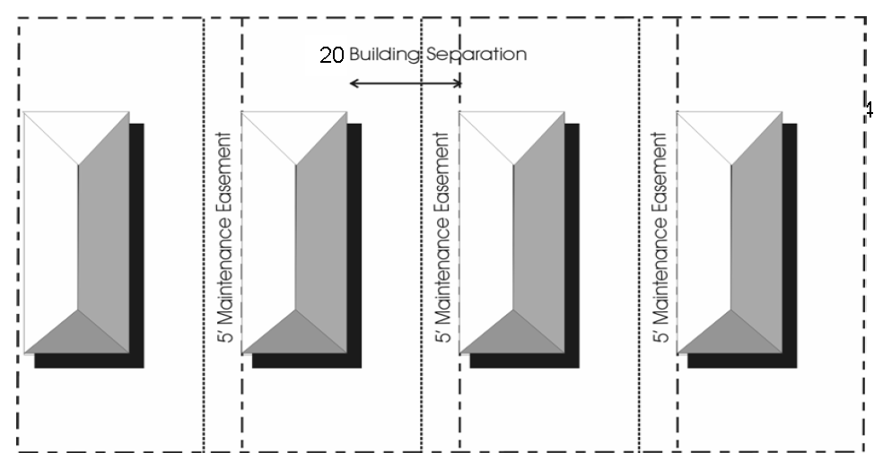
2. Fencing, walls, trellises, and other similar uses can be used as connecting elements between one-family dwellings on adjacent lots, subject to site plan review by the Planning Commission.
3. Twin Houses—Semi-detached, single-family dwellings which are connected along a common party wall (a code-approved firewall) to a similar unit. Each structure has only two dwellings. For a Twin House, the structure shall be set back a minimum of ten (10) feet from the side yard opposite of the common party wall. See Illustration below.
4. Garages, carports, utility storage structures shall be permitted accessory uses and may be either attached as part of the main building or detached; however, said structures shall not be used as connecting elements and shall meet the setback requirements for accessory structures if detached or for primary structure if attached.
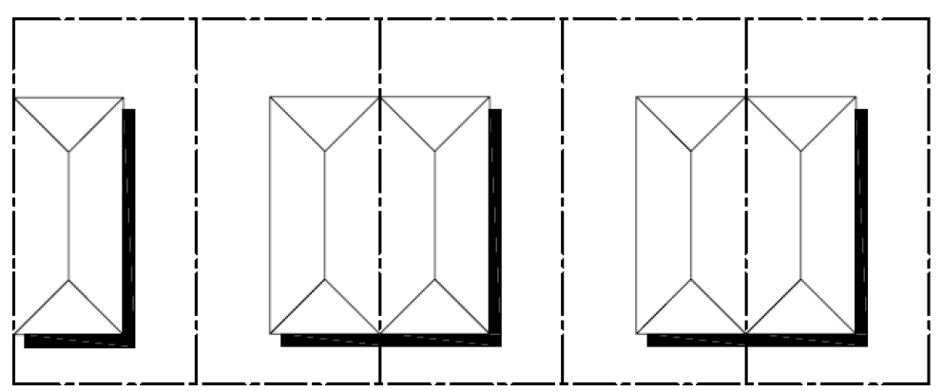
Dimensional Standards:
1. Minimum Development Area: | None
2. Maximum Development Density: | 8 units/gross acre
3. Minimum Average Net Lot Area: | 5,000 square feet *
4. Minimum Lot Width: | 50 feet
Minimum Corner Lot Width: | 50 feet
5. Maximum Percent of Lot Occupied by Buildings: | 50/60 percent **
6. Minimum Setbacks from Property Lines
a. Front | 25 feet
b. Interior Side Yard | 0 feet
c. Opposite Interior Side Yard | 20 feet ***
d. Street Side Yard | 25 feet
e. Rear | 25 feet
7. Maximum Height of Structure/Number of Stories | 35 feet/2.5 stories

* This shall not include any credit for streets, recreation areas, common open space or water bodies. Private roads shall not be used in calculating the net lot area.
** Where there is not maintained common open space, a zero lot line dwelling including accessory structures shall not occupy more than fifty (50) percent of the lot area, sixty (60) percent coverage is allowed if there is maintained common open space.
*** The connecting elements such as fences, walls, trellises, patios, garden features, and other similar elements shall be permitted within the ten (10) foot setback area provided, however, no structure, with the exception of fences or walls, shall be placed within the required five (5) foot utility, wall maintenance, drainage, or other easements, or in an buffer area. And, in no case shall a zero lot line dwelling be built closer than fifteen (15) feet to the property line of a lot which is zoned as R-1 or R-2 Residential.
Accessory structures shall be setback at least five (5) feet from any property line or eight (8) feet from another structure in any residential development or twenty (20) feet in any commercial or industrial development, and shall not be located on any type of easement or buffer area. When an accessory structure is to be located in the rear yard of a corner lot, the accessory structure shall be setback at least ten (10) feet in any residential development or twenty-five (25) feet in any commercial or industrial development from the side street property line.
Fences may be located on the side or rear property lines unless an easement exists, in which case they shall not be located on any easement area. Front and side fences shall be no closer than ten (10) feet from any street right-of-way line and shall not be located within any sight distance area.
Street Frontage: Each lot shall have a clear, direct frontage on public streets or to accessways complying with private street requirements.
Platting Requirements: Each dwelling shall be located on its own individual platted lot. If areas for common use by occupants of the development are shown on the plat, satisfactory arrangements shall be made for the maintenance of the common open space and facilities as provided herein. The plat shall indicate the zero lot lines and all related easements.
Openings Prohibited on the Zero Lot Line Side: The wall of the dwelling located on the lot line shall have no windows, doors, air conditioning units, or any other type of openings, provided, however, that atriums or courts shall be permitted on the zero lot line side when the court or atrium is enclosed by three (3) walls of the dwelling unit and a solid wall of at least eight (8) feet in height is provided on the zero lot line. Said wall shall be constructed of the same material as exterior walls of the dwelling unit. Where adjacent zero lot line dwellings are not constructed against a common lot line, the builder or developer must provide for a perpetual wall-maintenance easement of five (5) feet in width along the adjacent lot and parallel with such wall.
Maintenance and Drainage Easements: A perpetual five (5) feet wide wall-maintenance easement shall be provided on the lot adjacent to the zero lot line property line which, with the exception of walls and/or fences, shall be kept clear of structures. This easement shall be shown on the plat and incorporated into each deed transferring title of the property. The wall shall be maintained in its original color and treatment unless otherwise agreed to in writing by the two affected lot owners. Roof overhangs may penetrate the easement on the adjacent lot a maximum of twenty-four (24) inches, but the roof shall be so designed that water runoff from the dwelling placed on the lot line is limited to the easement area.
Off-street Parking: A minimum of two (2) off-street parking spaces shall be provided on each platted lot. Except for parallel parking on public roads, tandem parking is permitted only on individual lots and in the driveways connecting such lots with the adjacent roads, provided said driveways are for the exclusive use of each individual lot. However, tandem parking shall be limited to no more than one (1) such tandem parking space for each individual lot. Parking shall be prohibited on sidewalks or in the front yard area directly in front of the home. Additional provisions for Off-street parking and loading are required and defined in Article 8.
Trees and Landscaping: Every development is unique and planting of trees and landscaping is required for all developments. A landscaping plan shall be submitted for approval by the Plan Review Committee.
Common Open Space and Maintenance of Facilities: Common open space is not required but may be permitted. If common open space is provided, satisfactory provisions shall be made to assure that nonpublic areas and facilities for the common use of occupants of Zero Lot Line development shall be maintained in a professional manner without expense to the general taxpayer of the City of Cleveland. Such may be provided by the incorporation of an automatic-membership home association for the purpose of continually holding title to such nonpublic areas and facilities and levying assessments against each lot, whether improved or not, for the purpose of paying the taxes and maintaining such common open space. Such assessments shall be a lien superior to all other liens save and except tax liens and first mortgage liens, which are amortized in monthly or quarter - annual payments over a period of not less than ten (10) years. Other methods may be acceptable if the same positively provide for the proper and continuous payment of taxes and maintenance without expense to the general taxpayers. The instrument incorporating such provisions shall be approved by the City Attorney, as to form legal sufficiency, before submission to the Board of Alderman and shall be recorded in the public records of Bolivar County, if satisfactory to the Board of Aldermen.
Commencement of Development: If development is not commenced within twelve (12) months from the date of approval of a site development plan, the approval hereof shall become null and void and the same may not be developed in accordance with said plan; provided, if development is permitted in stages, subsequent stages may be commenced within eighteen (18) months after the completion of the previous stage; otherwise, such subsequent stage may not be developed in accordance with the previously approved plan and such approval shall be null and void. Commencement of construction shall include, where necessary, substantial site improvement, which shall include but not be limited to active and continuous road improvement, excavation, grading and leveling, installation of utilities, and the like.
Provisions for signage are defined in Article 9.
Planned Unit Developments and Zero Lot line developments shall have a fifteen (15) foot wide buffer area along the side and rear property lines of the overall property. Additional details and provisions for buffering and landscaping are defined in Article 10, Section 1005.
Zoning Table
Zoning District | Min. Lot Area in Sq. Ft. | Min. Lot Width at Front Setback Line | Max. % of Lot Occupied by Bldgs. | Minimum Setback |  |  | Max. Height of Structure/Max. # of Stories
 |  |  |  | Front | Side (b) | Rear | Max. Height of Structure/Max. # of Stories
A-1 Agricultural | 2 acres | 100' | 30% | 35' | 15' (b) | 30' | 50' / 2.5
R-1 Residential, S-F detached | 12,500 | 100' | 30% | 35' | 15' (b) | 30' | 50' / 2.5
R-2 Residential, S-F detached | 9,000 | 80' | 40% | 30' | 10' (b) | 25' | 40' / 2.5
R-3 Residential, S-F detached | 6,000 | 60' | 60% | 25' | 8' (b) | 25' | 30' / 2
R-4 Residential, S-F detached | 5,000 | 50' | 60% | 25' | 8' (b) | 25' | 30' / 2
R-5 Residential, Multi-Family (detached or attached) | 5,000(d) | 50'(e) | 60% | Ext. 35' | Ext. 15' (b) | Ext. 30' | 60' / 3
 |  |  |  | Int. 15' | Int. 5' | Int. 15' | 60' / 3
R-6 Manufactured Housing | 3,200 | 30' | 70% | 25' | 15' (b) | 25' | 20' / 1
B-1 Neighborhood Commercial | 6,000 (a) | 60' (a) | 50% | 25' | 15' (b) | 25' | 35' / 2
B-2 Central Business District | (a) | (a) | No  Restriction | 25' (c) | 15' (c) | 30' (c) | 60' / 5
B-2H Historic Central Business District | (a) | (a) | No  Restriction | 0' | 0' | 20'  (c) | 60' / 5
B-3 Highway Commercial | 10,000 (a) | 80' (a) | 30% | 60' | 25' (b) | 25' | 60' / 5
X-1 Government | (a) | (a) | 50% | 60' | 25' (b) | 20' | 60' / 5
M-1 Light Industrial | (a) | (a) | 50% | 60' | 25' (b) | 50' | 45' / 3
M-2 Heavy Industrial | (a) | (a) | 50% | 100' | 25' (b) | 50' | 45' / 3
PUD Planned Unit Development | (a) | (a) | As proposed, should match base districts

(a) It is the intent of this Ordinance that the minimum lot area shall include that area sufficient to meet requirements for the building or buildings for all primary and accessory uses, all parking and loading requirements, buffering, yards, setbacks, and open space requirements on the site. Further, the new construction on the site shall be compatible with and "blend" with the existing character of the neighborhood.
(b) The setback line for a side yard abutting a side street shall be the same as the front setback.
(c) Existing buildings in the B-2 and B-2H zoning districts that do not meet the front, side, or rear setbacks are non-conforming structures and may be rehabilitated using the existing building footprint or setbacks to maintain the continuity of the neighborhood.
(d) For each additional family add 2,000 square feet.
(e) For each additional family add 5 feet.

ARTICLE 7. - SUBDIVISIONS

Sec. 701. - General.
A "subdivision" has been previously defined in this document as the division of a parcel of land into two or more lots for the purpose of transferring ownership or construction of a building. If a new street is being built, any division of land is a subdivision.
All land subdivisions developed, redeveloped, or constructed within the City of Cleveland shall comply with the provisions of these regulations.
It shall be unlawful for any person, firm or corporation to lay out for the purpose of selling, or offering for sale, a tract or parcel of land within the City of Cleveland into two or more building sites without first having the tract or parcel of land surveyed and platted by a Licensed Professional Engineer or Licensed Land Surveyor. Also the plat of the proposed subdivision must be submitted to the Planning Commission and Plan Review Committee for their evaluation and recommendation to the Mayor and Board of Aldermen. After approval by the Mayor and Board of Aldermen of Preliminary and Final versions of the proposed subdivision plat, the approved Final Plat shall be recorded as provided by law with said Professional Engineer's or Surveyor's signature and seal.
All proposed subdivisions shall conform to the Cleveland Comprehensive Plan, Zoning Ordinance and other regulations such as building codes, in effect at the time of submission to the Planning Commission. All highways, streets, and other features of the Comprehensive Plan shall be platted by the subdivider in the location and to the dimensions, if any, indicated by the Comprehensive Plan, Zoning Ordinance, and other regulations.
Where community or public facilities of the Comprehensive Plan are located in whole or in part of a proposed subdivision, the public board, commission, or body having jurisdiction and/or financial responsibility for the acquisition of such facility or facilities shall execute a written option to acquire by purchase, file suit for condemnation, or relinquish the location of such facility or facilities. Provided further, however, the option to acquire must be exercised and fully consummated within twelve (12) months following the date of the recording of the final plat.
No final plat of land within the force and effect of an existing zoning code, building code, or other official code, ordinance, or regulation shall be approved unless it conforms to all such regulations.
General subdivision information shall describe or outline the existing conditions of the site and the proposed development as necessary to supplement the drawings required below. This information may include data on existing covenants, land characteristics, and available community facilities and utilities, and information describing the subdivision proposal such as number of residential lots, typical lot width and depth, price range, business areas, playgrounds, park areas, and other public areas, proposed protective covenants and proposed utilities and street improvements.
No building or structure, or any portion thereof, shall be constructed within the limits of special flood hazard areas inundated by the 100-year flood, as identified in the applicable Flood Insurance Rate Map distributed by the Federal Emergency Management Agency, unless the lowest floor elevation of the building or structure is higher than, or is raised by filling to, an elevation at least to or higher than the Base Flood Elevation. The applicant shall conduct on-site topographic surveys to locate the precise floodplain line on the subject parcel. Any structure placed within the floodplain shall be anchored firmly to prevent floodwaters from carrying it downstream.
No building or structure shall be erected, structurally altered, or added to, until a building permit has been issued by the City of Cleveland. All building permit applications shall be in accordance with the requirements of this ordinance, and no building permits shall be issued unless it conforms to all regulations. No building permit shall be accepted or processed until and unless the property where the proposed building will be situated has been given Preliminary and Final subdivision Plat approval and the approved Final Plat has been properly recorded.
Sec. 702. - Design and construction.
In consideration of acceptance by the City of Cleveland and the assumption of the responsibility for maintaining the utilities and streets constructed therein, the owner or owners of the subdivision shall cause to be constructed where required by the Governing Body and at no expense to the City, the following improvements according to the specifications set forth in this Article and the specifications of the Building Official, the City Engineer, or other authorized staff of the City of Cleveland. Design and supervision of work shall be conducted and acknowledged by a Licensed Professional Engineer. After acceptance of the subdivision by the City, following the required period of maintenance by the developer, all such improvements shall become property of the City and the plat shall so state.
Prior to the installation of paving, easements for the installation of gas mains, telephone and television cable and electric lines shall be granted and such of said utilities as go beneath pavement shall have been installed by the respective parties to insure no cutting of pavement. If such improvement installation is required after the pavement is installed, then those improvements will be installed in a manner that does not require cutting of, or other damage to, the pavement.
Prior to the sale of any subdivision lots or the recording of the Final Plat, the sub-divider shall furnish a Surety Bond or Maintenance Bond in the amount of the estimated cost of construction for any and all work that is not fully completed, guaranteeing the faithful performance of all covenants, stipulations and agreements regarding construction, and guaranteeing the work against the incorporation of faulty materials or poor workmanship for a period of one (1) year after the date that construction was certified as complete by the City Engineer. The bond shall be held for a period of at least one (1) year before being released by the Governing Authority upon recommendation of the City Engineer.
702.1. - Survey Monuments.
Survey monuments shall be placed at all corners or changes of alignment along the boundary of the subdivision and at all block corners, angle points, or points of curves in street right-of-way boundary lines and at all lot corners in alignment in lot boundaries. These monuments shall consist of iron pipe of not less than one-half (½) inch in diameter and not less than twenty-four (24) inches in length or steel rod of not less than three-eighths (3/8) inch diameter and not less than twenty-four (24) inches in length.
Should conditions prohibit the placing of monuments on the property line; offset marking will be permitted; provided, however, that exact offset courses and distances are shown on the subdivision plat. Iron pipes or steel rods shall be set at all lot corners. If survey monuments are removed during construction, they shall be replaced.
702.2. - Blocks.
The lengths, widths and shapes of blocks shall be designed with due regard to:
a. Provision of adequate building sites suitable to the special needs of the type of use contemplated.
b. Zoning requirements as to minimum lot sizes, setbacks, required yards, and required buffers.
c. Needs for convenient access, circulation, control and safety of street traffic.
d. Limitations and opportunities of easements or topography.
As a usual practice blocks shall be generally rectangular. Block lengths shall not exceed one thousand (1,000) feet or be less than four hundred (400) feet. Blocks shall normally be wide enough to allow two (2) tiers of lots of appropriate depth.
The Governing Body, following consultation with the Planning Commission and Plan Review Committee may elect to make exceptions for block design in particular cases.
702.3. - Lots.
The lot size, width, depth, shape, orientation, and the minimum building setback lines shall be appropriate for the location of the subdivision and for the type of development and use contemplated.
Lot dimensions shall conform to the requirements of the zoning portion of this ordinance and as approved by the Planning Commission or Governing Body.
The minimum size of residential lots where a public sanitary sewer is not available shall be determined by the Governing Body after studies have been made of the soil condition existing on the site of the proposed subdivision and upon recommendations of the City Engineer with the approval of the Mississippi State Health Department.
Depth and width of properties reserved or laid out for commercial and industrial purposes shall be adequate to provide for off-street service and parking facilities required by the type of use and development contemplated on the site.
All new developments in Cleveland shall be part of a subdivision and shall be assigned to a platted lot and numbered. There shall be no "leftover" lots or land created by "default" through being omitted or excluded from a subdivision.
Corner lots for residential use shall have extra width to permit appropriate building setback from and orientation to both streets.
The subdividing of the land shall be such as to provide, by means of a public street, each lot with satisfactory access to an existing public street.
Double frontage and reverse frontage lots should be avoided except where essential to provide separation of residential development from traffic arteries or to overcome specific disadvantages of topography and orientation.
Corner lots and double frontage lots shall have access from only one (1) street. This shall be the street inside the subdivision, a local road and not an arterial. This shall be noted on the subdivision plat.
Side lot lines shall be substantially at right angles or radial to street right-of-way lines.
All lots or spaces intended for permanent detention area, common areas, parks, drainage paths, or other open spaces shall be designated as such on the Preliminary and Final Plat with a note that states how these spaces will be maintained and that these areas will not be developed.
702.4. - Streets.
Streets shall be designed and constructed in conformance with the design standards set forth in this ordinance, the Future Transportation Plan portion of the Comprehensive Plan, and/or as specified by the Plan Review Committee, and approved by the Governing Body.
The arrangement, character, extent, width, grade, and location of all streets shall conform to the Future Transportation Plan portion of the Comprehensive Plan and shall be considered in their relation to existing and planned streets, to topographical conditions, to public convenience and safety, and in their appropriate relation to the proposed uses of the land to be served by such streets.
Where such is not shown in the Future Transportation Plan portion of the Comprehensive Plan, the arrangement of streets in a subdivision shall either:
a. Provide for the continuation or appropriate projection of existing principal streets in surrounding areas; or
b. Conform to a plan for the neighborhood reviewed by the Planning Commission and the Governing Body to meet a particular situation where topographical or other conditions make continuance or conformance to existing streets impracticable.
Such a neighborhood plan shall be prepared by the subdivider or developer and shall be approved by the Plan Review Committee and Planning Commission. Street stubs to adjacent, undeveloped properties shall be required to ensure adequate future circulation. Any time that a street terminates at the edge of undeveloped property there is the intent to extend the street when the property develops. In such cases, a cul-de-sac or other approved turn-around is required.
Minor streets shall be so laid out that their use by through traffic will be discouraged. But, the city's general grid system shall be continued and encouraged so as to allow multiple options for traffic trips inside the city.
Where a subdivision abuts or contains an existing or proposed arterial street direct driveway access to the arterial shall be minimized for adequate protection of residential properties and to afford separation of through and local traffic. Residential subdivisions shall require reverse frontage extra deep lots with a non-access reservation strip along the rear property line. This non-access strip shall be a landscaped buffer zone. Other special design may be considered for the subdivision including rear access service alleys. Commercial or industrial subdivisions may be allowed to access the arterial in a limited manner or may be designed to create a limited access frontage road. The commercial or industrial development may be allowed to face the arterial and "front" the arterial or frontage road, or it may have a reverse frontage lot with landscaped buffer as described for residential lots. The preferred access to all lots that are adjacent to an arterial street is through a side road.
Where a subdivision borders on or contains a limited access highway right-of-way (ROW) or railroad right-of-way (ROW), the subdivision may be designed to require a street approximately parallel to the ROW at a distance suitable to allow for the land to be appropriately used on both sides. Such distances shall also be determined with due regard for the requirements of approach grades and future grade separations.
Street segments that do not intersect directly across from one another, but where there is an "offset" or "jog" of the street continuation, centerline offsets of less than one hundred twenty-five (125) feet apart shall be avoided.
Streets shall be laid out so as to intersect as nearly as possible at right angles, and no street shall intersect any other street at less than sixty (60) degrees unless approved by the Plan Review Committee.
Property lines at street intersections shall be rounded with a radius of twenty (20) feet on a minor street and twenty-five (25) feet on a collector, or major street. The Plan Review Committee may require comparable cutoffs or chords in place of rounded corners. A comparable chord shall be considered a chord or line connecting the points of tangency of the radius it is replacing.
A tangent of at least one hundred (100) feet shall be introduced between reverse curves on arterial and collector streets.
When connecting street lines deflect from each other at any one point by more than ten (10) degrees, they shall be connected by a curve with a radius sufficient to insure an adequate sight distance for minor and collector streets, or of such radii as the Plan Review Committee shall determine for special cases:
Type | Minimum Sight Distance
Arterial Thoroughfare | 350′
Major Street | 275′
Collector or Business Street | 150′
Minor or Local Street | 100′

Half streets shall be prohibited, except where essential to the reasonable development of the subdivision in conformity with the other requirements of these regulations and where the Plan Review Committee finds it will be practical to require the dedication of the other half when the adjoining property is subdivided. Wherever a half street is adjacent to a tract to be subdivided, the other half of the street shall be platted within such tract and two full lanes of pavement shall be required on the developing property.
Culs-de-sac or "dead-end" streets, designed to be so permanently, shall be of such length as may be deemed necessary and adequate by the Plan Review Committee, and shall be provided at the closed end with a turn-around having an outside roadway diameter of at least one hundred ten (110) feet.
No street names shall be used which will duplicate or be confused with names of existing streets. Street names shall be subject to the approval of the Governing Body.
Street signs shall be placed by the developer at time of construction of the subdivision and then become the responsibility of the City.
Street grades shall be approved by the City Engineer. Care shall be exercised in construction of curb and gutter to insure proper drainage, when such improvements are required.
Street Trees: Trees will be permitted within street boundary lines with right-of-way width of at least sixty-four (64) feet. Street trees will not be permitted within seven (7) feet of the center line of any public storm or sanitary sewer. Trees of a type not exceeding fifty (50) feet in height and with a trunk diameter not in excess of thirty (30) inches at a point two (2) feet above the ground level at maturity will be permitted when planted at not less than fifty (50) feet intervals.
Lawn grasses will be permitted within the right-of-way boundary of an intersecting street. All planting strips shall be graded and sod or seeded with Bermuda, St. Augustine, Zoysia or similar grasses. Any planting other than lawn grasses within boulevard rights of way and/or median strips must be approved by the Plan Review Committee.
Street Sight Distance: No fence, wall, hedge or shrub planting which obstructs sight lines at elevations between two and one-half (2.5) feet and ten (10) feet above the roadways shall be placed or permitted to remain on any corner lot within the triangular area formed by the street property lines and a line connecting them at points twenty-five (25) feet from the intersection of the street lines, or in the case of a rounded property corner from the intersection of the street lines extended. The same sight line limitations shall apply on any lot within ten (10) feet from the intersection of a street property line with the edge of a driveway pavement of alley boundary.
Street right-of-way widths and pavement widths, unless otherwise determined by the Governing Body, shall be as follows:
Street Type | Minimum ROW Width* | Min. Pavement Width* | Curb and Gutter
Arterial | 120 or more | Variable | Open Ditch or curb and gutter
Major | 80 | 36—44 | Yes
Collector or business street | 60 | 36 | Yes
Local or Minor, for row houses & apartments | 60 | 36 | Yes
Local or Minor, for other residences | 60 | 30 | Yes
Cul-de-sac | 50** | 30 | Yes
Cul-de-sac Circle or Turnaround | 110 | 80 | Yes
 | *From face of curb to face of curb in feet.

All pavement or surfacing designs must be approved by the City Engineer before any construction is undertaken to insure adequate design for the existing soil conditions and proposed use to which it is subjected.
To attain purposes of the Future Transportation Plan as contained in the Comprehensive Plan, the City may require that certain streets serving a subdivision be constructed to higher standards than would be necessary to serve the particular subdivision. When higher standards are so imposed, the City may assume a proportionate share of the increased cost of construction. Such cost shall not exceed the difference between that required for construction of the minimum street capable of adequately serving the subdivision and the cost of street construction imposed by the City, as determined by the City Engineer.
Where off-site roadway or utility improvements are required as a result of the proposed development, those improvements shall be the responsibility of the applicant, and shall be constructed or installed prior to any final inspection.
Streets to be constructed for the development of a subdivision or extension of any road within the City of Cleveland shall conform to the following specifications. This includes all grubbing, grading, laying of sub-base, base, pavements, curbs and gutters, culverts, bridges, storm sewer mains and structures. Design and supervision of work shall be done by a Licensed Professional Engineer.
Sub-Bases. Where any excavation and stripping of soil for roadbed construction, the sub-base shall be compacted to ninety-five (95) percent of maximum density by standard proctor prior to any base material being placed for compaction. Adequate test shall be taken to cover the project area. All tests shall be performed by a certified testing lab and results shall be reported to the Project Engineer and City Engineer prior to any further construction.
Base. A layer of four (4) inch topping material shall be placed on the sub-base and compacted to ninety-five (95) percent of maximum density by standard proctor. Topping material may be a sandy-loam material or may be a SB-2 limestone base. Adequate test shall be taken to cover the project area. All tests shall be performed by a certified testing lab and results shall be reported to the Project Engineer and City Engineer prior to any further construction.
Reinforced Concrete Pavement. Pavement for all roads and streets shall consist of 6″ reinforced concrete, unless otherwise approved by the Planning Commission and Board of Aldermen. Pavement shall conform to the Mississippi Standard Specifications for Road and Bridge Construction for concrete pavement. All pavement shall be constructed of Class PA concrete as specified. The mix design shall be submitted to the Project Engineer and City Engineer prior to the placement of concrete. Concrete shall be batched and supplied by a State Certified Batch Plant. Proof of certification shall be submitted to the Project Engineer and City Engineer prior to construction. Concrete being placed for pavement shall be tested by a certified testing lab to certify it meets minimum standards set forth in the specifications. Concrete cylinders shall be made so that a seven (7) day, fourteen (14) day and a twenty-eight (28) day break may be made. Reports shall be delivered to the Project Engineer and City Engineer in a timely manner.
Reinforcing Steel. Reinforcing steel shall be supplied and placed by the contractor as set forth in the attached Standard Details. All reinforcing steel shall meet the requirements of Section 711-Reinforcing Steel of the latest edition of the Mississippi Standard specifications for Road and Bridge Construction and Section 501-Reinforcing Steel (Placement). Notification shall be given to the Project Engineer and the City Engineer twenty-four (24) hours prior to placement of concrete for inspection purposes.
Construction. All plans and specifications shall be submitted to the Plan Review Committee for approval prior to any construction being performed. All construction work shall be performed by a contractor who is licensed by the State Board of Contractors for each particular area of the development. Any of the above listed specifications that are not adhered to shall cause the project to not be accepted by the City of Cleveland for maintenance and is considered to be a violation of this Ordinance.
702.5. - Alleys.
Alleys shall be provided in commercial and industrial districts, except that the Governing Body, following consultation with the Planning commission, may elect to waive this requirement where other definite and assured provision is made for service access, such as off-street loading, unloading and parking consistent with and adequate for the uses proposed.
The right-of-way width of an alley in commercial and/or industrial sections shall be a minimum of twenty-five (25) feet. Where alleys are used in residential areas, the right-of-way width shall be a minimum of twenty (20) feet. Pavement width shall be approved by Plan Review Committee. Any new alley proposed as part of a new development shall be paved with concrete or asphalt meeting the minimum standards as defined by the City Engineer unless otherwise approved by the Planning Commission and Board of Aldermen.
Alley intersections and sharp changes in alignment shall be avoided, but where necessary, corners shall be cut off sufficiently to permit safe vehicular movement.
Dead-end alleys shall be avoided where possible, but if unavoidable, shall be provided with adequate turn-around facilities at the dead-end as determined by the Plan Review Committee.
702.6. - Sidewalks.
Where constructed, sidewalks shall be five (5) feet wide and constructed of concrete and shall be located within the street right-of-way. Sidewalk materials should blend with the natural landscape, avoiding slick concrete. Examples of acceptable finishes are broom finished, colored, or exposed aggregate concrete. Asphalt sidewalks are prohibited.
ADA access ramps, complying with the requirements of Federal law, shall be provided for both sidewalks adjacent to public streets, as well as sidewalks provided internally within the development.
Pedestrian crosswalks shall be provided both internally and externally to the development where deemed essential to provide circulation or access to schools, playgrounds, shopping centers, transportation, and other community facilities. Public crosswalks, not less than ten (10) feet wide, shall be striped in conformance with the latest edition of the Manual on Uniform Traffic Devices. Crosswalks on private property, internal to the site, shall either be delineated by white, reflectorized pavement striping or may be delineated by materials of a different color and texture from the surrounding parking lot, otherwise conforming to the overall color scheme of the development with added signage denoting crosswalk areas.
702.7. - Utility, Drainage, and Ingress/Egress Easements.
Easements across lots or centered on rear or side lot lines shall be provided for utilities where necessary and shall be at least twelve (12) feet wide at ground level with an additional six (6) feet wide over-hang on each side from twelve (12) feet above ground and up or a width designated by the Plan Review Committee.
Where easements intersect or short changes in alignment are necessary, corners shall be cut off sufficiently to permit equipment access. The minimum chord will be the chord of a segment having a minimum radius of ten (10) feet.
No structures, trees, shrubs, or buildings will be permitted in easements.
Any overhanging limbs, shrubbery, or vegetation of any kind may be removed from within the limits of easements at the sole discretion of the maintenance personnel of the utilities installed or to be installed in or above the easements.
Every easement shall terminate at both ends upon a street, alley, or other easement, except that dead-end easements will be permitted if not more than one hundred fifty (150) feet in length with no turns or bends.
Where a subdivision is traversed by a water course, drainage way, channel or stream, there shall be provided a storm water easement or drainage right of way conforming substantially with the lines of such water course or an accepted canal or drainage course, and such further width or construction, or both, as will be adequate for the drainage purposes as determined by the Plan Review Committee. Parallel streets or parkways may be required in connection therewith.
Where a sewer is not constructed in a dedicated public street, road, or alley, an easement not less than twenty (20) feet in width for the construction, operation and maintenance of the sewer shall be established in the name of the City of Cleveland.
702.8. - Grading.
Grading and centerline gradients shall be in accordance with plans and profiles approved by the City Engineer.
Areas to be graded by cutting or filling shall be rough graded to within 0.2 of a foot of the accepted elevation after necessary allowance has been made for the thickness of topsoil, paved areas, and other installations.
Final cross sections and profiles of streets and other installations shall conform to grades approved by the City Engineer. The profiles shall be drawn to a standard scale; elevations shall be based on Mean Gulf Datum. Two (2) reproducible copies of all as-built construction drawings shall be furnished to the City Engineer and Director of Public Works upon completion of various improvements within the subdivision.
In all zoning districts, the lowest floor elevation in all new construction shall be a minimum of six (6) inches above the crown of the road that the lot has frontage on.
Grading shall be continued until the area conforms to the lines, grades, slopes and typical cross sections shown on the accepted plans.
Temporary soil erosion shall be minimized through the retention of natural vegetation and topography continuously until the completion of the project. The period of construction shall be of a duration reasonable to the size and complexity of the development. Topsoil shall be retained upon the site and placed over landscaped areas at a depth of not less than six (6) inches. The required development plan shall include an erosion control plan. The methods utilized and the minimum standards for care of the area during construction shall be in conformance with the requirements of the City of Cleveland.
All timber, logs, trees, brush, vegetable matter and other rubbish shall be removed so as to leave the areas that have been disturbed with a neat and finished appearance. All tree stumps, masonry and other obstructions shall be removed unless otherwise approved by the Plan Review Committee.
Buildings and improvements shall be located on the site to minimize changes to the existing topography and the loss of existing, mature landscaping. All existing trees eight (8) inches or larger in diameter shall be reflected on the Development Plan, and where they are proposed to be removed, justifications shall be provided.
Areas of natural vegetation shall be preserved along property lines where possible, including fence rows and drainage ways, and should be incorporated into the site's overall design concept.
Erosion control measures shall be in place before any major grading work is done. Installation of all improvements shall be done in such a manner as to provide for the most effective control of erosion and sediment. The construction plan shall be accompanied by an erosion and sediment control plan. Practical combination of the following technical principles shall be used:
a. The smallest practical area of land shall be exposed at any one time during development.
b. When land is exposed during development, the exposure shall be kept to the shortest practical period of time.
c. Temporary vegetation or mulching shall be used to protect critical areas exposed during development.
d. Sediment basins (debris basins, desilting basins, or silt traps) shall be installed and maintained to remove sediment from runoff waters of land undergoing development.
e. Provisions shall be made to effectively accommodate the runoff caused by changed soil conditions during and after development.
f. Permanent final vegetation and structures shall be installed as soon as practical in the development.
g. The development plan shall be fitted to the topography and soils so as to create the least possible erosion.
h. Whenever feasible, natural vegetation shall be retained and protected.
702.9. - Drainage.
When the sub-divider submits the Final Plat of the subdivision to be dedicated, he shall also submit plans showing the proposed storm drainage system.
Drainage improvements constructed for new developments shall maintain any natural watercourse, shall not deter the natural drainage patterns, and shall prevent the collection of water in any low areas. Where the subject property is impacted by a surface drainage ditch, creek, river, or other waterway, the banks of the waterway will be stabilized as directed by the Plan Review Committee.
Wetlands, which are important to storm water retention, shall be maintained. The elimination of wetland areas upon the site, and the mitigation required for such elimination, shall be governed by the U. S. Army Corps of Engineers.
The drainage plan will show location and size of pipes and ditches, manholes and catch basins, culverts with headwalls and aprons for same, and bridges with plans for same approved by the Plan Review Committee, contours of the project, street layout and lot pattern with lot numbers. The drainage plan will also show the invert elevations, grade and the drainage area contributory to each drainage pipe or channel, including off-site areas.
Design and supervision of work shall be done by a qualified Licensed Professional Engineer in accordance with standard specifications of the City Engineer of the City of Cleveland.
The rate of Post-development drainage and storm water runoff shall not exceed pre-development levels. This shall be shown and attested to on the construction and drainage plans by the developer's engineer. Large developments shall provide on-site temporary and permanent storm water storage facilities.
Storm water entry and discharge points shall be protected to minimize erosion and to avoid relocating a problem to upstream or downstream properties.
In order to minimize storm water runoff, the amount of the site in impervious surface, such as roofs and pavement, should be minimized. The maximum impervious surface for any individual site shall not be greater than seventy-five (75) percent of the property.
No project shall cause downstream properties, water courses, channels, or conduits to receive storm water runoff from the proposed project at a higher peak flow rate than would result from the same storm event occurring over the site of the proposed project with the land in its natural, undeveloped condition. Where downstream conditions would be overtaxed by runoff from present or planned developments, and where runoff cannot be absorbed upon the site, detention areas shall be created to slow runoff. All storm water storage facilities shall be designed with sufficient capacity to accommodate all runoff caused by the project in excess of the runoff which would have resulted from the site left in its natural, undeveloped state. The storage capacity of all storage facilities shall be sufficient to store one hundred fifteen (115) percent of the excess flow, in each watershed, which would result from a twenty-five (25) year storm of twenty-four (24) hour duration.
All storm drainage systems shall be designed and constructed in accordance with the rainfall and runoff data in current use by the City Engineer and subject to the approval of the City Engineer. The Governing Body reserves the right to require that main sewers or canals be designed to handle storms occurring on an average frequency of twenty-five (25) years when engineering studies indicate such to be advisable. The Governing Body reserves the right to prohibit the filling of low-lying areas and to zone such areas for uses that would not be damaged by short duration flooding, where the estimated economic gains such areas might produce is not substantially greater than the cost of providing adequate storm drainage and other required improvements and services.
The cost of such work shall be borne by the sub-divider or developer. After these improvements have been constructed to the City's standards, and maintained for the specified period, all such improvements shall become the property of the City of Cleveland.
Whenever the Plan Review Committee deems it appropriate and necessary, in keeping with and in facilitating development of the Comprehensive Plan, the sub-divider may be required to install drainage structures in excess of those required to adequately serve the sub-division. In these cases, the City may reimburse the sub-divider for the difference in cost between the drainage facilities actually needed in the sub-division and the cost of the drainage facilities necessary to provide for planned future development.
702.10. - Water Supply
Public water shall be supplied to the site by the City in accordance with their established policies concerning construction and financing. The on-site water supply system shall be constructed by the developer and shall be adequate to supply the requirements of the subdivision for domestic use and fire protection in accordance with the standards of the State Rating Bureau. The cost of pipe sizes in excess of those required to actually serve the Subdivision may be borne by the City of Cleveland.
Design and supervision of work shall be done by a qualified Licensed Professional Engineer in accordance with standard specifications of the City Engineer of the City of Cleveland.
702.11. - Sanitary Sewers
The Sanitary Sewer system for the City of Cleveland is administered by the Director of Public Works and the City Engineer, or their authorized representative under the Sewer User ordinance of the City of Cleveland. All property inside the City of Cleveland is required to make use of the sanitary sewer and wastewater treatment system if it is available.
Sanitary sewers shall be constructed to provide a minimum of one (1) four (4) inch connection at the street boundary line for each lot or parcel of record and shall be so designed and constructed as to form an integral part of the sanitary disposal system of the City in conformity with the Comprehensive Plan and in accordance with current specifications of the City Engineer.
Minimum pipe size allowed shall be eight (8) inches in diameter, except where a line shall provide service for no more than four single family residences and shall not exceed one hundred fifty (150) feet in length. In such cases, a six (6) inch pipe may be used. A minimum service connection of four (4) inches for one (1) single family dwelling and a minimum service connection of six (6) inches for two-family dwellings or more shall be required.
Sanitary manholes shall be spaced at intervals not to exceed four hundred (400) feet and at each junction or change in alignment.
Design and supervision of the work shall be done be a Licensed Professional Engineer.
Prior to the assumption by the City of the maintenance of the sanitary sewer system, the sub-divider shall convey title of the system to the City.
When any of the sanitary sewers within a proposed subdivision or sewers necessary to connect the proposed subdivision with the City sewer system or an outlet acceptable to the City Engineer are so located that portions thereof may be a segment of a sanitary sewer main or fall out, the Plan Review Committee may require the sub-divider to install sewer pipe for that portion of the line which may become a main or outfall sewer of such size as may be necessary to facilitate future expansion of the sanitary sewer system. In these instances, the City may reimburse the sub-divider for the extra cost incurred for installing larger sewer mains. If a sewerage lift station is required to service the subdivision, the cost of said lift station shall be borne by the sub-divider. Should a lift station be required with a greater capacity than that needed to serve the proposed subdivision, the City Engineer may require the sub-divider to install a greater capacity lift station. In these instances, the City may reimburse the sub-divider for the extra cost incurred by installing a greater capacity lift station.
702.12. - Storm and Sanitary Sewers Outside City.
City of Cleveland requirements and policy regarding the construction or extension of storm or sanitary sewers outside the corporate limits of the City which connect to City owned and operated sewers or which the City may, at some future time, be requested to accept for operation and maintenance, shall be as follows:
a. Any storm or sanitary sewer main, submain, lateral, or service connection or pumping station constructed outside the corporate limits of the City of Cleveland to connect with, and discharge into, a sewer maintained and operated by the City or any department of the City shall be constructed in accordance with these provisions.
b. Any storm or sanitary sewer main, submain, lateral, service connections or pumping stations constructed outside the corporate boundaries of the City of Cleveland which will not, at the time of construction, be connected to or discharge into the City sewer system, but which the owner or builder may expect the City to accept for operation and maintenance, at some future date, shall be constructed in accordance with these provisions. When, at some future time the City extends its area of responsibility for storm and sanitary sewers to include said sewer or any part thereof, the City may refuse to accept the entire sewer or any portion thereof that it determines to be unsatisfactory because of inadequate size, improper design, inaccessible location, or inferior materials or workmanship in construction. Further, the City may replace such sewer or part thereof that it considers unsatisfactory, and assess the cost of such replacement against the property benefited in accordance with the provisions of Chapter 495 of the Laws of Mississippi of 1950 as amended.
c. Design and construction—Improvements shall be designed by and constructed under the supervision of a Licensed Professional Engineer.
d. All design and construction shall be in accordance with the design criteria and specifications in use by the City Engineer at the time such design is accomplished.
e. All construction described above shall be properly designed and of sufficient size to adequately serve the potential requirements of the entire area not already similarly served.
f. All construction described above must be inspected during construction by the City Engineer or his authorized representative, and such construction will not conform to the requirements of this policy until the City Engineer or his authorized representative, shall have issued a certificate of acceptance certifying that it conforms to the requirements of the specifications then in current use by the City Engineer for such construction.
g. Location—Where a sewer is not constructed in a dedicated public street, road, or alley, an easement not less than twenty (20) feet in width for the construction, operation and maintenance of the sewer shall be taken in the name of the City of Cleveland.
h. Acceptance by the City—At such time as the corporate limits of the City of Cleveland may be extended to include a sewer extension or any part thereof, the portion that was designed and constructed in accordance with the requirements established herein and any other sewer construction within the newly established corporate boundaries shall be considered for adoption by the City. After inspection, all facilities that the City considers satisfactory shall become the property of the City of Cleveland with no cost to the City. The City shall assume responsibility for operation and maintenance of such sewers subject to all statutes, ordinances, rules, regulations, and policy decisions governing the operation of the municipal sewer system, storm or sanitary.
i. Responsibility for operation and maintenance—Operation, repair, or maintenance of any sewer extension, including all pipe lines, manholes, pumping stations or other appurtenances thereto shall be the responsibility of the party or parties constructing said sewers, and the City of Cleveland does not agree to assume responsibility for any of these functions until such time as the corporate boundaries may be extended to include said sewers.
ARTICLE 8. - OFF-STREET PARKING, LOADING, AND DESIGN REQUIREMENTS
For each dwelling, multiple dwelling, business or industrial establishment there shall be provided and maintained off-street parking facilities to accommodate the motor vehicles used by the occupants, customers, clientele and employees of such structures. It is the intention of this ordinance that each lot should be designed to accommodate the parking requirements of the normal occupants of the lot/building/house on the lot in a hard surface area, driveway or garage without regular parking in the street.

Sec. 801. - General requirements.
1. In all zoning districts, a minimum area of one hundred sixty two (162) square feet per automobile shall be used in the computing of the total area to be devoted to a single parking space. A parking space shall be considered at least nine (9) feet by eighteen (18) feet in standard size. All parking spaces, drives, and lots shall be concrete, asphalt or other hard-surface material approved by the Plan Review Committee.
2. Any parking space shall be used for parking only. Any other use of such space, including repair work or servicing of any kind (other than in an emergency) or the requirement of any payment for the use of such space, shall be deemed to constitute a separate commercial use and to be in violation of this Ordinance.
3. No building or accessory structure shall be erected in any off-street parking area, except a parking garage containing parking spaces equal to the requirements set forth in this Ordinance.
4. On-street parking is prohibited, except in the downtown area of Historic Central Business District and where it already exists.
5. Coves should be left clear of parked vehicles to allow access and turning of emergency vehicle and school buses.
6. All parking facilities shall be located on the same lot or plot of ground as the building or buildings served.
7. Collective off-street parking facilities may be provided; however, such facilities shall be no less than the sum of such facilities as would otherwise be individually required.
8. No parking or storage of vehicles is allowed on any property except on the paved driveway or designated hard-surface parking pad.
9. Motor vehicles may be temporarily parked in the front yard area of residences or other properties during the process of constructing, repairing or maintaining the premises upon which they are parked. By way of example, this provision may refer to cement trucks, dump trucks and other construction equipment.
10. The loading of household goods into personal vehicles, moving vans, or other storage devices, such as "PODS", should be done quickly and shall not be allowed to continue over a period of more than ten (10) days.
11. All recreational equipment such as boats and boat trailers, travel trailers, pickup campers or coaches, recreational vehicles (RV), motor homes, motorized dwellings, tent trailers, and the like shall be parked or stored on a paved driveway or other approved hard surface behind the building line of the residence. They shall not be parked in the street, nor shall they be used for temporary residences while parked on a lot in Cleveland except for being parked in specifically designated areas established and approved for such use.
12. Commercial vehicles, commercial trucks, and commercial trailers are not permitted to park in residential zoning districts.
13. Junk vehicles which include any vehicle that does not have a current inspection sticker and/or is without current a state license plate, shall not be parked or stored on any residentially zoned property other than in completely enclosed buildings or behind approved fencing not visible to any public view. Further, the repair of inoperable vehicles, and/or junk vehicles, in the front yard of residences or in the street or public right-of-way is prohibited.
14. All areas used for access, display of motorized vehicles, trailers, boats, recreational vehicles, or manufactured mobile homes, whether for customer or business purposes, shall be hard surfaced of concrete, asphalt or compacted gravel maintained adequately for all-weather use and so drained as to avoid the flow of water across sidewalks.
15. Parking spaces that back directly into the adjacent street in any commercial or industrial zoning district are prohibited, except where they already exist, primarily in the downtown area of the B-2H zone.
16. New residential development in the B-2H zone, when more than two (2) new units are being created, shall provide for off-street parking as required for other residential buildings. In the case of two or fewer units being developed in existing buildings in downtown, the existing parking spaces may be considered for the required parking.
17. Specific off-street parking requirements based on particular uses shall be as set forth herein. Off-Street parking requirements for uses not specifically mentioned herein shall be the same as those required for a similar or related nature:
(1) Animal Clinic, Boarding Facility or Kennel: Minimum of one (1) parking space for each four hundred (400) square feet of gross floor area.
(2) Antique Shops: Minimum of one (1) parking space for each four hundred (400) square feet of gross floor area.
(3) Appliance Stores: Minimum of one (1) parking space for each four hundred (400) square feet of gross floor area.
(4) Auto Sales and Repair: Minimum of ten (10) spaces, plus two (2) spaces for each three hundred (300) square feet of auto repair or sales area.
(5) Automobile Service: Minimum of two (2) parking spaces for each service bay or similar facility; one (1) parking space for each fuel pump, plus four (4) additional spaces.
(6) A Bar in combination with a Restaurant: The bar will require a minimum of one (1) parking space for each fifty (50) square feet of floor area, and the restaurant will require an additional one (1) space for each one hundred (100) square feet of floor area.
(7) Barber and Beauty Shops: Minimum of one (1) parking space for each one hundred (100) square feet of gross floor area.
(8) Bus Terminals: Minimum of five (5) parking spaces for each loading or unloading bay, plus ten (10) additional spaces.
(9) Convenience Stores: Minimum of five (5) parking spaces, plus one (1) space for each three hundred (300) square feet of retail floor area.
(10) Daycares and Private Schools: Minimum of three (3) parking spaces for each classroom or childcare room, plus one (1) parking space for each employee or staff member.
(11) Dental Clinics: Minimum of one (1) parking space for each two hundred (200) square feet of gross floor area.
(12) Department Stores: Minimum of one (1) parking space for each two hundred (200) square feet of gross floor area.
(13) Dry Cleaning: Minimum of one (1) parking space for each three hundred (300) square feet of gross floor area.
(14) Entertainment including Dance Halls, Exhibit Halls without permanent seating arrangements, Skating Rinks, Bowling Alleys, Arcades, and other similar uses: Minimum of one (1) parking space for each one hundred (100) square feet of gross floor area.
(15) Financial Institutions: Minimum of one (1) parking space for each three hundred (300) square feet of gross floor area.
(16) Food or Grocery Stores: Minimum of one (1) parking space for each two hundred (200) square feet of gross floor area.
(17) Funeral Homes: Minimum of one (1) parking space for each three (3) seats in parlors and chapels, plus space for funeral vehicles, with a minimum of ten (10) required parking spaces.
(18) Furniture Stores: Minimum of one (1) parking space for each four hundred (400) square feet of gross floor area.
(19) Hospitals: Minimum of one (1) parking space for each bed intended for patients, excluding bassinets, and one (1) space for each two hundred (200) square feet of gross floor area.
(20) Hotels, Motels, Tourist Homes, Tourist Courts, and Rooming Houses: Minimum of one and one-tenth (1.1) parking space for each guest or sleeping room or suite, excluding restaurants, bars, and lounges which will be computed separately.
(21) Industrial and Manufacturing Establishments: Minimum of one (1) parking space for each five hundred (500) square feet of gross floor area, plus one (1) space for each vehicle to be stored or stopped simultaneously.
(22) Lounges, Taverns, and Bars: Minimum of one (1) parking space for each one hundred (100) square feet of gross floor area.
(23) Manufactured Homes: Minimum of one (1) parking space for each rooming unit.
(24) Medical Clinics: One and two-tenths (1.2) parking spaces for each two hundred (200) square feet of gross floor area.
(25) Multi-Family Dwellings: Minimum of one (1) parking space for each rooming unit.
(26) Personal Service Establishments: Minimum of one (1) parking space for each three hundred (300) square feet of gross floor area.
(27) Private Clubs, Lodges, Fraternities and Sororities: Minimum of one (1) parking space for each one hundred (100) square feet of gross floor area.
(28) Professional Offices, excluding medical/dental clinics or offices: Minimum of one (1) parking space for each three hundred (300) square feet of office floor area.
(29) Repair Shops: Minimum of one (1) parking space for each four hundred (400) square feet of gross floor area.
(30) Restaurants and Eating Establishments: Minimum of ten (10) parking spaces, plus one (1) space for each four (4) seats of total capacity.
(31) Retail Sales: Minimum of one (1) parking space for each two hundred (200) square feet of gross floor area.
(32) Sanatoriums, Nursing Homes, Convalescent Homes, Orphanages: Minimum of one (1) parking space for each five (5) beds.
(33) Single-Family Dwellings: Minimum of one (1) parking space for each rooming unit.
(34) Theaters, Auditoriums, Churches, Stadiums, Gymnasiums, Convention Halls, and other places of Public Assembly: Minimum of one (1) parking space for each four (4) seats in the main auditorium, based on maximum seating capacity.
(35) Wholesale and Warehouses: Minimum of one (1) parking space for each one thousand (1,000) square feet of gross floor area.
(36) Other Uses: Parking requirements for other uses shall be determined by the Building Official.
18. All required parking spaces per employee / manager / or staff shall be calculated for maximum "on duty" at any given time (not total employed by the organization).
19. In determining the number of parking spaces required, if such spaces result in fractional parts thereof, the number of spaces required shall be construed to be the next highest whole number.
20. Whenever a use is increased in floor area or units of service or whatever base used, additional parking spaces shall be provided in amounts specified for those uses, if the existing parking space is inadequate to serve the increased activity.
Sec. 802. - Loading space requirements.
1. On the same premises with every building, structure, or part thereof erected and occupied for manufacturing, storage, warehouse goods display, department store, wholesale store, market, hotel, hospital, mortuary, laundry, dry cleaning, grocery or other uses similarly involving the receipt of distribution of vehicles or materials or merchandise, there shall be provided and maintained adequate space for standing, loading, and unloading services in order to avoid undue interference with public use of streets or alleys.
2. Such space shall include, at minimum, a twenty (20) feet by forty (40) feet loading space with a minimum height clearance of fourteen (14) feet, for every ten thousand (10,000) square feet or fraction thereof of building floor space or land use for the above purposes. All loading area spaces shall be hard surfaced of either concrete or asphalt, maintained adequately for all-weather use, and so drained as to avoid the flow of water across sidewalks.
3. All loading areas shall not be visible from any adjoining public street.
Sec. 803. - Parking area/lot design.
1. All parking spaces, drives, loading areas, storage areas, and lots shall be surfaced with concrete, or other material approved by the Plan Review Committee.
2. Specifically, storage parking areas for the following businesses or similar activities: new or used vehicle sales, manufactured homes sales, wrecker service/impound yards, boat sales, and tractor-trailer drop-off and/or service lots, and similar uses shall be paved in an approved manner.
3. The parking area on any lot, as set forth and designated in this Ordinance, shall be considered as required open space on the lot and shall not be reduced or encroached in any manner.
4. To maintain a sense of natural surroundings and a consistent streetscape, parking and service areas should be screened from public view or surrounded by landscape buffers whenever possible.
5. Detailed plans shall be submitted for approval of all parking lot designs including spaces, curb cuts, driveways, and landscaping in commercial or industrial districts to the Plan Review Committee and accepted before any building permit may be obtained therefore.
6. All vehicular parking areas shall have spaces that are delineated by white, reflectorized pavement striping that meet the following dimensional requirements:
Parking Angle | Space Width | Space Length | Aisle Width (1-way) | Aisle Width (2-way) | Width at Curb
90° | 9'-0" | 18'-0" | 24'-0" | 24'-0" | 9'-0"
60° | 9'-0" | 21'-0" | 18'-0" | 20'-0" | 10'-5"
45° | 9'-0" | 19'-10" | 15'-0" | 20'-0" | 12'-9"
30° | 9'-0" | 16'-10" | 12'-0" | 20'-0" | 18'-0"
Parallel | 8'-0" | 24'-0" | 12'-0" | 24'-0" | n/a

7. ADA Accessible Parking: In all developments, ADA accessible parking spaces shall be provided which have a minimum width of twelve (12) feet. The number of handicapped parking spaces in relation to the total number of spaces is listed below:
Total Spaces in Lot | Required number of Handicapped spaces
Up to 25 | 1
26 to 50 | 2
51 to 75 | 3
76 to 100 | 4
over 100 | 4+ portion calculated as above

8. Unlimited access to parking areas along the entire frontage of a property is prohibited. As properties with unlimited access redevelop, defined driveways shall be re-established.
9. Entrances and exits to the site shall be so located such that parking spaces and traffic aisles do not conflict with entering and exiting traffic. Further, entrances and exits shall be clearly defined.
10. The Curb Radii for the connection of entrance / exit drives at the street right-of-way intersection shall be a minimum radius of ten (10) feet or as directed by the Plan Review Committee. Intersections with arterial and collector streets shall require intersection geometrics as directed by the Plan Review Committee.
11. Driveway entrances and exits of a parking area shall not be computed as a part of the required parking lot space or area. When driveways are constructed or reconstructed, a ramp (up or down), must be included to connect to existing sidewalks.
12. Driveway entrances and exits, also known as curb cuts, shall be located no closer than fifty (50) feet from the intersection of two streets, as measured at the curb line from the end of the radius of the intersection. The requirements for state or federal highways may be greater than fifty (50) feet from the intersection.
13. In those instances where the width of property proposing an entrance/exit is less than fifty (50) feet, the curb cut shall be placed adjacent to the interior side lot line furthest distant from the street intersection.
14. Curb cuts shall be located directly across from one another on the opposite sides of a public or private street or offset by a minimum of seventy-five (75) feet unless approved otherwise by the Plan Review Committee.
15. Curb cuts, other than those shared between two properties, shall be located a minimum of five (5) feet from any property line.
16. The number of curb cuts for commercial uses shall be limited to two (2) curb cuts for every three hundred (300) feet of street frontage. Properties that are less than three hundred (300) feet across, or that have less than three hundred (300) feet of frontage on the street, shall be limited to two (2) curb cuts per street frontage unless otherwise approved by the Plan Review Committee.
17. Residential lots, even corner lots, are intended to have one driveway and shall have no more than two (2) curb cuts. A circular drive shall count as two (2) curb cuts.
18. Since street rights-of-way (ROW) are often wider than the existing pavement, there can be a difference entrance/exit drive width at the property line/ROW line versus the curb/pavement edge. Curb cuts shall meet the following minimum widths:
Residential Lots or uses: Twelve (12) feet wide at the right-of-way line, eighteen (18) feet at the curb line.
Commercial Lots or uses:
(1) One Way—Fourteen (14) feet wide at the right-of-way line, thirty-four (34) feet wide at the curb line.
(2) Two Way—Twenty-four (24) feet wide at the right-of-way line, forty-four (44) feet wide at the curb line.
(3) Three Way—Thirty-six (36) feet wide at the right-of-way line, fifty-six (56) feet wide at the curb line.
Industrial lots or uses/Truck Entrances: Radius curb cut or curb return size based upon the accepted standard utilizing truck turning templates.
19. All parking areas and loading areas shall be provided with a permanent concrete curb and be poured as an integral part of the drive.
20. Parking lots or areas adjacent to public streets shall be so designed that all vehicles leaving the facility will be traveling forward when entering a street, alley, or public thoroughfare.
21. Fire lanes: Every non-residential use shall provide access for fire vehicles and emergency apparatus from a public street, as follows:
(a) Each parking lot serving adjacent to or abutting upon buildings including specifically, but not limited to, shopping centers, theaters, hospitals, churches, schools and similar locations devoted to concentrated public use, where the parking of motor vehicles and other obstructions would interfere with access of fire department vehicles for fire protection, shall have a clearly marked fire lane across the front of the buildings, which shall be a minimum of twenty-four (24) feet in width; the location, of these designated lanes shall be marked and clearly indicated on the original plans for construction or alteration of such buildings and shall be approved by the Plan Review Committee.
(b) Existing parking lots shall and are required to mark and maintain such lanes.
(c) Signs shall be erected prohibiting the parking of motor vehicles within the fire lanes. Fire lanes shall be striped according to City of Cleveland regulations.
(d) Failure to provide such lanes or the blocking of the parking of a vehicle by any person or by any other means constitutes a violation of this Ordinance.
22. The parking areas shall be maintained in a clean manner with all litter and other debris removed daily. Grass shall be removed from all curbs and sidewalk areas. Potholes in the parking lot surface, cracks in the pavement or sidewalks, and all other signs of the physical deterioration of all approved improvements shall be repaired or replaced within thirty (30) days following notification by the City.
23. Continuing Maintenance of Overall Traffic, Parking, Loading, and Pedestrian Facilities: The driveways, private streets, parking areas, traffic aisles, fire lanes, loading areas, exterior lighting, signage, internal crosswalks, curb stops, pedestrian facilities, and such other transportation related improvements depicted upon the approved Development Plan, shall be considered as binding elements of the project in the same manner as the proposed buildings, landscaping, and other details. The applicant, his successors, assigns, and/or subsequent owners and their agents shall be responsible for the continued maintenance of all such private improvements in accordance with the approved Development Plan.
ARTICLE 9. - SIGNS

Sec. 901. - General requirements.
Signs have been previously defined as any means of identification, description, display, illustration, or graphic element affixed onto a building, or a visible contrivance, or structure in any shape or form, inside or outside of the building, intended for public display, the purpose of which is to advertise any product, service, place, activity, institution or business. The City of Cleveland allows a variety of sign types in different zoning districts. Repeated from definitions in Article 4 are the following types of signs:
1. Banner Sign—Any sign intended to be hung either with or without frames possessing characters, letters, illustrations or ornamentations applied to paper, plastic, or fabric of any kind. National flags, flags of political subdivisions, and symbolic flags of any institution or business shall not be considered banner signs.
2. Blade Sign—A small sign which is suspended from an overhang, canopy, marquee, or awning, or is suspended from a mounting attached directly to the building wall and hangs perpendicular to the building wall. An 8-foot clearance is required between a blade sign and the finished grade. Blade signs are typically seen in downtown areas and historic districts.
3. Bench Sign—A sign located on any part of the surface of a bench or seat placed adjacent to a public right-of-way.
4. Billboard Sign—A freestanding sign structure which advertises activities that do not take place on the site.
5. Directory Sign—Any sign on which the names and indications of occupants or the use of the building or shopping center is given. This shall include office building and church directories.
6. Freestanding Sign Structure—Any permanent sign structure not securely attached to the outside wall, roof, or window of any building. Also known as a ground or post sign.
7. Illuminated Sign—Any sign illuminated in any manner by an artificial light source.
8. Nonconforming Sign—Any sign which does not conform to the regulations of this section. All nonconforming signs may be allowed to remain as long as they are kept in good repair and not altered or changed.
9. Projecting Sign—Any sign other than a wall sign affixed to any building or wall whose leading edge extends beyond such building or wall. A projecting sign may extend a maximum of six (6) feet outward from the wall at a minimum height of twelve (12) feet from ground level.
10. Roof Sign—Any signs erected or constructed wholly upon and over the roof of any building and supported solely on the roof structure. This type of sign is prohibited in Cleveland.
11. Subdivision Entrance Sign—A permanent ground mounted sign that identifies the name and entrance location of the subdivision.
12. Temporary Sign—Any sign that is not permanently attached to the ground, building, or another structure by direct attachment to a rigid wall, frame, or structure. Window signs are considered a type of temporary signage.
13. Wall Sign—Any sign painted on or permanently attached to and erected parallel to the face of the outside wall of any building which displays only one advertising surface.
14. Window Sign—Any graphic element painted upon or in any manner affixed to a window facing the outside and which is intended to be seen from the exterior. Window signs must be located and attached on the inside of the window and must not obstruct public view for security reasons.
Permits and Inspection: A permit shall be required for the erection, alteration, or reconstruction of any sign unless otherwise noted.
All signs may be inspected periodically by the Department of Community Development for compliance with this Article.
The Department of Community Development shall give written notice for the removal of any permanent or temporary sign erected or maintained in violation of this Article. Upon failure to comply with this notice, the Department of Community Development shall take legal action to enforce compliance with this Ordinance. The Department of Community Development may remove any sign immediately and without notice if the sign presents an immediate threat to the safety of the public when such sign is located within any public street or highway right-of-way. Any sign removal shall be at the expense of the property owner.
Sign Construction and Maintenance: Signs must comply with all building and electrical codes under current City regulations and be constructed of durable materials, maintained in good condition, and not permitted to become dilapidated. Any sign or outdoor advertising not conforming to such codes shall not be repaired and shall be removed if the cost of such repair work exceeds fifty (50) percent of the original cost of said sign or outdoor advertising display.
Obstruction to Exits: No sign shall be erected so as to obstruct any fire escape, required exit, window, or door opening intended as a means of egress.
Obstruction to Ventilation: No sign shall be erected which interferes with any opening required for ventilation.
Obstruction to Visibility: Window signs should be kept to a minimum to prevent safety and security problems.
Clearance from Electrical Power Lines and Communications Lines: Signs shall maintain all clearances from electrical conductors in accordance with local codes.
Clearance from Surface and Underground Facilities: Signs and their supporting structures shall maintain clearance and noninterference with all surface and underground facilities and conduits for water, sewage, gas, electricity, or communications equipment or lines. Furthermore, placement shall not interfere with natural or artificial drainage or surface or underground water.
Sign Illumination: Illumination devices shall be so placed and so shielded that rays therefrom or from the sign itself will not be directly cast into any residential district or in the eyes of an automobile or vehicle driver, and the intensity of light will not be objectionable to any surrounding areas, as approved by the Department of Community Development.
Dimensional Requirements:
Height Limitations: No signs shall exceed the height limit of the district in which they are located or thirty-five (35) feet, whichever is lower.
Setback Requirements: No portion of any sign shall be located closer than five (5) feet from any street right-of-way line or property line, and shall not be located within any sight distance area for vehicular traffic safety.
Determination of Sign Area: The sign area is that area enclosed by one continuous line, connecting the extreme points or edges of all images, logos, symbols, letters, etc. The area shall be determined using the largest sign area visible at any one time from any one point. This area does not include the main supporting sign structures. On a two-sided sign, only one face is counted in computing the sign area.
Sec. 902. - Exempt signs.
The following signs are exempted from all requirements of this section.
1. Flags and insignia of any government, except when displayed in connection with commercial promotion.
2. Legal notices, identification information, historical markers, or directional signs erected by governmental bodies.
3. Integral decorative, memorial, or architectural features of buildings, except trademarks.
4. Signs directing and guiding traffic and parking on private property, but bearing no advertising matter, shall not exceed six (6) square feet in area and shall maintain the setback requirements as stated herein.
Sec. 903. - Signs permitted without permits.
The following signs are permitted without permit but are to be placed no less than five (5) feet from the street right-of-way line.
1. Signs advertising the sale, lease, or rental of the premises upon which the sign is located, shall not exceed four (4) square feet in area for residential districts or thirty-two (32) square feet in other districts and shall not be located within any public right-of-way.
2. Professional name plates that shall not exceed two (2) square feet in area.
3. Signs denoting the names and addresses of the occupants on the premises; these directory signs shall not exceed six (6) square feet in area.
4. Signs denoting the architect, engineer, or contractor placed on premises where construction, repair, or renovation is in progress, which signs shall not exceed thirty-two (32) square feet in area and shall not be located within any public right-of-way.
5. Signs containing political messages, but bearing no advertising matter, shall not exceed eight (8) square feet in area and shall not be allowed to be displayed prior to ninety (90) days before the primary, runoff, or general election, in which the candidate who displays the sign is running, and must be removed no later than seven (7) days following said primary, runoff, or general election. Such signs shall not be located on any public property or public right-of-way.
6. Temporary signs bearing advertising matter provided that such signs do not create any visibility obstructions and meet the setback requirements as stated herein. No temporary signs shall be installed on any utility poles or traffic signs and shall be installed on the same property as the business being advertised.
Sec. 904. - Residential permitted signs and conditions.
The following types of signs are permitted in R-1, R-2, R-3, R-4, R-5, and R-6 Districts.
1. Signs which are exempt or permitted without a permit as noted above.
2. Subdivision Signs: The actual subdivision name (letters and spaces between letters) shall be limited to twenty-five (25) square feet on one side and in no case shall the total subdivision name exceed fifty (50) total square feet. The subdivision entrance sign shall be set back a minimum of ten (10) feet from the right-of-way on a lot that is part of the subdivision. Signs shall be a maximum of six (6) feet high as measured from surrounding grade.
3. For multiple family dwellings (R-5), group dwellings, manufactured housing (R-6) and for buildings other than dwellings, signage will be permitted following review by the Board of Appeals but in no case will more than twenty-five (25) square feet of sign area be permitted.
Sec. 905. - B-1 permitted signs and conditions.
1. Signs which are exempt or permitted without a permit as noted above.
2. On any occupied lot in the B-1 District, a maximum of two (2) permanent signs of any type having a total area of not more than fifty (50) square feet of sign area shall be permitted not withstanding any further restrictions of this section.
3. In addition to the two (2) allowable permanent signs in this district, Convenience stores with gasoline pumps are allowed one (1) additional permanent price sign per street frontage. The permanent price sign shall have a maximum total sign area of sixteen (16) square feet which is not included in the overall signage total.
4. In addition to all other signage, a maximum of one (1) freestanding sign not exceeding thirty-two (32) square feet which is not included in the overall signage total is permitted.
5. No projecting signs shall be permitted in the B-1 District.
6. No billboard signs shall be permitted in the B-1 District.
Sec. 906. - B-2, B-2H, and X-1 permitted signs and conditions.
1. Signs which are exempt or permitted without a permit as noted above.
2. On any occupied lot in the B-2, B-2H, or X-1 District, a maximum of two (2) permanent signs having a maximum total area of one hundred (100) square feet shall be permitted, notwithstanding any further restrictions of this section.
3. In addition to the two (2) allowable signs in the B-2 and X-1 districts, Automobile repair and Convenience stores with gasoline pumps are allowed one (1) additional permanent price sign per street frontage. The permanent price sign shall have a maximum total sign area of thirty-two (32) square feet which is not included in the overall signage total.
4. In addition to all other signage in the B-2 and X-1 zoning districts, a maximum of one (1) freestanding sign not exceeding thirty-two (32) square feet which is not included in the overall signage total is permitted.
5. No billboard signs shall be permitted in the B-2, B-2H, or X-1 Districts.
Sec. 907. - B-3, M-1, and M-2 permitted signs and conditions.
1. Signs which are exempt or permitted without a permit as noted above.
2. On any occupied zoning lot in the B-3, M-1, and M-2 Districts, a maximum of three (3) permanent signs of any type shall be permitted, notwithstanding any further restrictions of this section. The total sign area permitted in these districts is limited to one and one-half (1.5) square feet of signage for every linear foot of lot frontage with a maximum of three hundred (300) square feet for all signs. Where the linear feet of building frontage allows for more than three hundred (300) square feet of sign area, the Board of Appeals may approve additional sign area up to a maximum of five hundred (500) square feet.
3. Commercial or industrial uses in these zoning districts may include a maximum of one (1) freestanding sign, not to exceed seventy five (75) square feet and not included in the overall signage total.
4. In addition to the three (3) allowable signs in this district, Automobile repair and Convenience stores with gasoline pumps are allowed one (1) additional sign per street frontage which may be a permanent price sign. The permanent price sign shall have a maximum total sign area of thirty-two (32) square feet which is not included in the overall signage total.
5. On any vacant lot in these zoning districts on which no business enterprise is located, one billboard sign structure having a total sign area not exceeding two hundred fifty (250) square feet is permitted. There shall not be more than one such sign per vacant lot or one such sign every one thousand (1,000) feet per linear foot of highway, whichever is more restrictive. The setback shall conform to the requirements of the zoning district.
Sec. 908. - Prohibited signs.
1. Signs Imitating Warning Signals. No sign shall display intermittent lights resembling the flashing lights customarily used in traffic signals or in police, construction, fire, ambulance, or rescue vehicles, or shall any sign use the words "stop", "danger", or any other word, phrase, symbol, or character in a manner that might mislead or confuse an automobile or other vehicle driver.
2. Signs within the Street or Highway Right-of-Way. Except as herein provided, no sign whatsoever, whether temporary or permanent except traffic signs and signals and information signs erected by a public agency, is permitted within any street or highway right-of-way. Any sign installed or placed on public property shall be forfeited to the public and subject to confiscation.
3. Certain Attached and Painted Signs. Signs painted on or attached to trees, fence posts, and telephone or other utility poles or signs painted on or attached to rocks or other natural features or painted on the roofs of buildings are prohibited.
4. Roof Signs. Any signs erected or constructed wholly upon and over the roof of any building and supported solely on the roof structure are prohibited.
5. Adult Oriented Signs. Any sign that depicts or describes "specified sexual activities" or "specified anatomical areas" shall not be permitted in locations where the sign messages can be seen or read from any public right of way or any adjacent property.
Sec. 909. - Nonconforming signs.
Continuance—Except has hereinafter specified, any nonconforming sign may be continued in operation and maintained after the effective date of this Ordinance provided, however, that no such sign or device shall be changed in any manner that increased the noncompliance of such signs or devices with the provisions of this Ordinance for the zoning district in which such sign or device is located.
Termination—Nonconforming signs that are not altered or changed and are kept in good repair may be allowed to exist until such time of disrepair, alteration, or change.
ARTICLE 10. - DESIGN REVIEW GUIDELINES
The intent of the City's design standards is to promote a more pro-active growth and development strategy as well as good quality design, for the purpose of maintaining the long-term economic viability of the community, as well as its quality of life. Although this Ordinance does not require strict adherence to a particular design style, it does encourage respect for general design qualities and characteristics. Compliance with these standards is required in order to secure a building permit for multi-family developments, manufactured housing developments, and any non-residential projects including, but not limited to, individual commercial buildings or shopping centers and industrial developments. These guidelines control the design of uses in the Multi-family Residential (R-5), Neighborhood Commercial (B-1), Central Business (B-2), Highway Commercial (B-3), Light Industrial (M-1), Heavy Industrial (M-2), and Government (X-1) Zoning Districts within the City. Non-residential uses permitted as special exceptions within the Agricultural (A-1) and Single-family Residential (R 1-4) zoning districts shall also be required to follow the requirements of this Article.
The B-2H Historic Central Business District is regulated by the Crosstie Historic District Design Guidelines, the Historic Preservation Ordinance, and the Cleveland Heritage Commission.
Detached, single-family residences are exempt from these requirements.
This Article utilizes design element standards to evaluate a project's architectural design and site layout through the submission of a Development Plan. These design standards are itemized by design element:
1. Site preparation
2. Parking areas and traffic circulation
3. Lighting
4. Building form and materials
5. Landscaping, screening, and fencing
6. Signage
All standards for design and construction of infrastructure improvements on an individual site shall be conducted in accordance with those required for subdivisions.
A Development Plan must demonstrate the character and objectives of the proposed project to the Plan Review Committee in adequate detail for evaluation of the effects the proposed project would have upon the Zoning District and surrounding properties. The plan must provide sufficient and specific information to aid in the determination of what provisions, if any, should be included as part of the plan and be binding on the use and development of the subject property. The filing of a Development Plan for approval constitutes an agreement by the owner and applicant, their successors and assigns, that if the Development Plan is approved, any building or use and occupancy certificates issued for the improvement of the property shall be in conformance with the approved Development Plan.

Sec. 1001. - Site preparation.
1001.1. - General.
Where off-site roadway or utility improvements are required as a result of the proposed development, those improvements shall be the responsibility of the applicant and shall be constructed or installed prior to any final inspection or the issuance of an occupancy certificate.
All grading plans, storm water drainage plans, plans for the provision of storm water detention, and the engineering construction plans for parking areas, roadway and utility improvements shall be reviewed and approved by the Plan Review Committee.
1001.2. - Grading.
1. Temporary soil erosion shall be minimized through the retention of natural vegetation and topography continuously until the completion of the project. The period of construction shall be of a duration reasonable to the size and complexity of the development. The required development plan shall include an erosion control plan for sites larger than one (1) acre. The methods utilized and the minimum standards for care of the area during construction shall be in conformance with the requirements of the City of Cleveland.
2. Buildings and improvements shall be located on the site to minimize changes to the existing landscape, landforms, and topography as well as the loss of existing, mature landscaping. All existing trees eight (8) inches or larger in diameter shall be reflected on the Landscape Plan, and where they are proposed to be removed, justifications shall be provided.
3. Areas of natural vegetation shall be preserved along property lines, fence rows, and drainage ways and should be incorporated into the site's overall design concept.
1001.3. - Storm Water Drainage.
1. No project shall cause downstream properties, water courses, channels, or conduits to receive storm water runoff from the proposed project at a higher peak flow rate than would result from the same storm event occurring over the site of the proposed project with the land in its natural, undeveloped condition. Where downstream conditions would be overtaxed by runoff from present or planned developments, and where runoff cannot be absorbed upon the site, detention areas shall be created where possible to slow runoff. All storm water storage facilities shall be designed with sufficient capacity to accommodate all runoff caused by the project in excess of the runoff which would have resulted from the site left in its natural, undeveloped state. The storage capacity of all storage facilities shall be sufficient to store one hundred fifteen (115) percent of the excess flow, in each watershed, which would result from a twenty-five (25) year storm of twenty-four (24) hour duration.
2. Wetlands, which are important to storm water retention, shall be maintained. The elimination of wetland areas upon the site, and the mitigation required for such elimination, shall be governed by the U. S. Army Corps of Engineers.
3. Storm water entry and discharge points shall be protected to minimize erosion and to avoid relocating a problem to upstream or downstream properties.
4. In order to minimize storm water runoff, the amount of the site in impervious surface, such as roofs and pavement, should be minimized. The maximum impervious surface shall not be greater than seventy-five (75) percent of the property.
5. Where the subject property is impacted by a surface drainage ditch, creek, river, or other waterway, the banks of the waterway will be stabilized as directed by the Plan Review Committee. Proposed methods of stabilization should be as natural and vegetative as possible to retain the integrity of the existing waterway and to limit hard-surfaced engineered solutions.
6. No building or structure, or any portion thereof, shall be constructed within the limits of special flood hazard areas inundated by the 100-year flood, as identified in the applicable Flood Insurance Rate Map distributed by the Federal Emergency Management Agency, unless the lowest floor elevation of the building or structure is higher than, or is raised by filling to, an elevation higher than the Base Flood Elevation. The applicant shall conduct on-site topographic surveys to locate the precise floodplain line on the subject parcel. Any structure placed within the floodplain shall be anchored firmly to prevent floodwaters from carrying it downstream.
Sec. 1002. - Parking and vehicular and pedestrian circulation.
1002.1 - Parking and Vehicular Circulation Requirements:
1. All required parking spaces shall be provided on the subject site.
2. The number of required parking spaces, location and design curb cuts, entrances, exits, fire lanes, etc., shall be in conformance with the requirements of Article 8 of this Ordinance.
3. All vehicular parking areas shall be delineated by white, reflectorized pavement striping and shall be designed and built in accordance with Article 8 of this Ordinance.
4. To maintain a sense of natural surroundings and a consistent streetscape, it is recommended that parking and service areas be screened from public view or surrounded by landscape buffers.
5. All areas used for access, maneuvering, standing, parking, or display of motorized vehicles, trailers, boats, recreational vehicles, or manufactured mobile homes; whether for customer or business purposes, shall be hard surfaced of either concrete, asphalt, or compacted gravel, and maintained adequately for all-weather use, and so drained as to avoid the flow of water across sidewalks. Additionally, the following vehicle storage parking areas shall also be paved: vehicle sales, mobile and/or manufactured homes, wrecker service/impound yard, boat sales, and tractor-trailer drop-off and/or service lots.
6. Loading areas shall be hard surfaced of either concrete or asphalt, and shall be scaled to the loading demand created by the use of the property and the size of the delivery vehicles used.
7. All parking areas and loading areas shall be provided with a permanent concrete curb. In addition, all landscaped areas that can be encroached upon by a motor vehicle, shall be protected by a wheel stop constructed of concrete, appropriately anchored to the pavement, and set a minimum of two (2) feet back from the curb to restrict the destruction of landscape materials by vehicles.
8. The driveways, private streets, parking areas, traffic aisles, fire lanes, loading areas, exterior lighting, signage, internal crosswalks, curb stops, pedestrian facilities, and such other transportation related improvements depicted upon the approved Development Plan, shall be considered as binding elements of the project in the same manner as the proposed buildings, landscaping, and other details. The applicant, his successors, assigns, and/or subsequent owners and their agents shall be responsible for the continued maintenance of all such private improvements in accordance with the approved Development Plan. The parking areas shall be maintained in a clean manner free of all litter and other debris. Grass shall be removed from all curbs and sidewalk areas. Potholes in the parking lot surface, cracks in the pavement or sidewalks, and all other signs of the physical deterioration of all approved improvements shall be repaired or replaced within thirty (30) days following notification by the City.
1002.2. - Pedestrian circulation requirements:
1. Sidewalk materials should blend with the natural landscape, avoiding slick concrete. Examples of acceptable finishes are broom finished, colored, or exposed aggregate concrete. Asphalt sidewalks are prohibited in commercial and industrial developments. However, asphalt walking paths through common areas are allowed upon approval of the Plan Review Committee.
2. ADA accessible ramps, complying with the requirements of Federal law, shall be provided for both sidewalks adjacent to public streets, as well as sidewalks provided internally within the development.
3. Crosswalks shall be provided both internally and externally to the development as identified by the Plan Review Committee. Public crosswalks shall be striped in conformance with the latest edition of the Manual on Uniform Traffic Devices. Crosswalks on private property, internal to the site, shall either be delineated by white, reflectorized pavement striping or may be delineated by materials of a different color and texture from the surrounding parking lot, otherwise conforming to the overall color scheme of the development with added signage denoting crosswalk areas.
4. When, as a result of the proposed project, street signs, traffic signals, or traffic regulatory signs are required, the applicant shall be responsible for the installation of all such devices and signs. All such devices and signs installed on public right-of-way will be maintained by the City following completion of the project and inspection that such devices and signs were installed properly.
5. The driveways, private streets, parking areas, traffic aisles, fire lanes, loading areas, exterior lighting, signage, internal crosswalks, curb stops, pedestrian facilities, and such other transportation related improvements depicted upon the approved Development Plan, shall be considered as binding elements of the project in the same manner as the proposed buildings, landscaping, and other details. The applicant, his successors, assigns, and/or subsequent owners and their agents shall be responsible for the continued maintenance of all such private improvements in accordance with the approved Development Plan. The parking areas shall be maintained in a clean manner free of all litter and other debris. Grass shall be removed from all curbs and sidewalk areas. Potholes in the parking lot surface, cracks in the pavement or sidewalks, and all other signs of the physical deterioration of all approved improvements shall be repaired or replaced within thirty (30) days following notification by the City.
Sec. 1003. - Lighting.
A lighting plan for all exterior lighting shall be submitted with the required Development Plan complying with the following standards and specifications:
1. Private streets, driveways, parking lots, walks and service areas shall be kept properly and adequately lighted at all times so that the area will be safe for occupants and visitors. Lighting levels should be as even as possible, provided that such lighting may not cast light beyond the property's boundaries. All entrances and exits to both the subject property and any proposed structures shall be lighted.
2. Lighting fixtures within multi-family, commercial, and industrial developments in the Multi-family Residential (R-5), Manufactured Housing Residential (R-6), Neighborhood Commercial (B-1), Central Business (B-2), Highway Commercial (B-3), Light Industrial (M-1), Heavy Industrial (M-2), and Government (X-1) Zoning Districts, whether mounted upon a building or independently upon a light standard, shall not exceed twenty-five (25) feet in height.
3. All luminaries (the complete lighting unit, consisting of the light source and all necessary mechanical, electrical and decorative parts) shall be a "cut-off type" luminaire, with elements such as shields, reflectors, or refractor panels which direct and cut-off the emitted light at a specific angle. All luminaries shall have a cut-off angle of ninety (90) degrees or less.
4. The lighting from any luminaire shall be shielded, shaded, or directed to prevent either direct or reflected light from being cast upon any adjacent residential property, and to prevent glare and other objectionable problems to surrounding areas.
5. No exterior lighting fixture of any kind shall be so placed or directed such that the direct or reflected light therefrom shall interfere with the operation of automotive vehicles on any adjacent street.
6. No exterior light shall have any blinking, flashing, or fluttering light, or other illuminating device which has a changing light intensity or brightness of color.
7. Lighting fixtures shall be compatible in style with the architecture of their associated buildings.
8. Use of antique, pierced, ceramic, pierced metal, or other decorative fixtures when compatible with the overall architectural style of the building, (submit sample and specifications for approval) and in accordance with any approved streetscape plan may be used if approved by the Plan Review Committee.
Sec. 1004. - Building form and materials.
1004.1. - Exterior Building.
1. Multi-family structures shall be designed to be compatible with the character of single-family residential structures within the community. In all such cases, the compatibility of the multi-family, commercial, or industrial projects in the Multi-Family Residential (R-5), Manufactured Housing Residential (R-6) Neighborhood Commercial (B-1), Central Business (B-2), Highway Commercial (B-3), Light Industrial (M-1), Heavy Industrial (M-2), and Government (X-1) Zoning Districts, shall be determined by comparing the consistency of the design elements, colors, materials, and landscaping of the proposed buildings with the existing design elements, colors, materials, and landscaping of the adjoining residential structures.
2. Building facades of an individual structure on a single lot should generally be oriented parallel to the streets they face, such that their main entrances are visible as a means of creating continuous streetscapes.
3. The continuity of design goes beyond the primary elevation of the building. The materials and colors of the street face shall continue on the sides and rear of the building.
4. Building setbacks shall conform to the applicable zoning district requirements of the Zoning Ordinance for the City of Cleveland.
5. Building heights shall conform to the applicable zoning district requirements of the Zoning Ordinance for the City of Cleveland.
6. It is recommended that the wall of any such building be interrupted through the use of projections or recesses, portals, courtyards, plazas, or other appropriate architectural convention.
7. Building materials should suit the architectural style of the building and should be consistent or complementary throughout the structure or total project. The use of high quality construction materials is important for long-term durability and appearance. For the purposes of these standards, "predominate" means having the most publicly visible surface areas. The term "walls" shall be any exterior surface on a building that are either vertical or have a slope steeper than one half (1/2) foot of horizontal run for every twelve (12) feet of vertical rise. The preferred materials, in order of preference, are listed as follows:
a. Brick (100%).
b. Cementous Stucco (100%).
c. "Split-Face" Concrete Block.
d. Drivit, EIFS, or STOWE.
8. The use of flat-faced concrete block or metal veneer as the primary or predominate material is prohibited, except that metal veneer may be used in the M-1, M-2, and X-1 zoning districts as the primary or predominate façade material because of the nature of industrial zones. Metal veneer may be used as the primary or predominate façade material for additions to existing non-conforming metal structures when matching existing building materials in all commercial or industrial zoning districts.
1004.2. - Doors and Windows.
An essential characteristic of architecture is a traditional appearance of buildings, walls, and openings. Walls define the overall form of buildings, while openings give them a human scale and the appearance of being occupied. Treatment of doors, windows, and glazed surfaces, with the exception of steel fire doors which are located under portals or canopies with a depth of six (6) inches or more, shall be as follows:
1. The treatment of doors and windows shall be uniform throughout the building design, with the exception of designated fire doors.
2. Openings shall be encased with trim.
3. All glazing shall be clear, tinted neutral gray, leaded, frosted, or decorative glass. The use of mirrored glass may be approved by the Plan Review Committee.
4. Consideration is granted for the appropriateness of each architectural feature, such as use of decorative trim around the roof perimeter, all doors and windows, and signs; decorative wrought iron used as gates, fencing, windows, and railings; decorative use of brick, stucco, or stone accents around walls, columns, rooflines, doors and windows, including crown molding.
1004.3. - Roof Standards.
1. Roof design should be appropriate for the architectural style of the building. Material allowed on pitched roofs visible to the public, are enameled standing seam or ribbed metal, flat tiles of concrete or clay, architectural shingles, and copper. All surfaces concealed from public view by parapets (flat, built-up, or pitched roofs), may utilize wood textured composition shingles, architectural shingles, or other approved material. The use of plastic, fiberglass, other metal, or glass, shall be approved by the Plan Review Committee. The use of bright, high intensity colors is strictly prohibited.
2. Parapet facades may be used when of unified construction with the primary surface of the wall and of the same material and color. The parapet shall be designed such that the reverse side of all elements shall not be visible to public view. False mansards are prohibited. Canopies are permissible provided they are an integrated part of the overall building design, are not used to create the impression of a false mansard, and are not used as a location or support for wall-mounted signage.
Sec. 1005. - Landscaping, screening, and fencing.
1005.1. - General Landscaping Requirements.
Twenty (20) percent of all multi-family residential, commercial, industrial, or government zoned property shall be landscaped. Where side or rear yards are required as buffer strips, they may serve to meet the twenty percent requirement provided such area is in conjunction with or separately consist of twenty percent of the land area of the property. Grassy areas may be counted as a portion of the twenty percent requirement however the City of Cleveland recommends that neatly landscaped areas represent a majority of the required area. Such landscaped areas shall be planted and maintained so as to present a healthy, neat and orderly appearance. The required yard shall be kept free from refuse and debris. As part of the overall Development Plan, a Landscaping Plan shall be submitted for approval to the Plan Review Committee.
1005.2. - Screening and Bufferyards.
Transitional screening is required where commercial, industrial, or multi-family uses adjoin single-family residential areas or uses and within Planned Unit Developments with similar use relationships as set forth in Article 6 of this Ordinance.
1. Bufferyards shall be located on the outer perimeter of a lot or parcel, extending to the lot or parcel boundary line, along the side and rear property lines.
2. Bufferyards shall not be located within any portion of a public or private street right-of-way.
3. Bufferyards shall remain in the ownership of the owner of the property upon which it is located except as noted.
4. The bufferyard requirements of a specific use, property, development, or project, shall be determined by referring to Article 6 of this Ordinance.
5. A use, property, development, or project may continue to comply with the bufferyard requirements in effect at the time of the issuance of its initial approval, regardless of whether an adjacent lot, site, or common development is rezoned to a less intense district, requiring additional bufferyard area or screening.
6. Bufferyard areas shall be treated with sod and/or other types of vegetative ground cover for areas under ten thousand (10,000) square feet. Areas greater than ten thousand (10,000) square feet may be seeded with an improved turf type grass seed and/or other types of vegetative ground cover.
1005.3. - Fencing.
1. In addition to Bufferyards, service and utility functions shall be screened from public view in order to reinforce the natural environment and a consistent streetscape. Any materials such as milk crates, bread carts, shelving, pallets, cardboard collections, paper goods, etc., shall be stored on the interior of all commercial and multi-family structures unless stored in an approved area to prevent scattering and screened from any public view.
a. Garbage collection areas shall be located at the rear of buildings and shall be enclosed on all sides by a gated solid wall or approved gated opaque fencing.
b. Dumpster enclosures shall be located on a concrete pad, of such size as recommended by the Plan Review Committee.
c. The approach to the dumpster area shall be paved concrete, of a specification sufficient to support the weight and continual use of the garbage collection vehicle.
d. The screening on all enclosed dumpsters shall be a minimum of at least two (2) feet taller than the dumpster.
e. For compaction units, a floor drain shall be provided which ties to the sanitary sewer with an approved silt separator.
f. Either the dumpster enclosure must be constructed of sufficient size to accommodate all refuse materials to be recycled, such as grease barrels for restaurants and used oil barrels for automotive uses, or a separate enclosed pad of the same specification provided.
g. The use of chain-link fences as a screening device for garbage collection areas is strictly prohibited.
h. Fences shall not be located on any type of easement unless specifically approved by the Building Official.
i. Wall and fences shall not impede or divert the flow of storm water.
j. Walls and fences shall not block access to any above ground pad mounted transformer and shall provide a minimum clear access to the transformer doors, as required by the utility company.
k. Mechanical, communications, and service equipment, including satellite dishes and vent pipes, shall be totally screened from public view by parapets or walls. All building mounted equipment set forth above shall be either screened by parapets, walls, or painted to visually match adjacent surfaces.
ARTICLE 11. - HISTORIC PRESERVATION DESIGN REVIEW GUIDELINES
The City of Cleveland has two historic districts, one nationally recognized and one nationally and locally recognized. The nationally (only) recognized district is the Founders Historic District, a residential area just west of downtown. Property owners are able to apply for tax credits based on their location in this district, but they are not regulated as a part of this Article for design review regarding construction and rehabilitation of historic structures. However, property owners in the Founders District shall comply with all other Articles of this Ordinance. The Crosstie Historic District is a nationally and locally recognized Historic District, meaning that the City has recognized the need for extra review and control to preserve this area as a historic preservation district. All property owners within the local Crosstie Historic District shall comply with all regulations as described within this Article in addition to any other applicable City standards and requirements. The Crosstie Historic District, any other previously designated local historic districts, landmarks, or historic sites in the City of Cleveland, Mississippi are hereby re-designated and re-confirmed. These designations shall continue with their previously identified boundaries.
The Crosstie Historic District is significant because it exemplifies Cleveland's early pattern of development, beginning with the first establishment of commercial and industrial enterprises and the construction of its civic and institutional buildings. The district's period of significance covers approximately sixty years, 1886—1948. The district encompasses an ample collection of historic architecture, particularly commercial types and styles, and retains its architectural integrity. The significance of the bayou and railroad corridor as an origin point, as an influence, and as a stimulant to downtown's development cannot be over emphasized. Overall, the district is significant for more than its development pattern, its developmental period, or its architecture; the district is valuable as both a determinant factor in and as a reflection of the development of the city and the surrounding region.
The Crosstie Historic District has a unique and distinctive appearance because of the manner in which it developed and because of the pattern formed by its construction or visual character. Visual character refers to the general appearance of an area created by its architecture, open spaces, streetscape features, landscaping, etc. As the commercial core of the city, Downtown Cleveland features a loose grid street pattern arranged around its early transportation corridor. In general, most buildings are turn-of-the-century, one-story, attached in a row, and line the sidewalk. Brick construction, awnings, and signs are characteristic of this commercial area. The early transportation corridor, running through the center of the district, forms a unique and historic open space. Parking rows and lots line the railroad and sidewalks, and there are a few empty properties. Streetscape features connecting the buildings and spaces include raised sidewalks, streetlights, and some planters.
Crosstie Historic District Boundaries
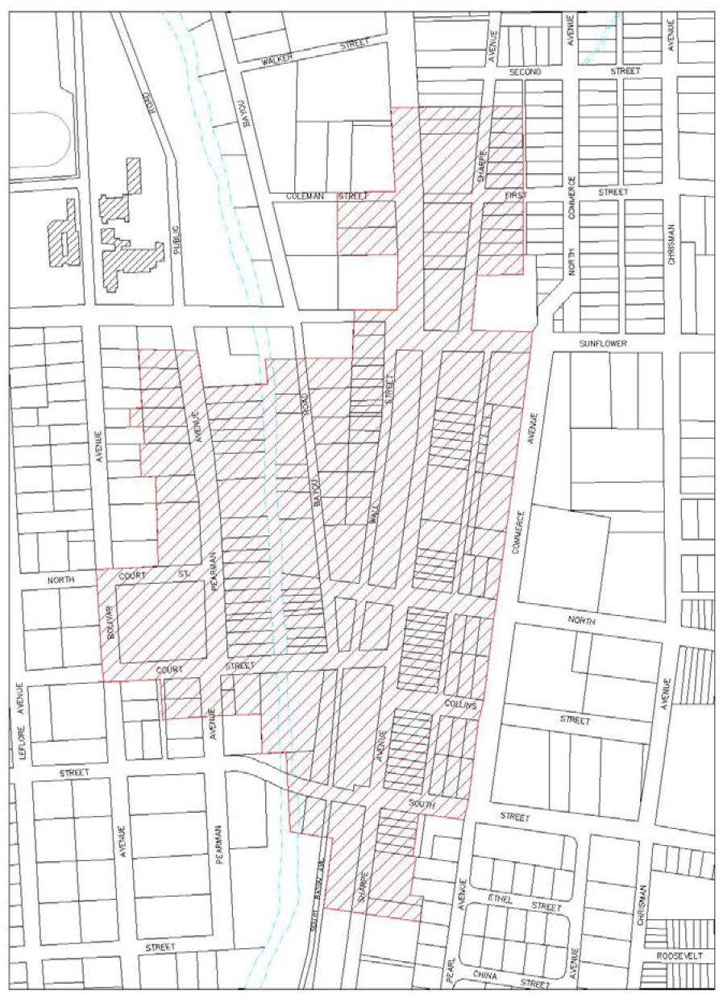

Sec. 1101. - Visual character.
1101.1. - Architecture.
Buildings are commonly identified and categorized by: age, use or function, building type, architectural style, method of construction, etc. Characteristics may be unique to a specific building or may be shared by a variety of buildings.
Common Elements of a Downtown Building
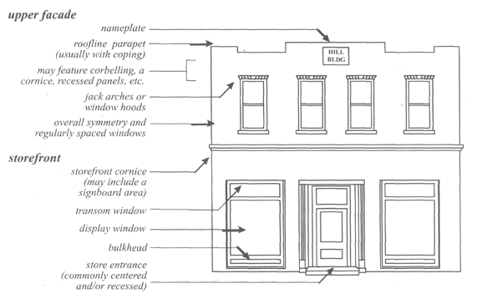
• Within the historic district, buildings range in age reflecting the period of significance. Most buildings are late nineteenth and early twentieth century. Modern infill construction is easily distinguished because of the failure to use compatible openings, materials, and ornamentation.
• In terms of use, buildings are constructed to shelter a variety of functions. The three most common uses found in the downtown area are: 1) commercial or retail establishments, 2) industrial or warehouse enterprises, and 3) public or civic institutions. The majority of buildings are commercial in character.
As buildings are reused, new uses which may or may not be the same as the original use are often introduced into an existing building. For example, professional offices occupy renovated interiors of residential buildings and old warehouses may be modified to house apartments. Preservationists refer to this "recycling" of buildings as adaptive reuse. Changes in use do not have to impair the historic character of a building.
• In general, type refers to a set of buildings which share distinctive architectural characteristics. A building type can indicate whether a building is rare or common in an area and in some cases, identify the historical period in which the structure was most likely built. The three most common commercial building types in the historic district are: the store-front, the double-front, and the business block.
Common Commercial Building Types
Store front The simplest type of commercial building is the store-front, names for the traditional use of its first floor. On buildings more than one story high, the upper level often serves a different use and features the elements common for upper facades. One-story storefronts are common in the historic district and often appear in twos and threes.
Double-front The double-front was built for two enterprises. Buildings may be one or two stories high. The double-front differs from the business block, which may also have two storefronts, in that it does not have an emphasized central entrance or a high degree of ornamentation. One-story, double-front commercial buildings are common in the historic district.
Business Block The business block refers to a commercial building which usually covers a large or entire city lot. The building ranges from two to four stories high and has a high degree of architectural detailing. A prominent central entrance may be emphasized further by a roof pediment. If the ground level is divided in to a series of storefronts, such buildings may be referred to as continuous business blocks. Secondary entrances to upper levels are common. The historic district contains a few prominent business blocks.
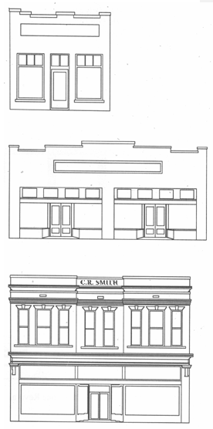
• Style is one of the most basic methods of classification. Essentially style refers to the external ornamentation or decoration of a building. When all the defining aspects of a particular style are present, a building may be labeled as a high style example. If only a few stylistic details are present, the building is referred to as having elements of a style or as influenced by a style. High style buildings are few in number and are often designed by an architect; whereas, buildings with elements of a style are quite common as local interpretations of an architectural style. Buildings with no stylistic details are termed vernacular and usually referred to by type.
The majority of buildings in the Crosstie Historic District are vernacular or have elements of an architectural style. Only a few structures exhibit clear high style construction. High style examples include the Post Office (now the Police Station), the Coca Cola building, the Nehi building, and the Regent and Ellis theaters.
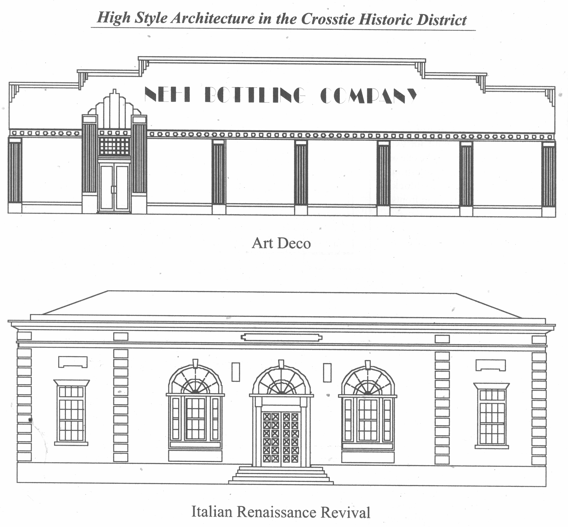
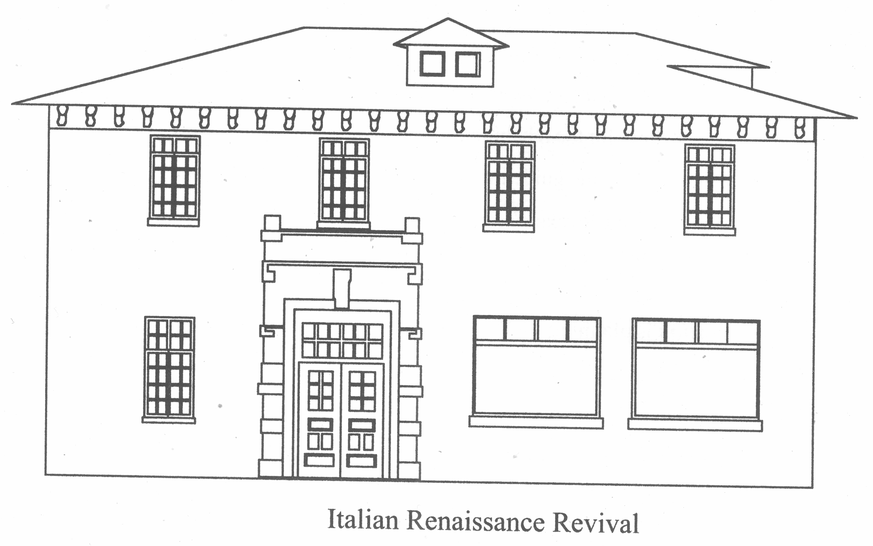
Other Aspects of Visual Character—An area's character is also defined by features other than buildings, such as open space (or lack thereof), site features, streetscape features, landscaping, parking, etc.
The bayou and railroad corridor through the center of the district is an important open space. Inappropriate modern plantings and excessive parking would diminish the integrity of this significant resource and of the district as a whole. The line-of-sight, such as the visibility of Sharpe Avenue from one end to the other, is also an important visual characteristic of the district which should be valued and preserved. Site features, such as fences, walls, satellite dishes, mechanical systems, etc. are generally utilitarian in character and unobtrusive in placement. Modern streetscape features, such as street lights, planters, and banners, provide additional recognition and cohesion for downtown enterprises. Parking should remain on-street, and no buildings or open space should be lost to additional parking areas.
Sec. 1102. - Five main concepts for buildings within the historical districts.
The following principles and guidelines are established in order to ensure any new development of buildings or any alteration to existing buildings within the Historic Preservation Districts is conducted in a respectable manner that accentuates and takes advantage of the historical character of Cleveland.
Based on the construction of historic downtowns, there are five main concepts that should guide the new construction of buildings to complement the existing historical character. The building a) placement and orientation, b) form and scale, c) skin, d) openings, and e) attachments all work together to create the downtown atmosphere that the City of Cleveland is preserving through the creation of historic preservation districts and architectural design guidelines.
1102.1. - Building Placement and Orientation.
Building placement is an important characteristic of site planning. Placement refers to where the building will be situated upon the lot. Building placement responds to elements such as setback and spacing. The building setback is how far the building is placed from the front, side, or rear property lines. The building spacing refers to the distance between buildings on adjoining lots. In the historic district, buildings share a similar setback and spacing. Most buildings in the historic district have a zero setback (located on the property line) and are attached (sharing side walls with flanking buildings.)
Principle 1: New buildings should follow the traditional placement pattern. Most buildings in the historic district have a zero setback (located on the property line) and are attached (sharing side walls with flanking buildings). A new building should not be placed forward or behind the established setback or façade line, which is the visual line created by the repetition of similar setbacks by historic buildings. New buildings should also be attached, having a zero setback, rather than freestanding. Institutional and civic buildings are exceptions to the rule; these buildings are generally freestanding and located centrally upon the property. Industrial architecture follows both patterns. When evaluating new construction, reference nearby buildings and the appropriate type of building (i.e. commercial, civic, industrial, etc.
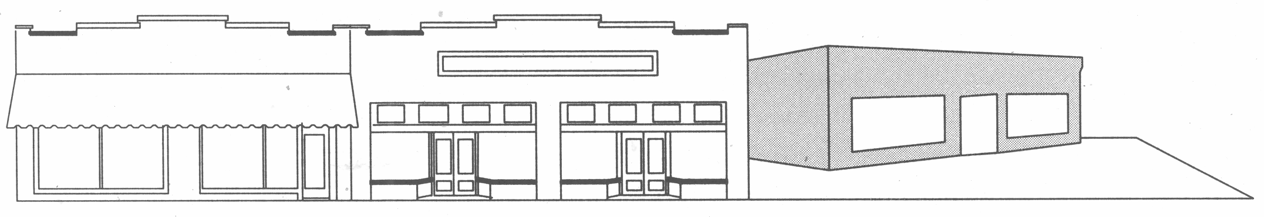
Inappropriate placement and orientation detracts from the visual character of the historic district.
Principle 2: New additions should be placed to the rear of existing buildings. Additions can have a tremendous negative impact upon building placement if added to the front of a building. The façade line would be disturbed. The most appropriate place for a new addition is on the rear of the existing structure.
Principle 3: New construction should maintain the setback established by neighboring historic buildings.
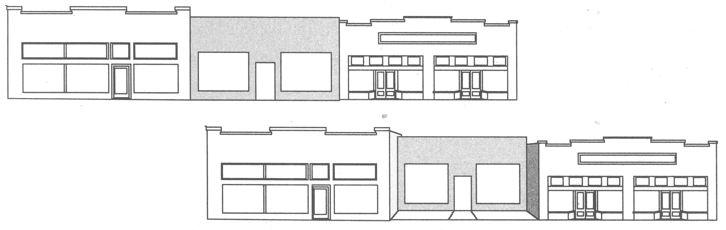
The new building (top row) follows the traditional setback of its historic neighbors while the new building (bottom row) disrupts the pattern by recessing its façade wall from the sidewalk line.
Principle 4: New construction should be placed so that the side spacing approximates that of historic buildings on the same block.
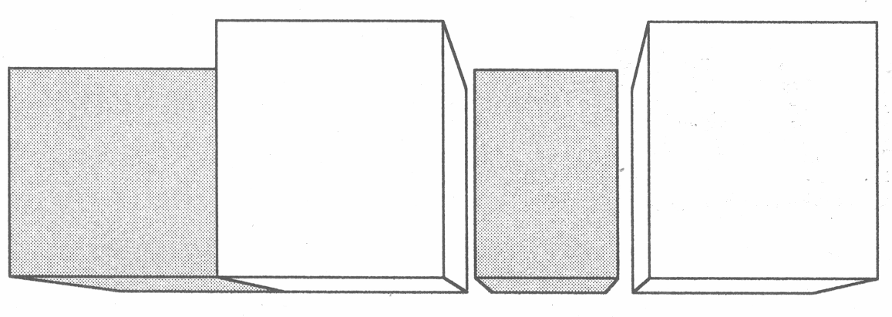
The new building (far left) shares its sidewall with the neighboring building unlike the new building (center), which disrupts this pattern by setting itself apart from the neighboring buildings.
Orientation is another significant site characteristic that simply refers to the direction that the primary entrance of a building "faces". In the historic district, the railroad had a tremendous influence on orientation where most buildings in the downtown area follow a clear pattern of being oriented towards the railroad.
Principle 5: New buildings should follow the traditional orientation pattern. Historically dependent on the railroad, most of the buildings in the downtown developed along the railroad corridor. Commercial establishments presented their "faces" to pedestrians in order to attract customers. Therefore, all buildings along a block tend to share a similar orientationtoward the street. Corner buildings usually face the more important of the two streets. Civic buildings may have multiple facades; thus, these structures may face more than one street. New buildings should repeat the orientation of the historic buildings on the same block. When evaluating new construction, reference the location, nearby historic structures, and the specific type of building (i.e. commercial, civic, industrial, etc.).
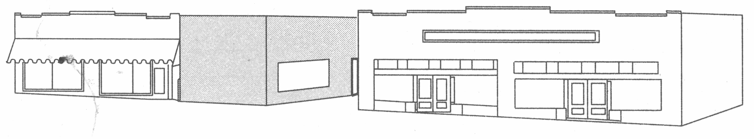
The new building (center) disrupts the traditional orientation pattern by not facing its primary entrance to the street.
Principle 6: New additions should not alter the orientation of historic buildings. New additions can alter the orientation of a historic building by shifting the primary entrance or creating a new primary entrance. New entrances should be carefully evaluated to determine their impact upon orientation.
1102.2. - Building Form and Scale.
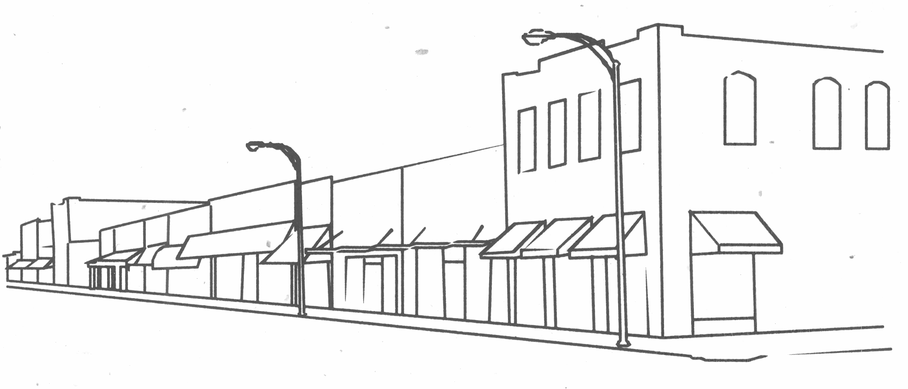
The repetition of similar form and scale creates unity in the historic district and distinguishes the area from other parts of the city.
Building form is the combination of the "silhouette" and the "footprint". It refers to the shape and appearance of a building. The "silhouette" of a building is defined by the outside lines of the building. Each building has four silhouettes or sides. On blueprints, each side is known as an "elevation." The front elevation is also known as the "façade." The shape, pitch, and complexity of the roof, also known as the parapet, influence the building form or the "silhouette".
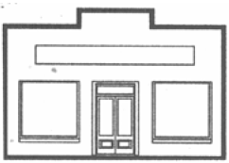
The "footprint" of a building is formed by the lines of the exterior walls of the building on the ground. On blueprints, this is known as the "plan" or "floor plan." Buildings in downtown Cleveland are primarily one single block with rectangular silhouettes and footprints. Parapets provide the only relief, or change in shape, to this geometric pattern.
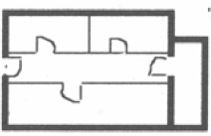
Principle 1: New construction should incorporate building forms that reflect the established form of the historic district. A dominant component of form is the roof and its shape, pitch, and complexity. Other ingredients are the height of the foundation, story heights, and whether a building is composed of a single block or several small blocks. Downtown buildings are primarily one single block with rectangular silhouettes and footprints. Parapets provide the only relief, or change in shape, to this geometric pattern. New buildings should feature parapets.
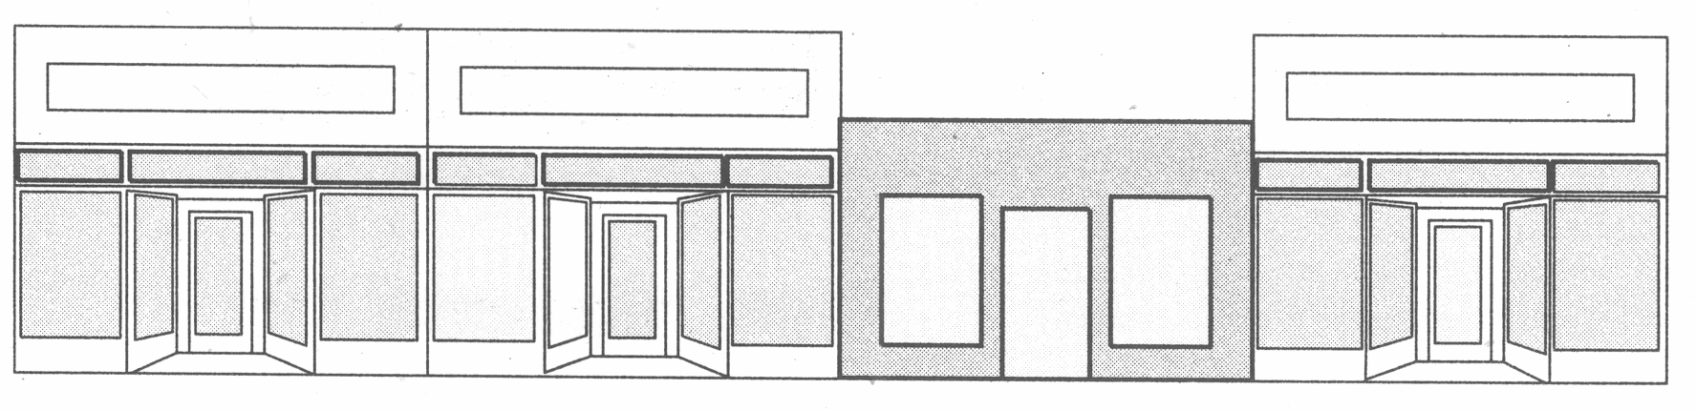
Though this new building has the same rectilinear form and number of stories as its historic neighbors, it fails to match their height due to a lower roofline and the lack of a parapet.

Principle 2: New addition forms should repeat the proportions of existing forms and should not destroy or obscure the form of the existing buildings. The roof form and foundation height of an addition should closely match the original proportion of the building. Additions, which are secondary and discernible, should not alter the footprint of a building so drastically as to completely obscure the original form.
a. Building Form: Roofline
Roofs are an important character and form defining feature. In the historic district, rooflines of commercial and warehouse buildings are distinguished primarily by the use of parapets, false walls which create a distinctive roofline and hide the low-pitched roof behind the parapet. A few examples, usually institutional or civic buildings, do not follow this general rule.
Principle a1: Roof design should be maintained and preserved. Important aspects of roof design include its pitch, shape, symmetry, and complexity. As most roofs in the historic district are simple parapet forms, changes which alter, cover, or detract from the parapet roofline are not appropriate. These rooflines are also important for their simplicity and should not be embellished.
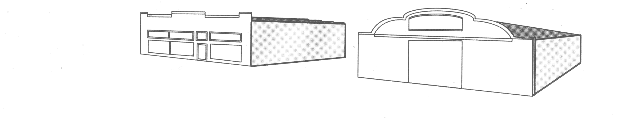
Parapets are a distinguishing feature of rooflines in the downtown area. Most are very geometric; however, a few possess curvilinear shapes.

Principle a2: During roof repair and replacement, new materials should match original materials. Architecturally distinctive roofing material should be carefully handled during repairs and reused when possible. As parapets are designed to hide a low-pitched roof plane, the actual roofing material is less significant for such buildings. Roof pitch and materials may be altered for improved drainage may be altered for improved drainage provided that the new roof does not rise above the parapet or lap over onto building elevations.
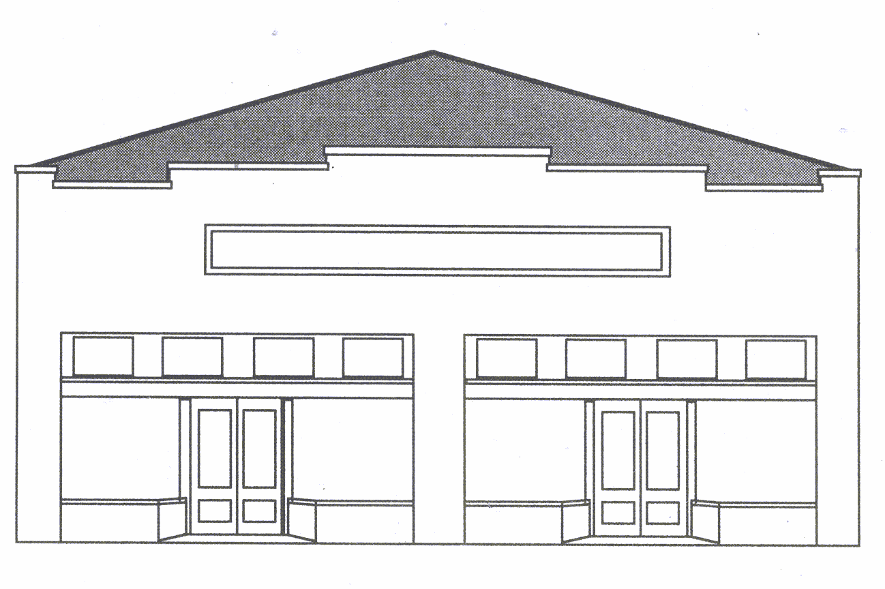
The addition of a new gable roof form is not consistent with the traditional use of parapets and disrupts the distinctive roofline created by a row of historic commercial buildings.

Principle 3: Secondary features and distinctive materials which contribute to design should be retained. Chimneys, often used for both decorative and utilitarian purposes, should be kept in good repair and not removed even when no longer in use. Skylights should be maintained whenever possible. Flashing, gutters, and downspouts should be examined and repaired during roof improvements; whereas, defunct roof pipes and vents may be removed.
Scale is the combination of mass and volume of a structure; it refers to the height, width, and depth. The majority of buildings in the downtown area are one-story with the exception of a few two-story buildings and a historic multi-story hotel. Most buildings are also no more than three or four bays wide meaning one building may have three or four different façade details or storefronts. The uniform scale of historic buildings and new construction is essential to the visual character of the historic district.
Principle 4: New buildings should follow the established scale of the historic district. The majority of buildings in the downtown area are one-story with the exception of a few two-story buildings and a historic multi-story hotel. Most buildings are no more than three or four bays wide. New buildings should approximate the height, width of adjacent and nearby historic buildings. Building depth should be evaluated if lot coverage becomes an issue. If a building is to occupy several empty lots, it is essential that the façade be segmented with horizontal divisions to approximate the widths found upon historic examples.
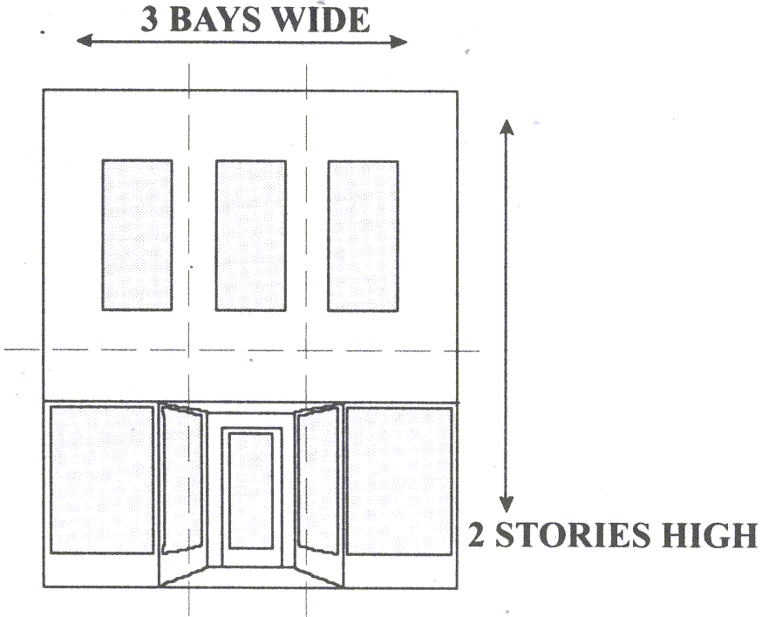
Width is a combination of actual linear footage as well as the number of vertical bays (horizontal divisions).
Height is both the number of stories as well as the height of the building above grade.

Principle 5: New additions should be proportional to and discernable from the existing historic structure. New additions should not overwhelm the original structure. Additions should not alter nor obscure the original scale of historic buildings; additions should remain secondary to the principal building. An addition should also have a perceivable juncture where it adjoins the original building. This can be achieved by using a slightly lower roofline, recessing the wall back from (rather than flush with) the original wall, or the use of a separating element.
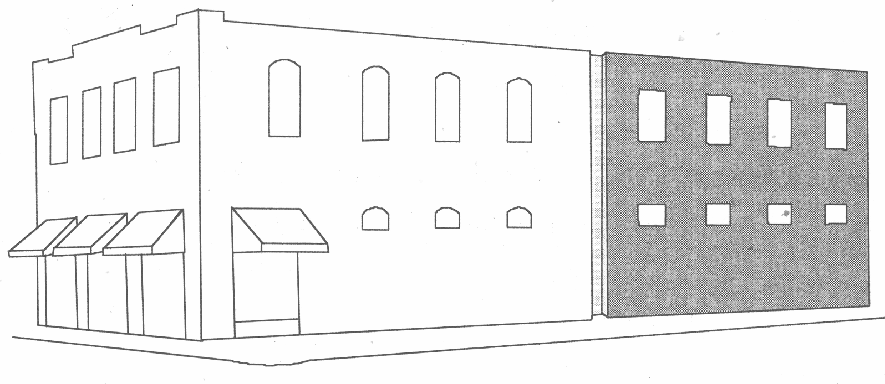
Additions are easily discernable through a small recessed "juncture" and the use of openings which differ in shape while respecting placement and size.
1102.3. - Building skin: Materials and ornamentation.
Materials and ornament have a significant impact upon visual character. Materials form the surface or walls of the building. The type of materials used defines a building in terms of both texture and color. In addition, ornamentation accentuates different portions of the building. The proper use of materials and ornamentation can allow a new building to become a contributing member of the historic district while introducing its own identity.
Principle 1: Exterior materials should be preserved and maintained. As the most common exterior material, brick is tremendously significant to the character of the historic district. Existing exteriors should not be covered by a modern replacement, including but not limited to: vinyl or aluminum siding, stucco or synthetic stucco (E.I.F.S.), western-motif plank siding, etc. Such materials rob a building of any historic integrity and its ability to contribute to the historic district.
Principle 2: New buildings should utilize traditional building materials. New buildings constructed with materials inconsistent with the district negatively impact the historic character of the area. Brick is the most common exterior material. Traditional materials uncommon to the area should not be used. Because of the permanence of masonry materials, the color of masonry materials for new construction should relate to existing historic buildings in the district to avoid inappropriate and uncharacteristic colors. Use of a primary color of brick for the façade and a secondary color for detail work will be considered; however, variegated brick is inappropriate.
Principle 3: New additions should utilize materials closely matching the original material of the building. Exterior materials for additions should relate in size, shape, and color to those of the original structure.
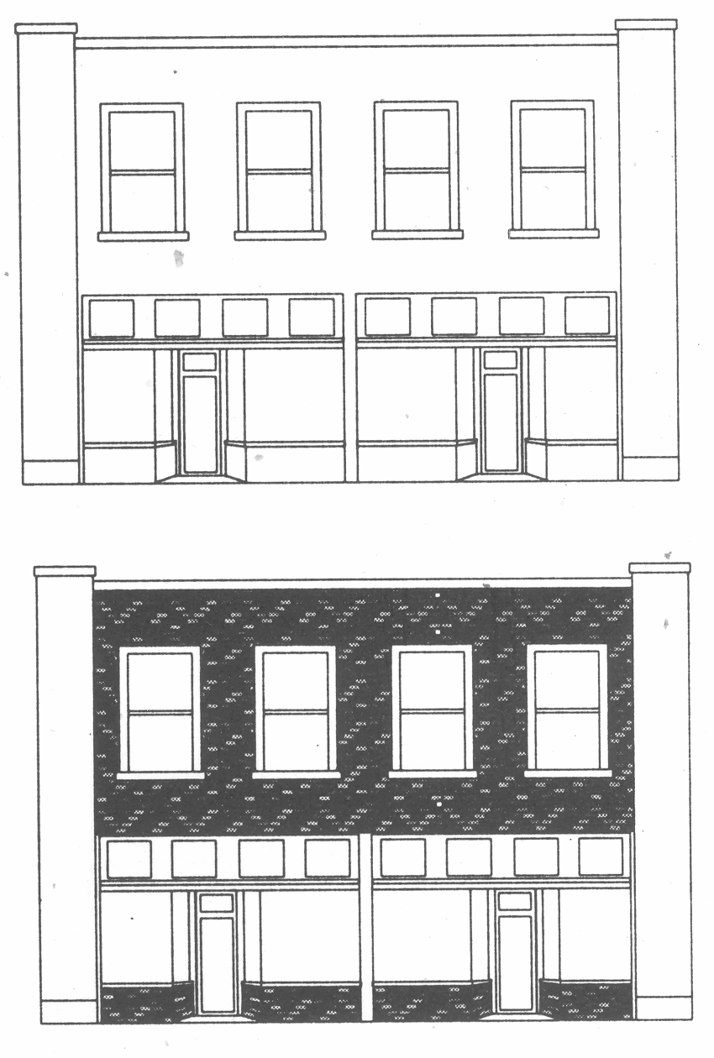
The use of variegated brick or synthetic materials for pilasters is inappropriate in the historic district.
Principle 4: Repairs should be limited to affected areas, be sensitive to historic materials, and utilize matching materials. Repair of exterior materials should remove only the damaged material and replace it in kind. Mortar for reporting should be carefully selected because modern cement is rigid and will damage historic bricks which expand and contract. The gentlest means possible should be used for cleaning building exteriors. Never sandblast to clean or remove paint from buildings. Unpainted buildings should not be painted unless previous repair or damage has caused significant contrasts in the brick and mortar; however, painting non-historic buildings can camouflage over-sized or variegated brick and increase compatibility. Iridescent and florescent paint colors are inappropriate; neutral colors are preferred. Historic paint palettes are available at most paint suppliers.
Principle 5: Architectural elements should be retained, never covered or removed. A distinguishing feature of commercial buildings in the historic district is the alignment of decorative features along a block of buildings. Decorative elements along the roofline visually connect the buildings. Decorative brickwork and brick corbelling is often common at the roofline, along the cornice, and on the parapet wall. Industrial buildings are usually devoid of ornament; however, the two soda bottling plants have a high degree of ornamentation. Institutional and civic buildings frequently use classical ornamentation, such as pediments, columns, entablatures, and quoins.
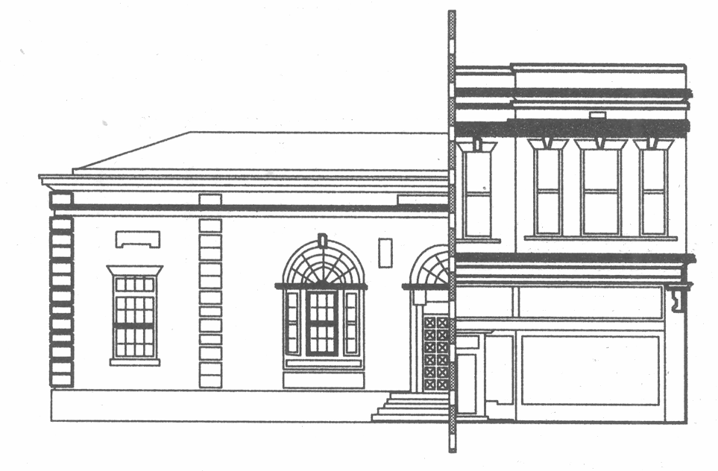
High style architectural elements are more common on institutional or civic buildings such as the old Post Office; however, some commercial facades are highly articulated like the Smith Block.

Principle 6: New buildings should use ornamentation reflecting the pattern established by existing construction. Ornamentation for new buildings should not exceed the degree of ornamentation found on existing buildings. Classical detailing should be reserved for banks and civic buildings; however, these details should be drawn from a period of development comparable to the district's architecture. Trim, brackets, braces, moldings, shingles and other such decorative features contribute ornamentation to buildings.
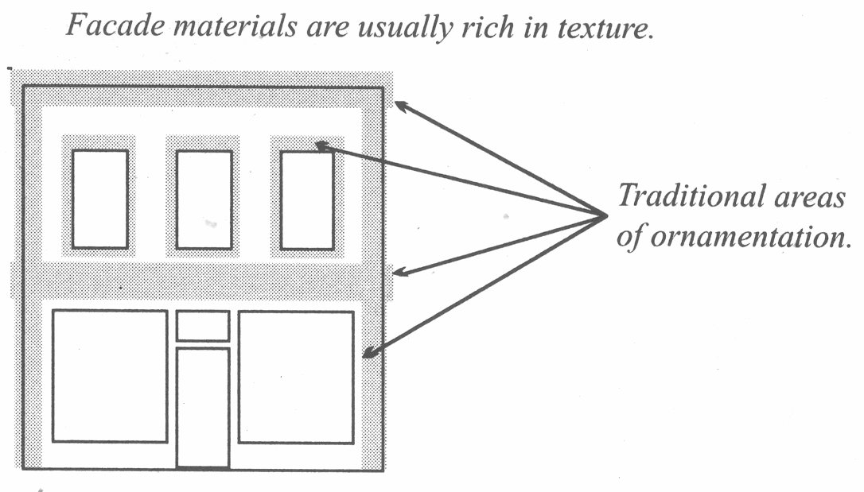
Principle 7: New additions should use the same or less ornamentation as found on the original structure. Less ornamentation for additions is encouraged. For additions to high style buildings, ornamentation which references the original structure's detailing may be considered; abstracted details are preferred. This change in ornamentation clearly denotes the addition as later construction.
1102.4. - Building openings: Storefronts, entrances, and windows.
Entrances and display windows combine to form a street level storefront for commercial enterprises. Storefronts are a distinctive feature of the historic district. Historic storefront design includes the primary entrance, large display windows, panels known as bulkheads beneath the windows, a transom row above the windows, and ornamentation such as cast iron columns, a decorative cornice line, and other details. This arrangement of features provides an ideal opportunity to display goods for public viewing. Recessed entrances, tiled entryways, and double doors also contribute to storefront design. Additionally, secondary entrances to upper floors or for service purposes are also common.
Principle 1: New buildings should carefully reference the historic use of façade elements. Storefronts, entrances, and window openings pierce the walls and create voids upon a building's façade that creates a rhythm along the streetscape. These façade elements, with a few minor variances, generally align along a block. Most buildings also emphasize façade symmetry. Openings on the façade of new buildings should follow the example established by surrounding historic buildings. Quantity and placement of openings in new buildings is extremely important. New buildings should carefully balance solid and void.
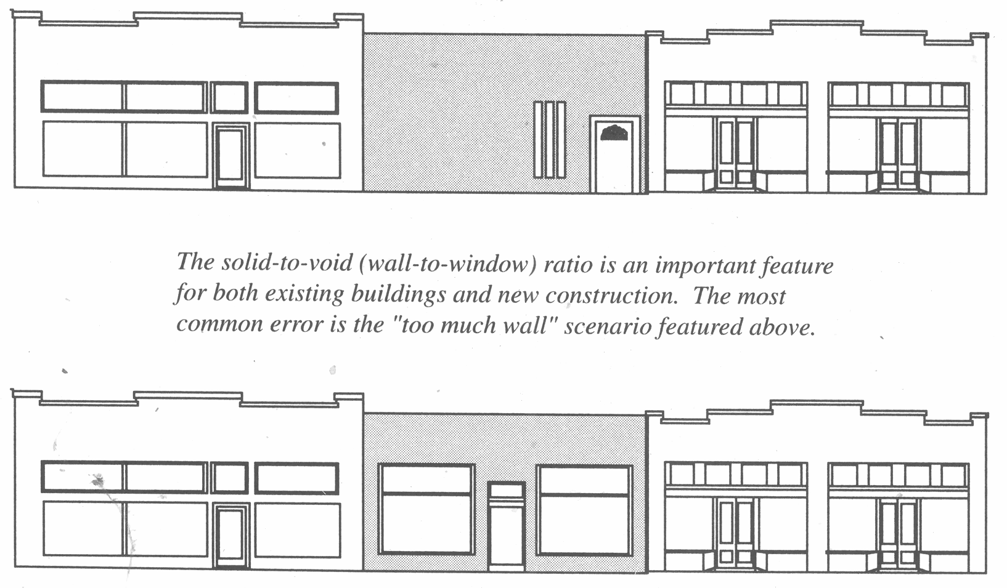
Principle 2: New additions should follow the established pattern of elements found on the original building. As additions should be located on the rear of existing buildings, only corner properties will have exposed side elevations. For such properties, it is important to respect the pattern established by similar corner properties.
Principle 3: Original storefront configuration and materials should be preserved and maintained. Storefronts should not be covered or enclosed. Entrances should not be relocated or infilled. Display windows and transoms should not be enclosed, replaced with a different window type, or covered with a false front.
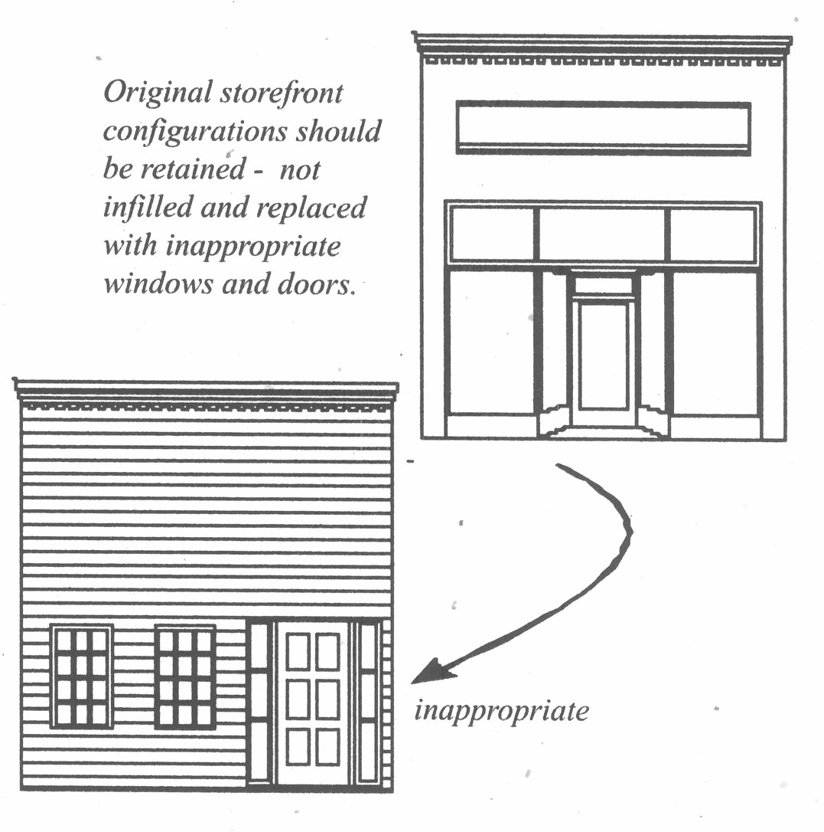
Principle 4: Replacement storefronts should follow the established traditional pattern. If the original storefront is too deteriorated to save, the replacement should accurately replicate the original. Where the original storefront no longer exists, the replacement should be based on historical research and physical evidence. Where no documentation exists, a new storefront should be designed which is compatible with original storefronts of adjacent and nearby historic buildings.
Principle 5: Existing entrances should be maintained and preserved. Entrances and their doors are evidence of the original use and design of a building. Original doors, their surrounds, and hardware should be retained. Entrance elementsthe location, the configuration (recessed or canted), the number and type of doors, and, tiled entryway floorsshould not be altered. Primary entrances should never be enclosed. Secondary entrances for upper floor access and service/delivery should be preserved even when no longer in use.
Principle 6: During repair and replacement of doors, care should be taken to match original materials and design. Deteriorated sections should be replaced rather than an entire door. If replacement of a door becomes necessary, the replacement should match the historic door in size, shape, materials, and panel patterns. Unfinished aluminum doors and residential type doors should not be installed. Adding decorative doors or surrounds to simple front entrances or utilitarian entrances diminishes the historic integrity of a building. Warehouse entrances are particularly simple and should not be embellished to create more formal entrances, such as those more characteristic of institutional and civic buildings or residential architecture.
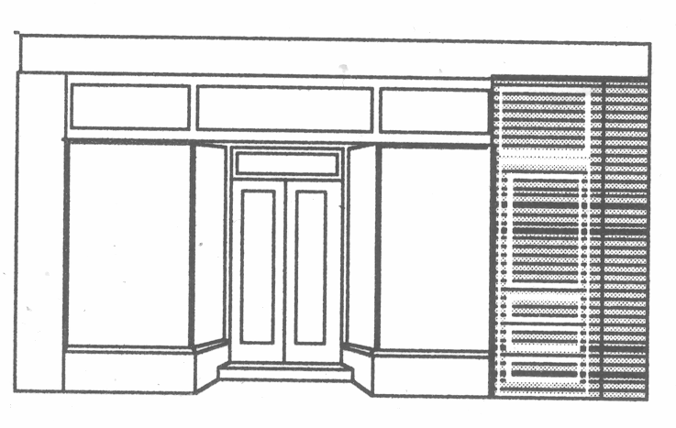
Original entrances should not be blocked-in, even if no longer in use.
Window and window features define the character of a building as well. Storefront windows of commercial buildings are used to create large expanses of glass and thus display space; however, on the upper facades and on institutional and civic buildings, the ratio of solid-to-void (wall to window) is very different. Typically, windows are regularly spaced with an emphasis on building symmetry. Upper windows are also trimmed with architectural detailing and window accessories, such as shutters, storm windows, and screens.
Principle 7: Historic windows should be preserved and maintained. Display windows and the transom row are essential to commercial storefront character. Smaller, sash windows and early metal frame windows are characteristic of industrial properties; these types of windows should remain simple and utilitarian. In contrast, institutional and civic buildings have prominent and regularly-spaced windows.
Principle 8: During repairs and renovation efforts, window configuration should be maintained. Display window and transoms should not be removed or covered. Damaged windows should be repaired by replacing affected sections with the same material and dimensions as the original. Replacement glass should be clear, not tinted. Additional or unfinished aluminum windows should not be installed. Installation of multi-divided pane windows is inappropriate and creates a false historic appearance.
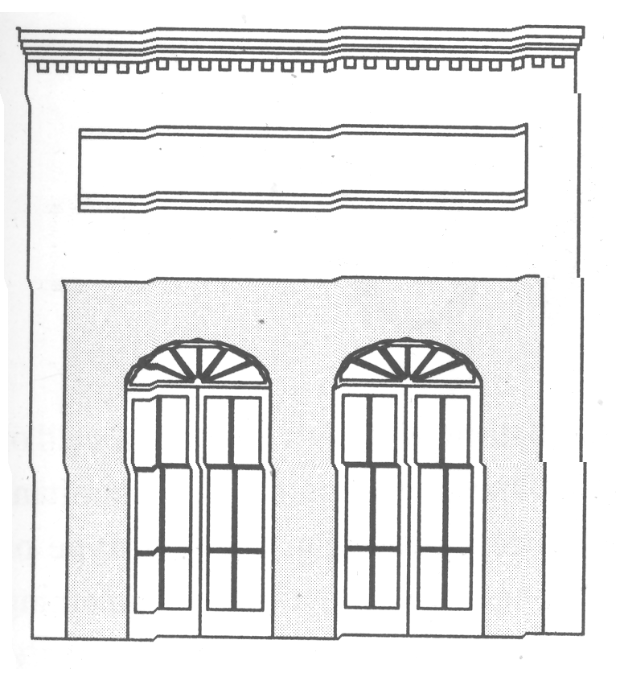
Non-historic decorative entrys and windows, referencing the Old West, Colonial New England, or New Orleans (depicted here) should not be added to falsify the storefront.
Principle 9: Storefront trim should be maintained and preserved. Bulkheads are the panels located beneath the display windows. Important bulkhead design elements include but are not limited to recessed panels, masonry ledges, and decorative trim. During repairs, it is important to replicate historic bulkheads. Wooden bulkheads should never be replaced with brick. Cast-iron columns and cornices should not be removed. Where the original ornamentation no longer exists, the replacement should be based on historical research and physical evidence.
During rehabilitation, careful removal of non-historic material may reveal physical evidence of the original façade.
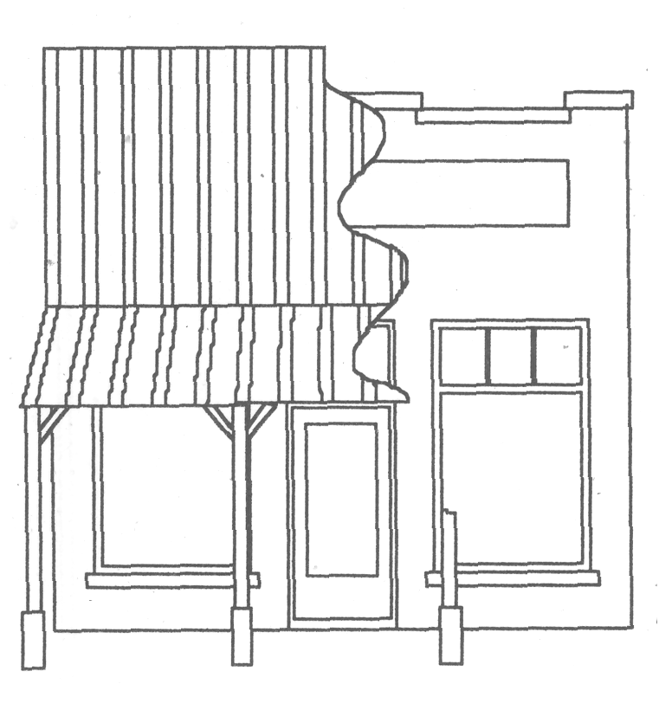 | Original roofline with coping and stepped parapet  Traditional signboard area  Obscured transom windows  Important bulkhead

Principle 10: Windows should be maintained and preserved. Historic windows are constructed of several components, such as rails, stiles, muntins, panes, sashes, and sills. Important aspects of window design include shape, dimension, grouping, spacing, type or operational category, pane arrangement, material, and ornamentation. Maintaining both window components and window arrangement is essential to building integrity.
Principle 11: During rehabilitation and renovation, the original window materials and design should be retained. Though in their original state historic windows do not equal today's standards of energy efficiency, they should not be replaced. Efforts to increase energy efficiency and the operation of windows should keep the historic components intact. Window openings should not be enclosed, covered, or partially infilled for the installation of different shape or size windows. Additional window openings should never be added to the front of a building. During renovation efforts, enclosed and covered window opening should be reversed and inappropriate replacement windows removed.
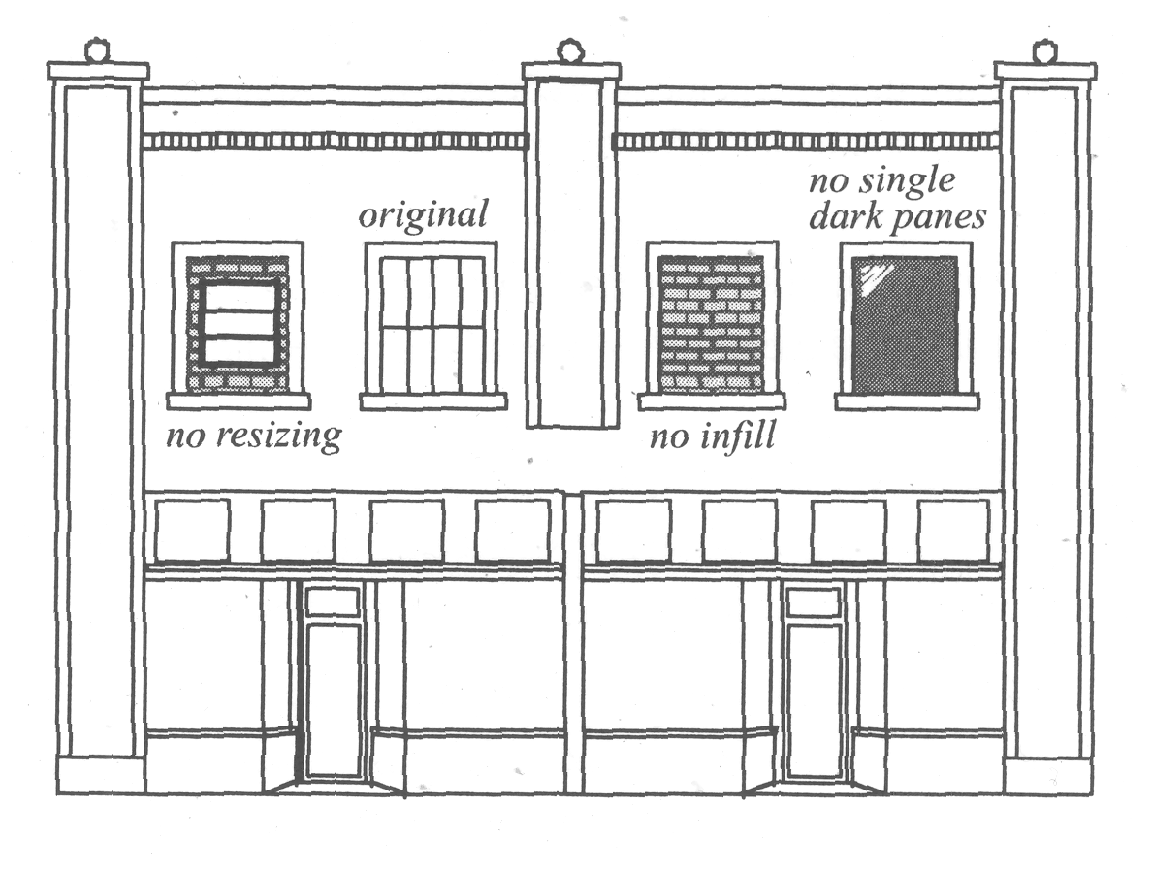
Principle 12: Windows should be repaired, rather than replaced. Damaged windows should be repaired by replacing the affected components and restoring the functional elements. Original window openings should be utilized if replacement is required by the severity of deterioration. Replacement windows should closely match the original window design. Fixed windows and simulated divided light windows ("snap-in" muntins) are inappropriate. Traditional framing materials such as wood are preferred for replacement windows; whereas, unfinished aluminum windows are inappropriate. New glazing should not be tinted or coated with a reflective material.
Principle 13: Visual impact of window accessories should be kept to a minimum. Storm windows and screens should not obscure the window's pane arrangement. Such features should be of wood or aluminum painted to match the original window frame, and the glazing should be clear. The use of interior storm windows rather than exterior storm windows is encouraged. Security grills with extensive metalwork should be avoided and are best installed on the interior of the building.
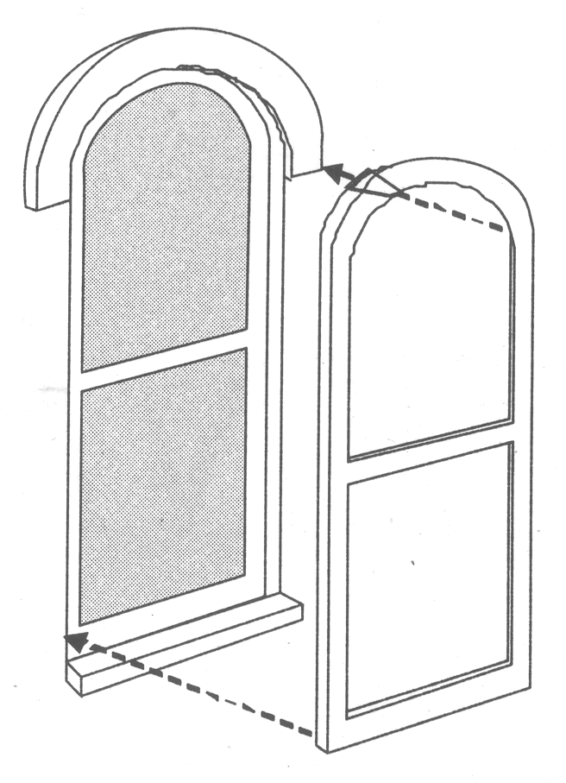
Storm windows and screens should match the shape and design of the window. Interior storm windows are a better solution.
1102.5. - Building attachments: Shutters, awnings, porches, and signs.
Principle 1: Historic shutters should be maintained. Shutters were used to provide shade, privacy, security, and decoration for buildings. Replacement shutters should be of the same material and design as the original. Where shutters have been lost or removed, historic photographs and hardware remnants may provide physical documentation of the original design. Windows which never had shutters should be left in this condition. Decorative shutters permanently affixed to the wall of a building are not considered appropriate replacements. Utilitarian type shutters on secondary elevations and on warehouse properties should not be replaced with decorative shutters.
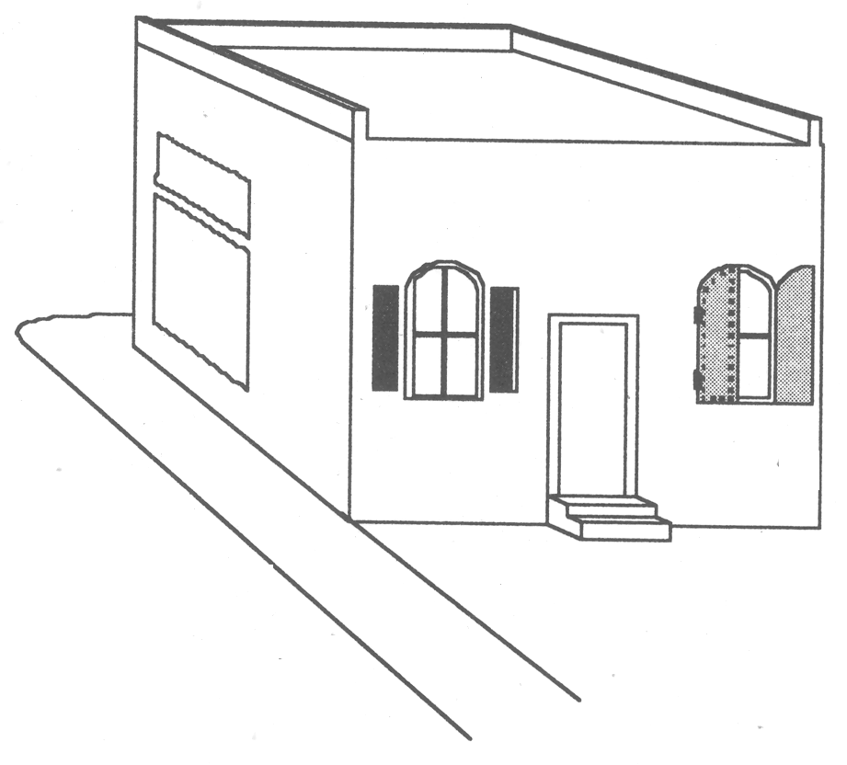
Shutter design should reflect the original use of the building and should fit the window opening.
Awnings, canopies, and porches frequently provide shade for building interiors, shelter for walkways, and ornament for exteriors. Awnings are common in this historic district. Canopies and porches are limited in number and are appropriate for only a few types of buildings.
Principle 2: Historic awnings, canopies, and porches should be preserved. Historic examples should be repaired using durable materials similar to the original.
Principle 3: The design of new awnings, canopies, and porches should be appropriate to the architectural character and historic documentation of the building and district. Inappropriate "theme" examples added during recent years are best removed or incorporated into a more appropriate design. Simple shed porches with wood posts reflect the earliest porches. For most buildings, awnings are the appropriate design; however, awnings would not be compatible for some early twentieth century buildings, which utilized flat, suspended metal canopies to reinforce their horizontal lines.
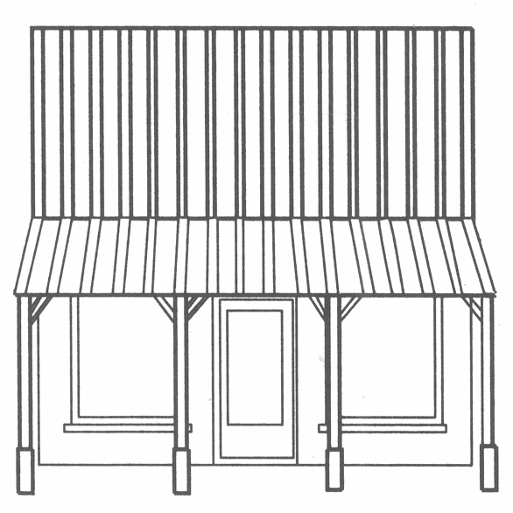
False thematic attachments, such as porches for an "Old West" look or balconies for a "French Quarter" appearance are inappropriate. Documented attachments may be restored.
Principle 4: Attachments should reinforce the scale and design of the host building. The design of new attachments should be evaluated in terms of placement, shape, size, and material. Awnings, canopies, and porches should be located to complement the building without obscuring storefront details and exterior ornament. Attachments should reflect the shape of and fit neatly within the frame of existing openings. Convex and concave awnings are generally inappropriate. Awnings and canopies should not span several buildings. Historic porches, especially those located on primary elevations, should not be enclosed.
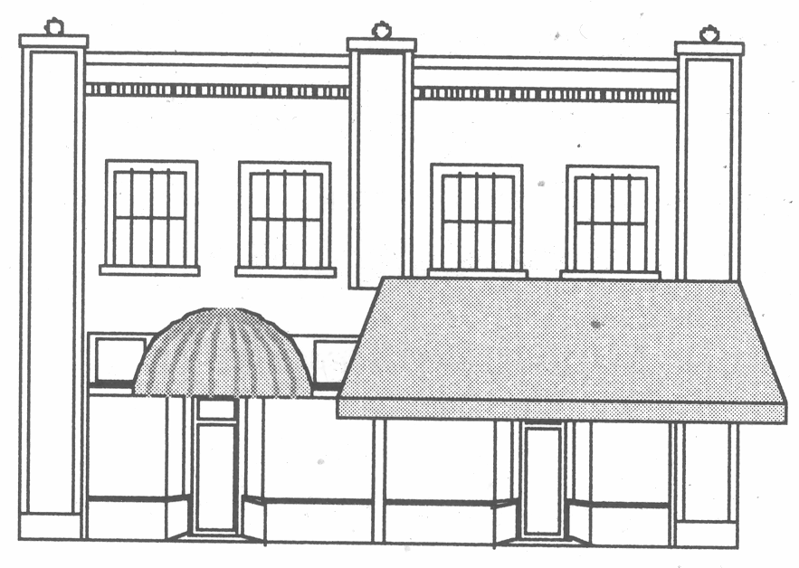
Awnings should be in scale and proportion to the building and should not cover stylistic details.
Awnings should not be shaped differently than the window or doorway. For example, rounded or "bubble" awnings are not appropriate attachments for squared entrances.
Principle 5: Materials and illumination for attachments should respect the historic character of the district. Fabric and metal are the most appropriate choices for awnings, and metal canopies may be considered. Internally lit awnings are not appropriate in the historic district.
Signs are the most common and most frequently altered features in the downtown area. Signs identify business establishments, building names, products sold, and services provided. Signs contribute significantly to the visual character of the area, and inappropriate and competitive signage can have a tremendous negative impact.
Principle 6: Historic signs should be preserved and maintained. Cornerstone inscriptions, inscribed surface lettering, "ghost" advertisements, and mosaic tile lettering on entrance flooring are common historic signs.
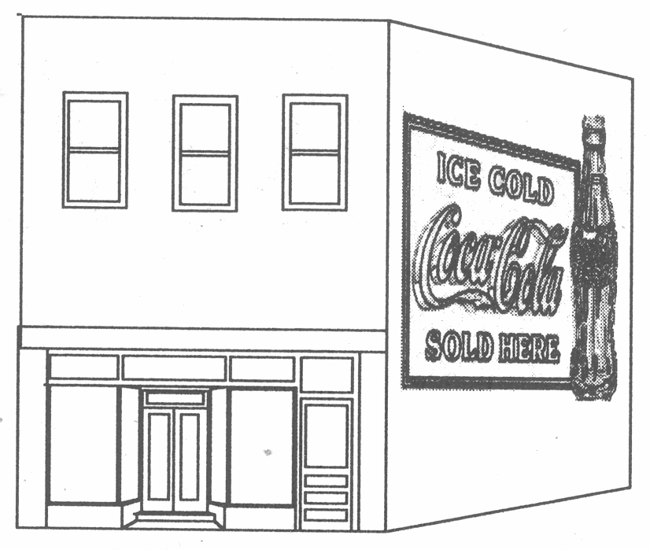
"Ghost" signs, fading painted signs, contain historic business names and product logos and should be retained. Murals are inappropriate and painted signs should be limited to historic precedents, such as the use of business names, product logos, and product advertisements.
Principle 7: Contemporary signs should be placed in traditional sign locations. Traditional sign placement includes: located within the defined area above the storefront, hanging perpendicular to the façade, painted display windows, and stitched or painted upon awnings. Signs should not cover storefront details and exterior ornament. Where possible, signs should be aligned with conforming signs on adjacent buildings.
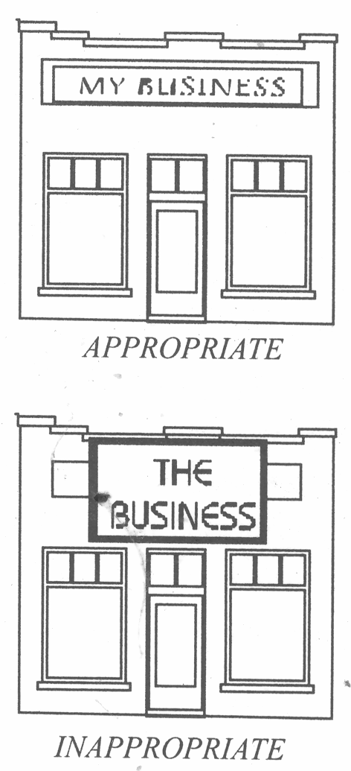
New signs should respect the proportions and design of the host building. Do not cover architectural features of the building with signs.
Principle 8: The installation of new signs should not alter or destroy historic materials or ornamentation. Signs should be mounted in such a manner to minimize the impact upon the building's exterior.
Principle 9: Contemporary signs should be of compatible design. Contemporary signs should be evaluated in terms of placement size, material, shape and lighting. Size and lighting should be limited to that which is necessary for identification purposes. Painted wood or metal signs are most appropriate; whereas, vinyl sign cabinets are not permitted. New signs should be simple or modern in design and avoid a false historic appearance. Illumination should be external and lighting fixtures should be unobtrusive.
Sec. 1103. - Maintenance requirements.
In order to insure the protective maintenance of historic resources, the exterior features of such properties shall be maintained to meet the requirements of the City's minimum housing code and building code.
Sec. 1104. - Demolition by neglect.
Any resource which is a landmark and all other resources within a preservation district shall be preserved by the owner or other persons having legal custody or control against decay and deterioration and shall be free from unreasonable structural defects. The owner or other persons having legal custody and control shall make such repairs if the resource is found to have one of the defects as discussed below. Repairs shall be made where deterioration to the extent that it creates or permits a hazardous or unsafe condition as determined by the Department of Community Development. Deterioration may be characterized by the following:
1. Those buildings which have parts attached that may fall and injure persons or other property.
2. Deteriorated or inadequate foundations
3. Defective or deteriorated floor supports or floor supports insufficient to carry imposed loads with safety.
4. Members of walls or other vertical supports that split, lean, list, or buckle due to defective material, workmanship, or deterioration.
5. Members of walls or other vertical supports that are insufficient to carry imposed loads with safety.
6. Member of ceilings, roofs, ceiling and roof supports, or other horizontal members which sag, split, or buckle due to defective material, workmanship or deterioration.
7. Member of ceilings, roofs, ceiling and roof supports, or other horizontal members which are insufficient to carry imposed loads with safety.
8. Fireplaces or chimneys which list, bulge, or settle due to defective material, workmanship or deterioration.
9. Any fault, defect, or condition in the building which renders the same structurally unsafe or not properly watertight.
If the Heritage Commission makes a preliminary determination that a resource is being demolished by neglect, it shall direct the Department of Community Development to officially notify the owner stating the reasons for this preliminary determination and shall give the owner thirty (30) days to commence work to correct the specific defects as determined by the Heritage Commission.
This notice to the property owner shall be certified by mail, restricted delivery, and mailed to the last known address of the record owner as listed on the tax roll. If this mailing procedure is not successful, notice shall be posted in a conspicuous, protected place on the resource in question.
If the owners fail to commence work within the time allotted as specified by the building permit, the Heritage Commission shall notify the owners in the same manner as mentioned above. This notification shall also require the owners to appear at a public hearing before the Heritage Commission and shall state the date, time, and location and be mailed at least thirty (30) days before the hearing. For the purpose of insuring a lawful notice, a hearing may be continued to a new date and time. The Heritage Commission shall receive evidence on the issue of whether the subject resource should be repaired and the owners may present evidence in rebuttal. If after such hearing, the Heritage Commission shall determine that the resource is being demolished by neglect, it may direct the Department of Community Development to bring misdemeanor charges against the owners if the necessary repairs are not completed within ninety (90) days of the determination of neglect.
Sec. 1105. - Public safety.
None of the provisions of this Article shall be construed to prevent any action of construction, alteration, or demolition necessary to correct abate the unsafe or dangerous condition of any resource, or part thereof, where such condition has been declared unsafe or dangerous by the Department of Community Development or the Fire Department and where the proposed actions have been declared necessary by such authorities to correct the said condition; provided, however, that only such work as is necessary to correct the unsafe or dangerous condition may be performed pursuant to this section. In the event any resource designated as a landmark or located within a preservation district, shall be damaged by fire or other calamity to such an extent that it cannot be repaired and restored, it may be removed in conformity with normal permit procedures and applicable laws, provided that:
1. The Department of Community Development concurs with the property owner that the resource cannot be repaired and restored and so notifies the Heritage Commission in writing.
2. The Heritage Commission, if in doubt after receiving such notification from the Department of Community Development, shall be allowed time to seek outside professional expertise from the State Historic Preservation Office and/or an independent structural engineer before issuing a certificate of appropriateness for demolition. The Heritage Commission may indicate in writing by letter to the Department of Community Development that it will expire a time period of up to thirty (30) days for this purpose, and upon such notification, this section shall be suspended until the expiration of such a delay period.

